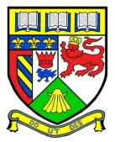**Keith Primary School**

Digital Profiles: A Guide for Parents  
August 2025

*In session 24-25, Keith Primary opted to move Learning and Achievement Profiles to an online format. This offers a convenient and engaging way for pupils, parents, and teachers to access and monitor progress throughout the academic year.*

The profiles will serve as a digital portfolio featuring everything from classwork to achievements and termly targets. By having this information readily available, we hope you will feel more involved in your child’s learning, leading to more discussions around what they are doing in school.

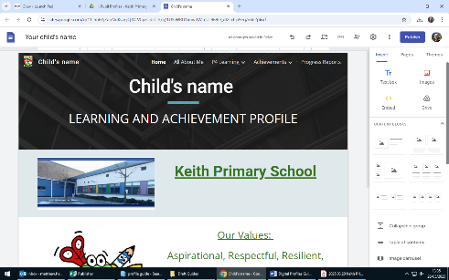

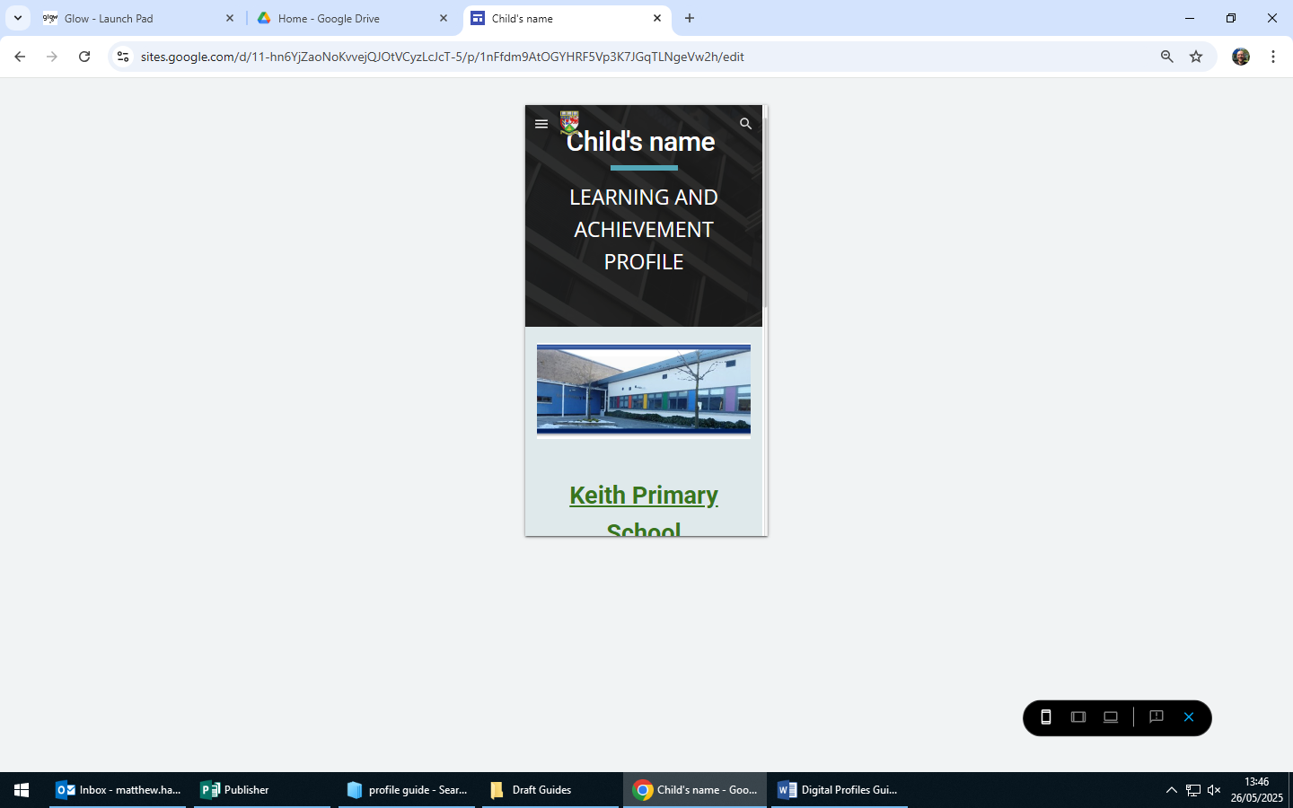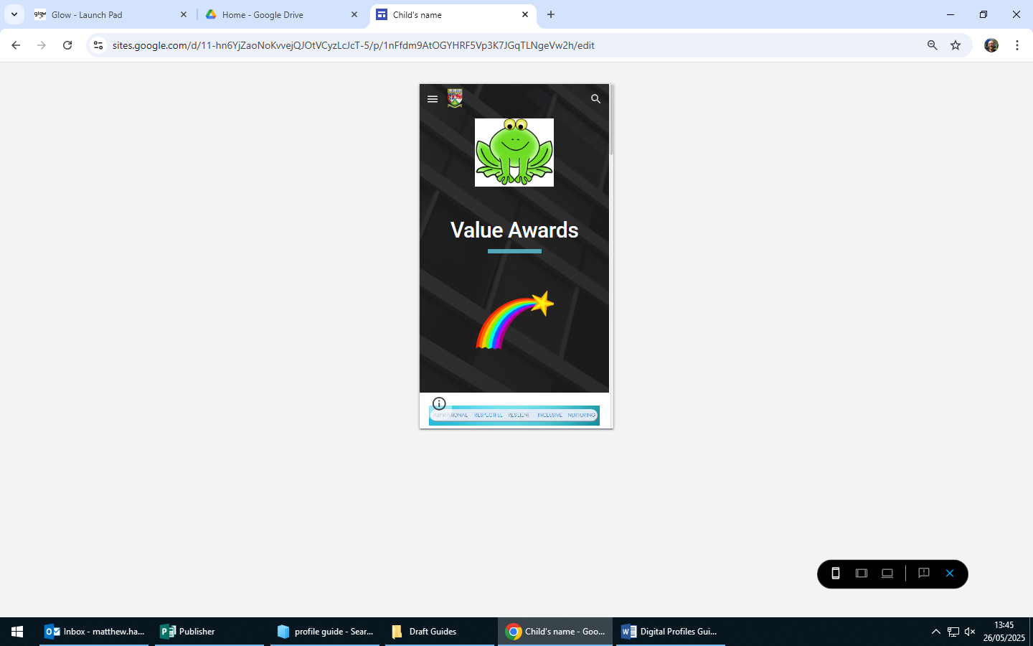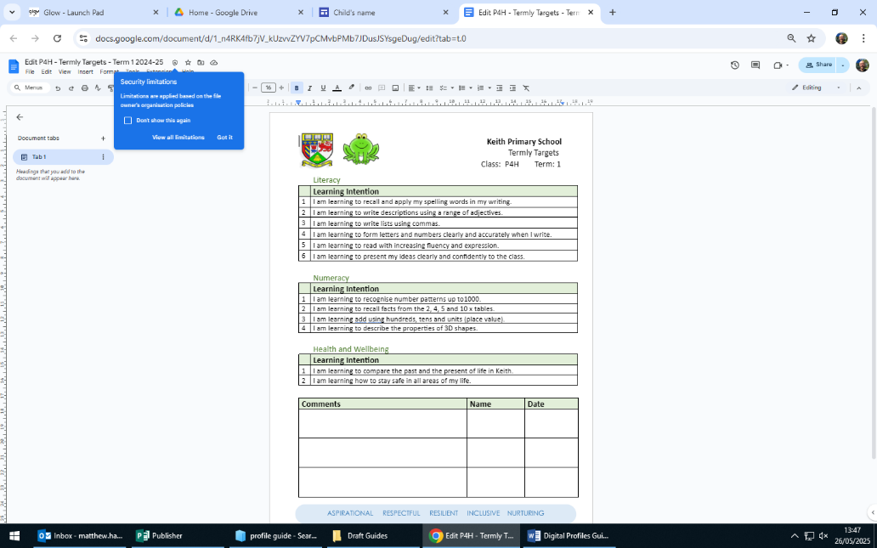

For our pupils, our online profiles encourage them to take a more active role in their learning by regularly reflecting on their accomplishments and setting future goals.

As the pupils journey up the school, they are able to take even more responsibility with these, giving them more ownership over what to include.

**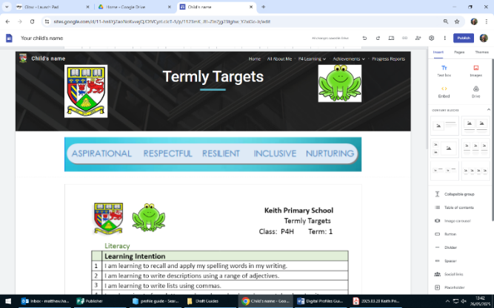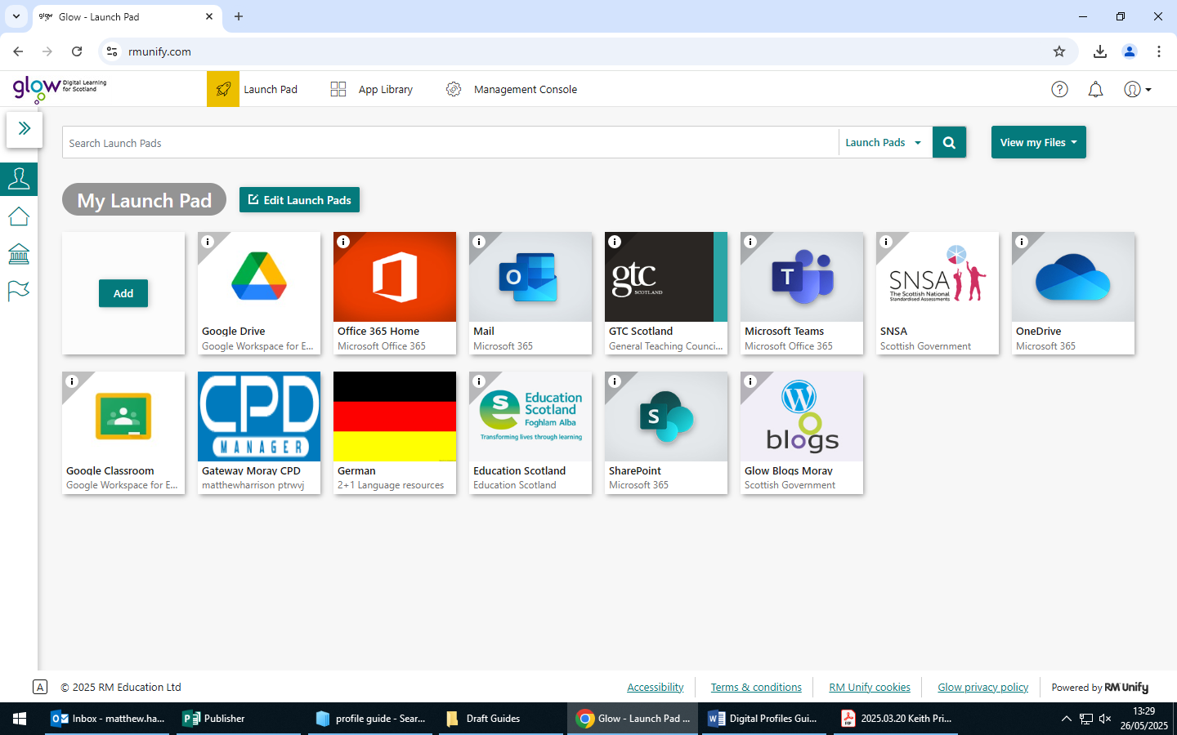

**How do I access profiles?**

Go to the website: **https://glow.rmunify.com/**

1. Log into *Glow* using the log in details provided by the class teacher.

2. Click on the *Google Drive* tile. You can use the search bar at the top if needed.

3. Click on *Shared with me* down the left hand side.

4. Click on the profile icon. Your child’s name will be along the top.

5. Click along the tabs and drop down arrows to view the profile.

On a **mobile device** you click on the three lines at the top right   
beside the school logo. This will bring up the menu where you   
can navigate through the different areas of the profile.

On a **laptop or desktop** these will be located along the top of   
the profile with drop down arrows to view the different sections.