**Keith Primary School**

Maths Assessment Policy: A Guide for Parents  
August 2025

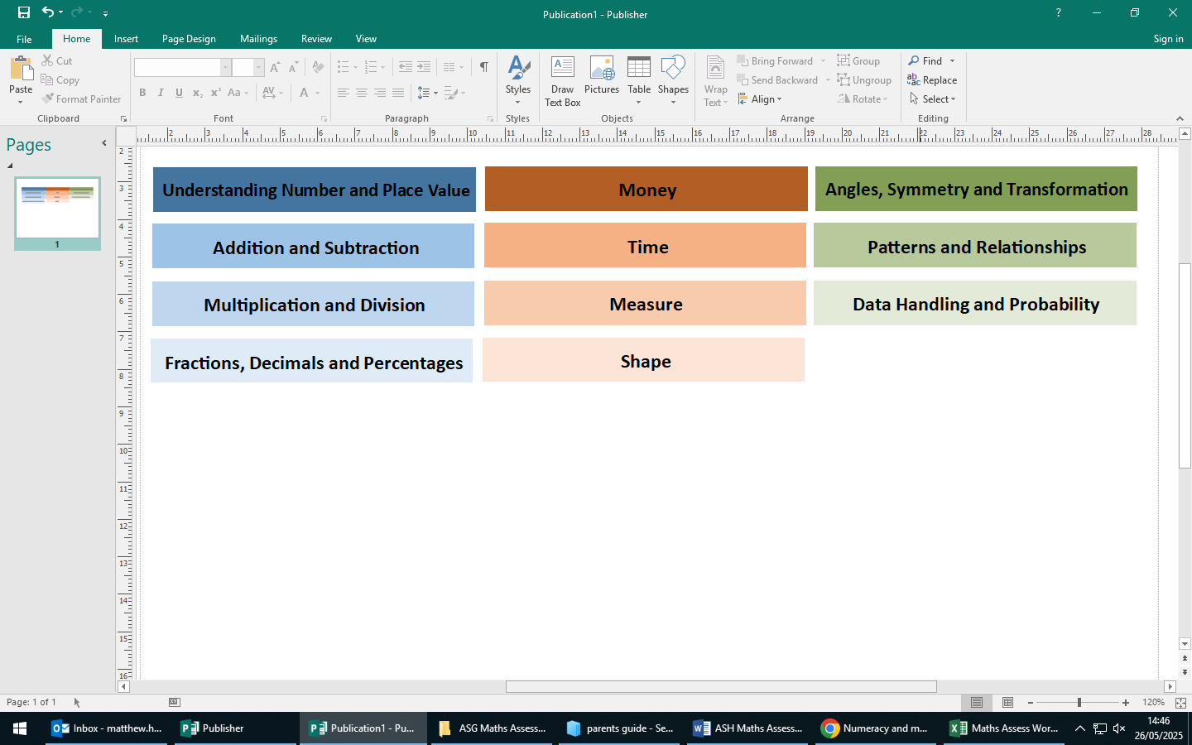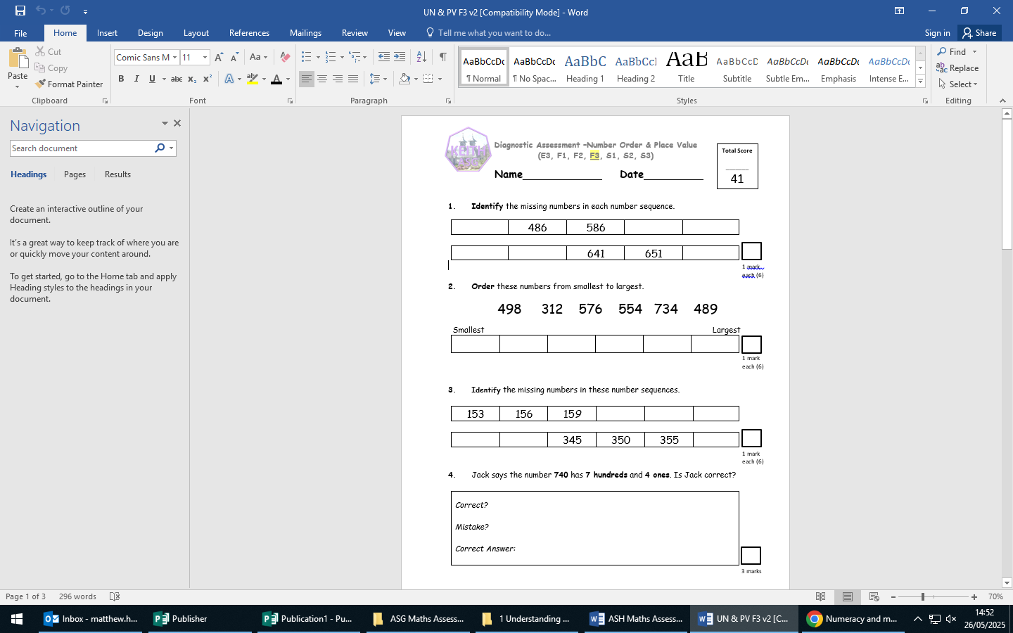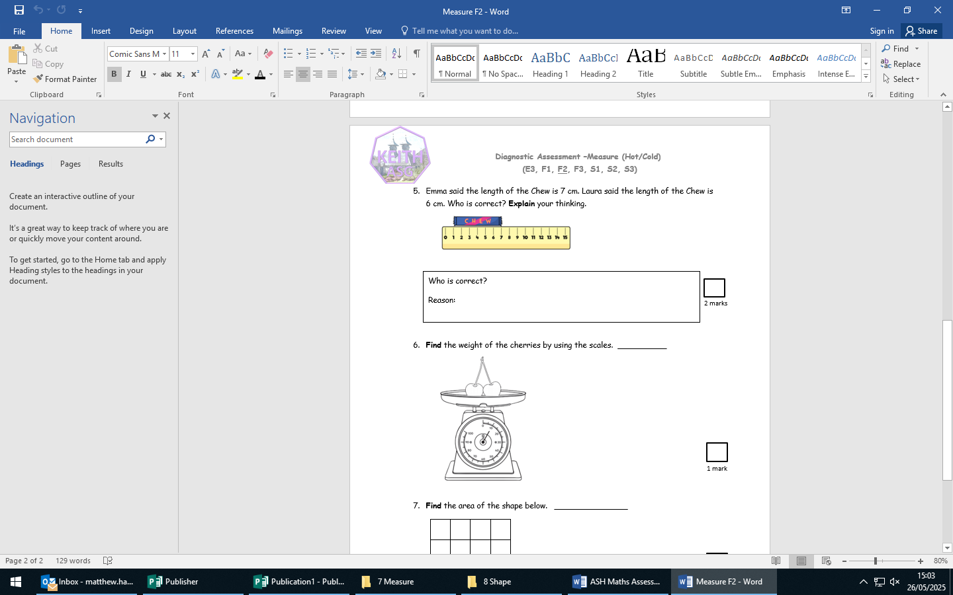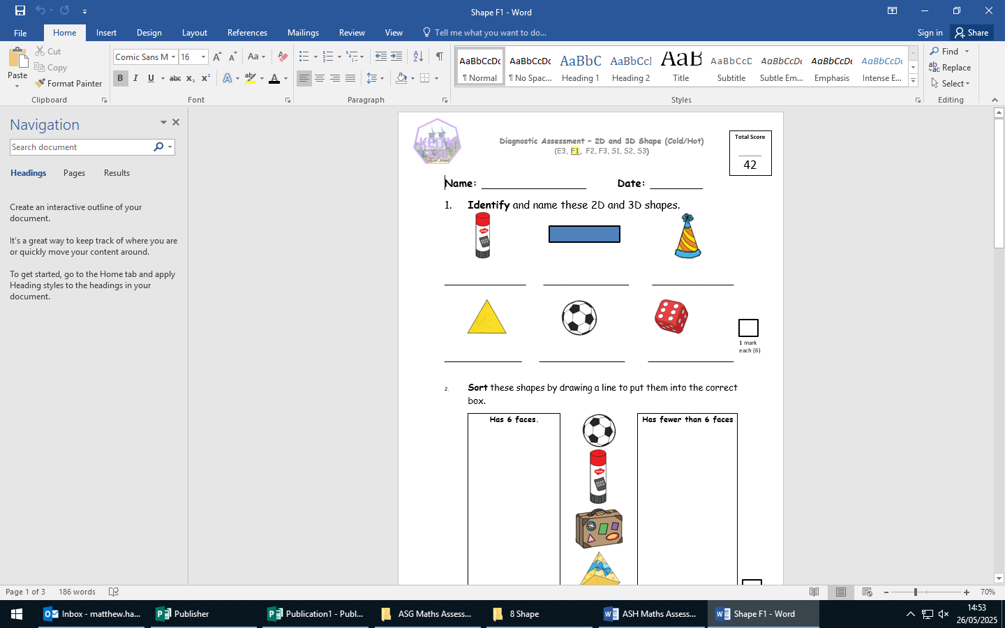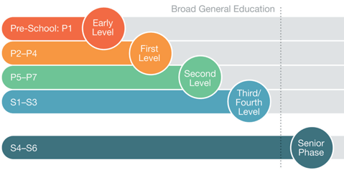

Children are first given a ***Cold Assessment*** at the beginning of a new maths topic (such as *Shape* or *Addition and Subtraction)*. This initial assessments help teachers plan lessons to meet the needs of the children in their class.

Once the topic has been taught, a ***Hot Assessment*** will be given out for children to complete. This second assessment sheet helps teachers know what children have learned and informs their next steps going forward.

Results are then recorded to allow teachers an overview of learners’ attainment. The information is also passed on to each teacher as pupils progress through school.

At each stage from P2 – P7, there are assessments covering each Numeracy and Mathematics topic (known in the curriculum as *organisers*). They are:

Keith Primary now uses a comprehensive progression of assessment activity sheets to assess the progress of all learners. This approach was developed in conjunction with the other five primary schools in the Keith Area School Group (ASG).

*At Keith Primary assessment plays an important role in our teaching of Numeracy and Mathematics. Teachers use* a variety of ways to assess their pupils’ learning.