



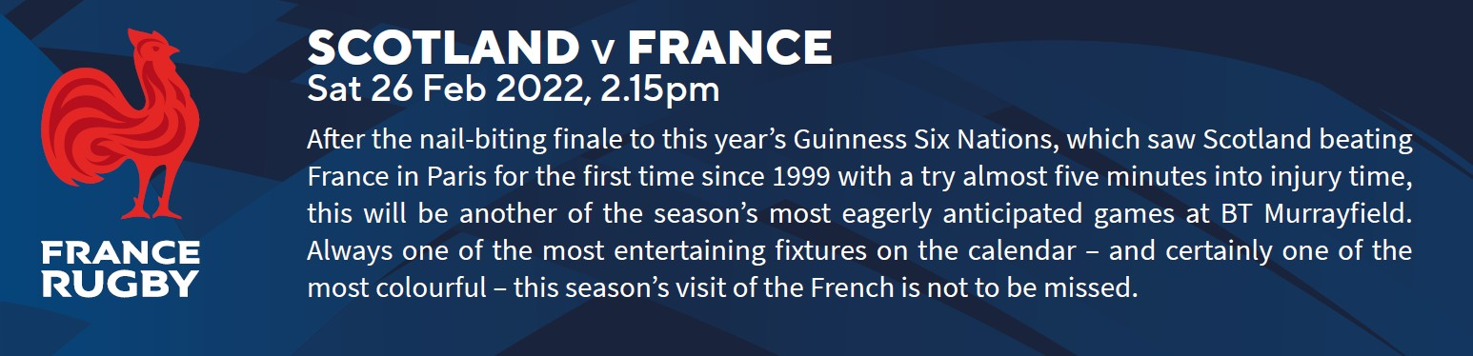

|  |  |
| --- | --- |
| **Itinerary 26th February** | |
| **TIME (approx.)** | **DETAILS** |
| 7:45am | Meet the coach in the school car park |
| 11am | Arrive at McDonald’s Dundee* for a break (45 mins) |
| 1.15/1.30pm | Arrival at the Stadium |
| 2pm | Pupils to be in allocated seats ready for the kick off |
| 2.15pm | Match Kick Off |
| 4.30pm | Depart from Edinburgh |
| 6pm | Arrive at McDonald’s Dundee* for a break (45 mins) |
| 10pm | Arrive Keith. Please note pupils will be asked to call/ message home when passing Huntly. |

|  |
| --- |
|  |
| **IN THE STADIUM**  You will be asked to be in **groups of 3 or 4** and you will be **allocated a member of staff** who will look after your group at the stadium.  Pupils are not permitted to take any bottles in the stadium, including water and soft drinks.  When you are outside watching the match you will not be moving much and it is very cold in the stadium. Make sure you have lots of layers on. **We recommend that you take a hat, scarf and gloves** (if you have hand warmers that is even better).  Behaviour—we expect the same standard of behaviour on the trip as we would at school. |
| **PUPIL CHECK-INS**  Staff will be taking a head count at several points during the day: on boarding the coach, after visiting McDonald (or KFC), before going to the gate (where tickets will be given), when seated before match, after the match at the gate (meeting point), returning to coach and finally back on the coach after McDonalds (Or KFC). |
| **PACKED LUNCH/DINNER**  You will be away from home from 8am until approximately 10pm. Please ensure sure that you bring something for lunch/ dinner and plenty of water/juice. Alternatively you can buy lunch or dinner at McDonalds in Dundee. Please note, as men- tioned above, you cannot take bottles into the stadium. |
| **IN AN EMERGENCY/REQUIRING FIRST AID**  **Queries/Emergency**. You will be allocated a member of staff who will look after you at the stadium, your member of staff will be able to help you with most queries. In the event of an emergency please contact the team leader (Dr Barclay) by phone on 07525761713 .  **First Aid.** Dr Barclay is trained in first aid and will be the initial point of contact if there is a first aid requirement. Trained professionals are always present at a match should any serious incidents occur and a staff member will alert the stadium medics if required. Parents will be informed of any first aid/medical incidents. |
| **COVID TESTING/PASSPORTS**  **Pupils DO NOT require Covid Passports** for the trip, however can we ask that pupils take a Lateral Flow Test on the 26th before leaving home. If you have a positive test you must stay at home but please contact us to let us know.  Contact Details in the event of a positive test on Saturday 26th February 2022:  Tel: 07525761713 |
| **WHAT DO I DO IF I AM ILL AND CANNOT ATTEND THE TRIP?**  If you are ill on the day of the rugby trip and cannot attend please let us know. The contact details are:  Tel: 07525761713 |
| **DO I NEED TO BRING MONEY?**  You are not required to bring any money. However, you can chose to buy food at McDonalds and there are kiosks that sell food and drinks at the stadium along with a rugby memorabilia shop. |
| **EMERGENCY CONTACT FOR PARENTS**  Parents, if you need to contact us on the day in the event of an emergency please use the details below:  Tel: 07525761713 |
| **MOST IMPORTANTLY…**  HAVE FUN!! |