COVID-19 Vaccine suggested social media

Unpaid Carers aged 16 and 17

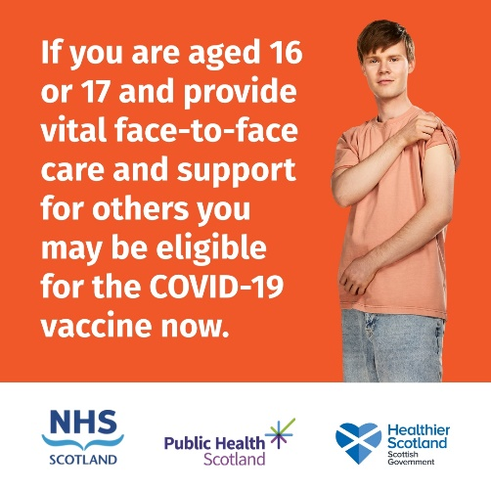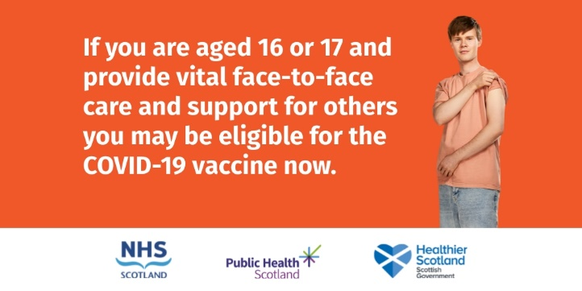

If you are aged 16 or 17 and care for someone due to old age, physical or mental illness, disability or for an addiction you may be eligible for the COVID-19 vaccine now. Visit https://nhsinform.scot/carersregister or call 0800 030 8013.

If you are aged 16 or 17 and regularly help someone with shopping, preparing meals, washing and dressing you may be eligible for the COVID-19 vaccine now. Visit https://nhsinform.scot/carersregister or call 0800 030 8013.

If you are aged 16 or 17 and provide vital and regular face-to-face emotional support to someone with a long-term health condition you may be eligible for the COVID-19 vaccine now. Visit https://nhsinform.scot/carersregister or call 0800 030 8013.

Those aged 16 or 17 who regularly provide vital face-to-face care to a family member, friend or neighbour may be eligible to register for the COVID-19 vaccine now. Visit https://nhsinform.scot/carersregister or call 0800 030 8013.

