Submitting Work for a Microsoft Teams Assignment
If you haven't submitted work using Microsoft Teams before, follow the steps below.
- Move to the Teams section of the sidebar and select the Team used for your course.
  - Alternatively, go to the Assignments section and navigate to your assignment from there.
- Navigate to the Assignments tab, or find the assignment in the Conversations tab.
- Open the assignment you would like to submit work to.
- Move to the My work section and select the + Add work button.
- Add the files you would like to submit for the evidence. We'll generate a Similarity Report for each file that is added and turned in if required.
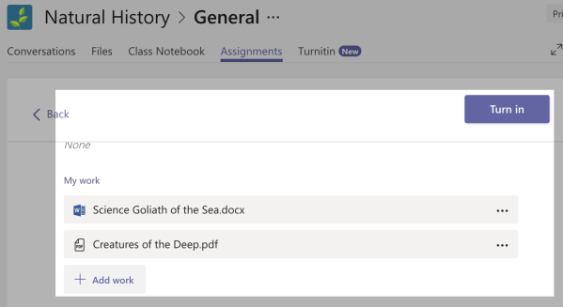
- When you're happy with your file selections, use the Turn in button to submit your files. This will make them available to your instructor and sends them to Turnitin to generate a Similarity Report if required.

