In the event of a school closure – useful links for home learning:

The main online platforms for our school will be

- GLOW – Staff will be using this and your child should have their log in. See individual Teams and KGS newsfeed to receive class and whole school information.
- Showmyhomework – staff are using this to guide pupils in home learning
- Scholar – useful for most subjects, but does not cover every curricular area

A useful starting point:

All S1-3 pupils follow a Broad General Education. The Education Scotland website details what your child should experience and achieve at each stage. All S1-3 should be working at level 3 with most S3 working at level 4 and some S1 working at level 2. https://education.gov.scot/education-scotland/scottish-education-system/broad-general-education/

Scottish Qualifications Authority (S4-6) – shows course outlines, guides and past papers and what pupils have to do in each subejct.

https://www.sqa.org.uk/sqa/45625.3728.html

Students will be directed by staff to continue education provision as much as possible through GLOW and Showmyhomework. Staff have checked that pupils have passwords as far as possible. Please contact the admin email should you have any problems. admin.keithgrammar@moray-edunet.gov.uk
Staff will check as much as possible on pupil progress and on return to school, pupils will be expected to show staff what work has been undertaken during school closure periods.

Other general sites that pupils can work through

www.Kahoot.com

Khan Academy
https://www.khanacademy.org
Especially good for maths and computing for all ages but other subjects at Secondary level. Note this uses the U.S. grade system but it's mostly common material.

BBC Learning
http://www.bbc.co.uk/learning/coursesearch/
This site is old and no longer updated and yet there's so much still available, from language learning to BBC Bitesize for revision. No TV licence required except for content on BBC iPlayer.

Futurelearn
https://www.futurelearn.com
Free to access 100s of courses, only pay to upgrade if you need a certificate in your name (own account from age 14+ but younger learners can use a parent account).

Seneca
https://www.senecalearning.com
For those revising at GCSE or A level. Tons of free revision content. Paid access to higher level material.

Openlearn
https://www.open.edu/openlearn/
Free taster courses aimed at those considering Open University but everyone can access it. Adult level, but some e.g. nature and environment courses could well be of interest to young people.

Blockly
https://blockly.games
Learn computer programming skills - fun and free.

Scratch
https://scratch.mit.edu/explore/projects/games/
Creative computer programming

Ted Ed
https://ed.ted.com
All sorts of engaging educational videos

National Geographic Kids
https://www.natgeokids.com/uk/
Activities and quizzes for younger kids.

Duolingo
https://www.duolingo.com
Learn languages for free. Web or app.

Mystery Science
https://mysteryscience.com
Free science lessons

The Kids Should See This
https://thekidshouldseethis.com
Wide range of cool educational videos

Crash Course
https://thecrashcourse.com
You Tube videos on many subjects

Crash Course Kids
https://m.youtube.com/user/crashcoursekids
As above for a younger audience

Crest Awards
https://www.crestawards.org
Science awards you can complete from home.

iDEA Awards
https://idea.org.uk
Digital enterprise award scheme you can complete online.

Paw Print Badges
https://www.pawprintbadges.co.uk
Free challenge packs and other downloads. Many activities can be completed indoors. Badges cost but are optional.

Tinkercad
https://www.tinkercad.com
All kinds of making.

Prodigy Maths
https://www.prodigygame.com
Is in U.S. grades, but good for UK Primary age.

Cbeebies Radio
https://www.bbc.co.uk/cbeebies/radio
Listening activities for the younger ones.

Nature Detectives
https://naturedetectives.woodlandtrust.org.uk/naturedetectives/
A lot of these can be done in a garden, or if you can get to a remote forest location!

British Council
https://www.britishcouncil.org/school-resources/find
Resources for English language learning

Oxford Owl for Home
https://www.oxfordowl.co.uk/for-home/
Lots of free resources for Primary age

Big History Project
https://www.bighistoryproject.com/home
Aimed at Secondary age. Multi-disciplinary activities.

Geography Games
https://world-geography-games.com/world.html
Geography gaming!

Blue Peter Badges
https://www.bbc.co.uk/cbbc/joinin/about-blue-peter-badges
If you have a stamp and a nearby post box.

The Artful Parent
https://www.facebook.com/artfulparent/
Good, free art activities

Red Ted Art
https://www.redtedart.com
Easy arts and crafts for little ones

The Imagination Tree
https://theimaginationtree.com
Creative art and craft activities for the very youngest.

Toy Theater
https://toytheater.com/
Educational online games

DK Find Out
https://www.dkfindout.com/uk/?fbclid=IwAR2wJdpSJSeITf4do6aPhff8A3tAktnmpaxqZbkgudD49l71ep8-sjXmrac
Activities and quizzes

Twinkl
https://www.twinkl.co.uk

ASN
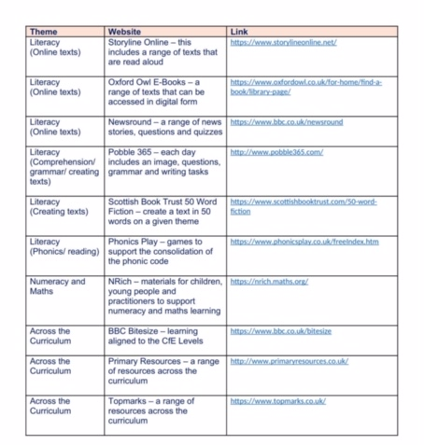

Design and Technology

Bright red books: https://www.brightredbooks.net/subjects/
Technology Student : http://www.technologystudent.com/
Focus On DT: https://www.focuselearning.co.uk/u/33524/xveqpwbltkrvfcDmqztsBczqdvfwAsprh
Design Class : https://www.designclass.co.uk/
Qiuzlet: https://quizlet.com/en-gb
How it’s made: YouTube
http://www.ergonomics4schools.com/index.htm
BBC Bitesize
https://www.bbc.co.uk/bitesize

Engineering science:
https://blogs.glowscotland.org.uk/my/engineeringsciencemoray/

Design and Manufacture:
http://www.technicaldept.co.uk/page7.html
https://blogs.glowscotland.org.uk/nl/ghstechnical/higher-design-and-manufacture/
Bright red books youtube: https://www.youtube.com/playlist?list=PLtCeaeJ34A5KfCUBEJUgENXwsxKXEu84o

RME/Philosophy
Youtube Channel – Wireless Philosophy - https://www.youtube.com/user/WirelessPhilosophy
Youtube Channel - School of Life – Western Philosophy - https://www.youtube.com/playlist?list=PLwxNMb28XmpeypJMHfNbJ4RAFkRtmAN3P
Youtube Channel – School of Life – Great Ideas - https://www.youtube.com/playlist?list=PLwxNMb28XmpdJpJzF2YRBnfmOva0HE0ZI
Youtube Channel – Crash Course Philosophy - https://www.youtube.com/playlist?list=PLq5rFUzhsrBXuE0wxECMeTYSV-_52fGt5
Youtube Channel – BBC Matters of Life and Death - https://www.youtube.com/playlist?list=PLcvEcrsF_9zJ1HDgvx0Q0C8P7OY_CsocP

