PUPIL
FAIR TRAVEL SCHEME
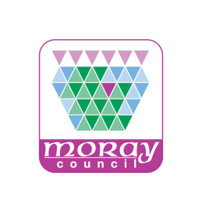
APPLICATION FORM
- Surname | For official use only  Scheme Applied for  CEYP  Young Person  Eligibility confirmed  Who by:_______________  What date:____________
- First name(s)

- Date of Birth (day-month-year)

- Address

Postcode

- School Attended

- Teacher (to confirm eligibility)
Name

Contact Number (if known)

- I agree to the terms of service*

* - Pupils in the Fair Travel Scheme will be permitted to purchase Student dayrider products for Elgin, Elgin City Plus, Moray Area and Moray Coast zones any time from 15:40 until end of service Monday to Friday and all day at weekends and holidays on production of their pass.
- Customers making use of this offer should be able to produce their pass to the driver upon purchase or on boarding services, and to any company official who requests to see the pass.
- The customer is responsible for keeping their pass safe; any issues with the loss or replacement of passes should be directed to Moray Council.
Once completed this form, along with an electronic photograph of the applicant, should be emailed to: CommunitySaftety@moray.gov.uk

