KEITH GRAMMAR SCHOOL
THURSDAY 28TH FEBRUARY 2019
All S6, School Hall 10-12
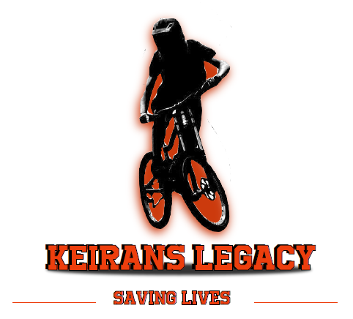
LEARN HOW TO SAVE A LIFE!!!
KEIRAN’S LEGACY SAVING LIVES BANDS AVAILABLE
£2 EACH TO PURCHASE AFTER THE SESSION
REGISTERED CHARITY NUMBER: SC047384

