The Moray Council

How to install new certificate from Meraki MDM

Version Control
Version | Date | Author | Change Description
1.0 | 24/06/19 | Andy Mackenzie | Creation

In order to see the required Wi-Fi network to make the changes:- Open the settings page by selecting the Settings Icon on home screen (as below)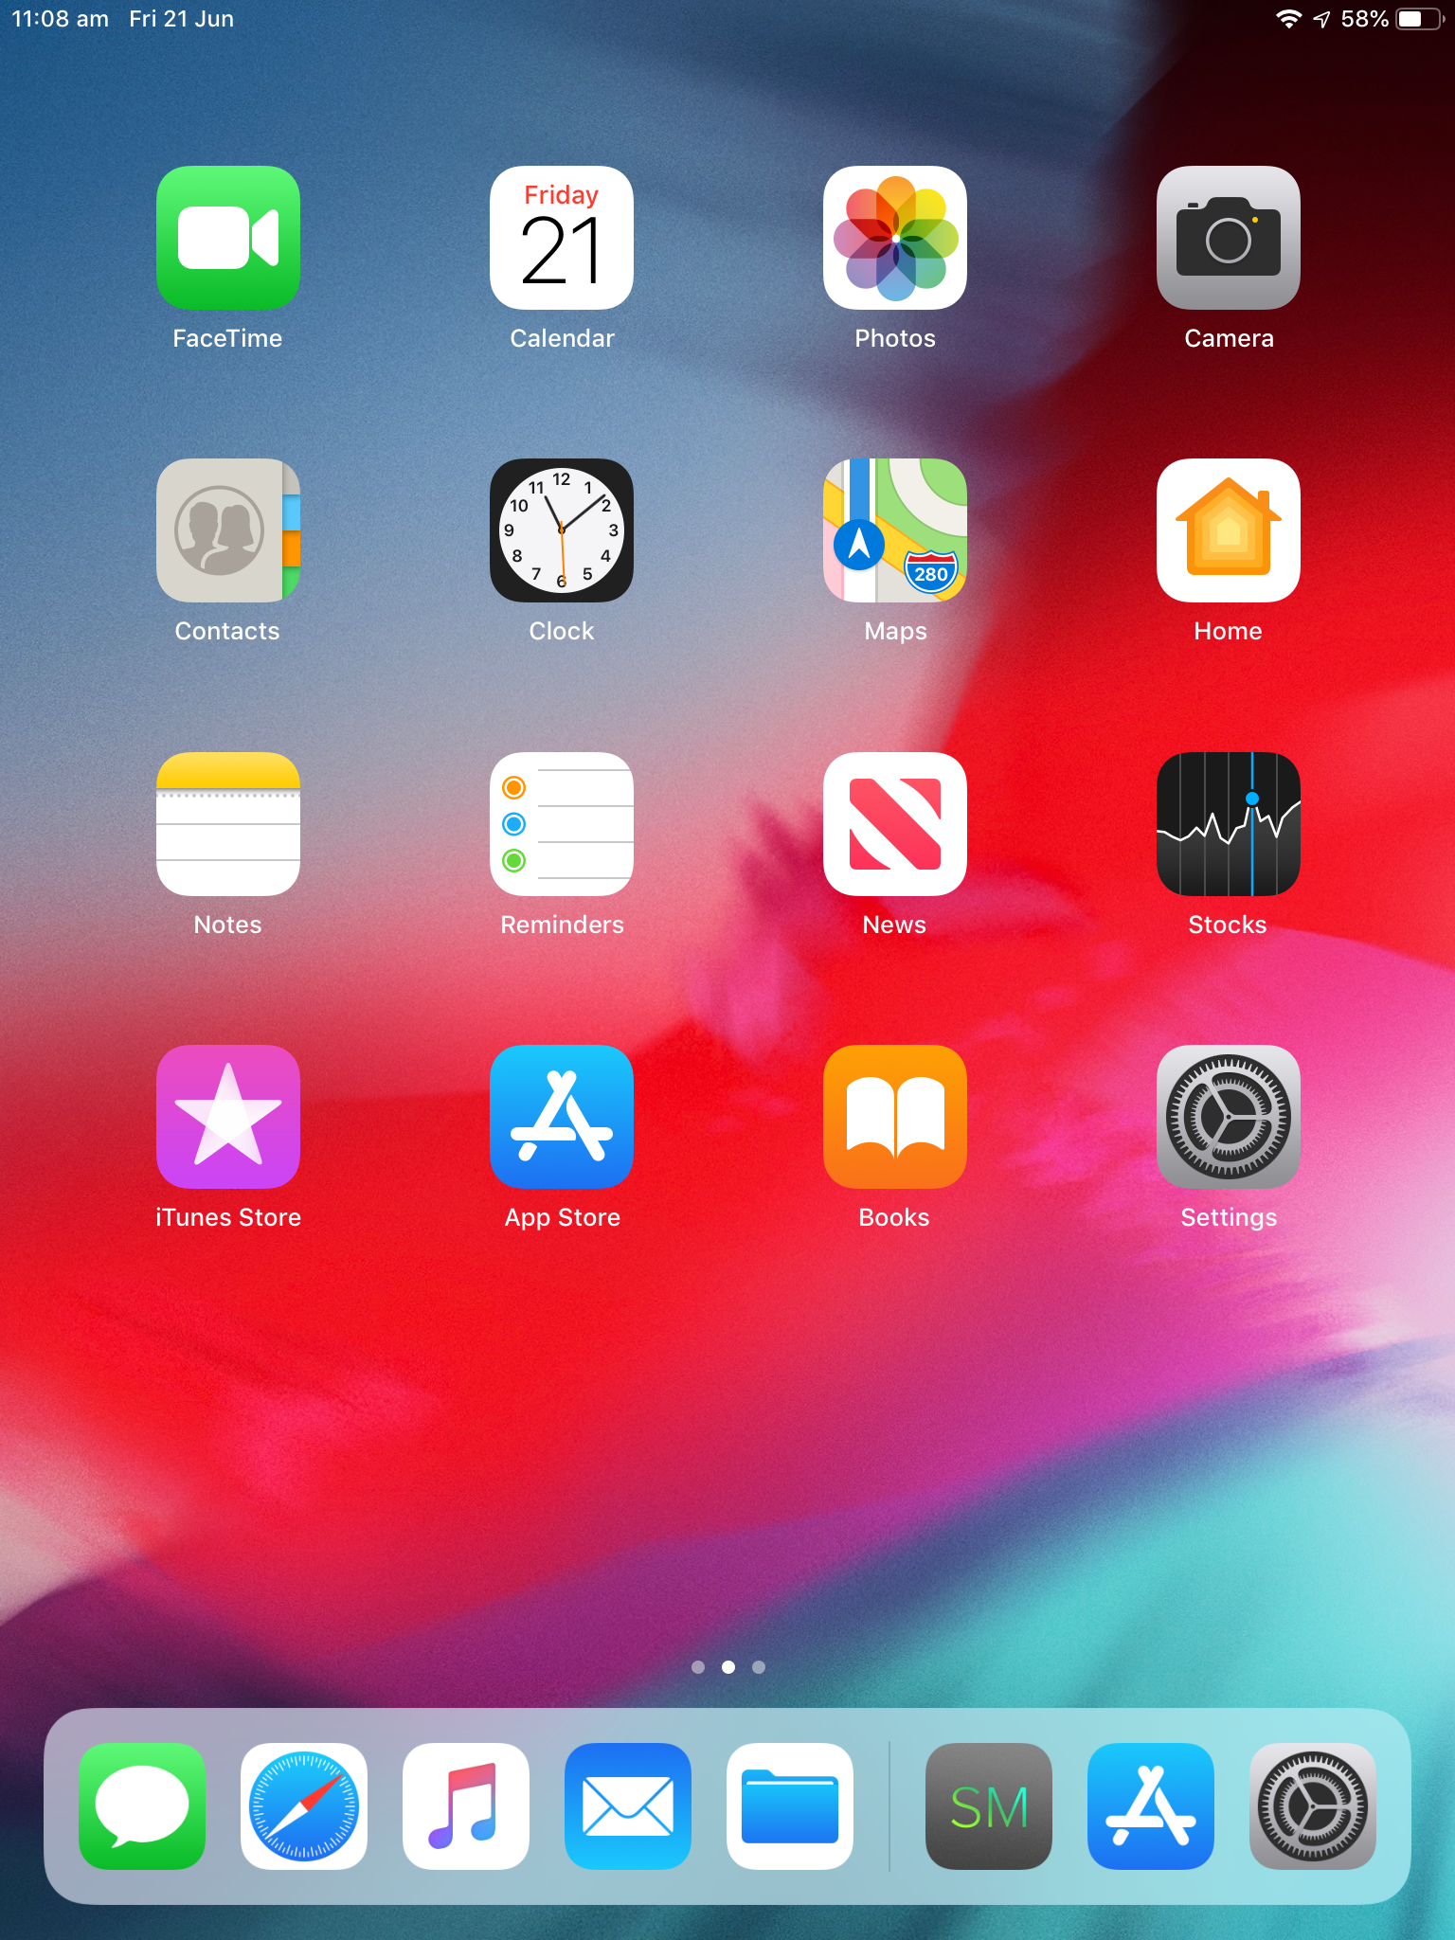

This will then take you to the settings screen where you need to select Wi-Fi on the left hand side menu
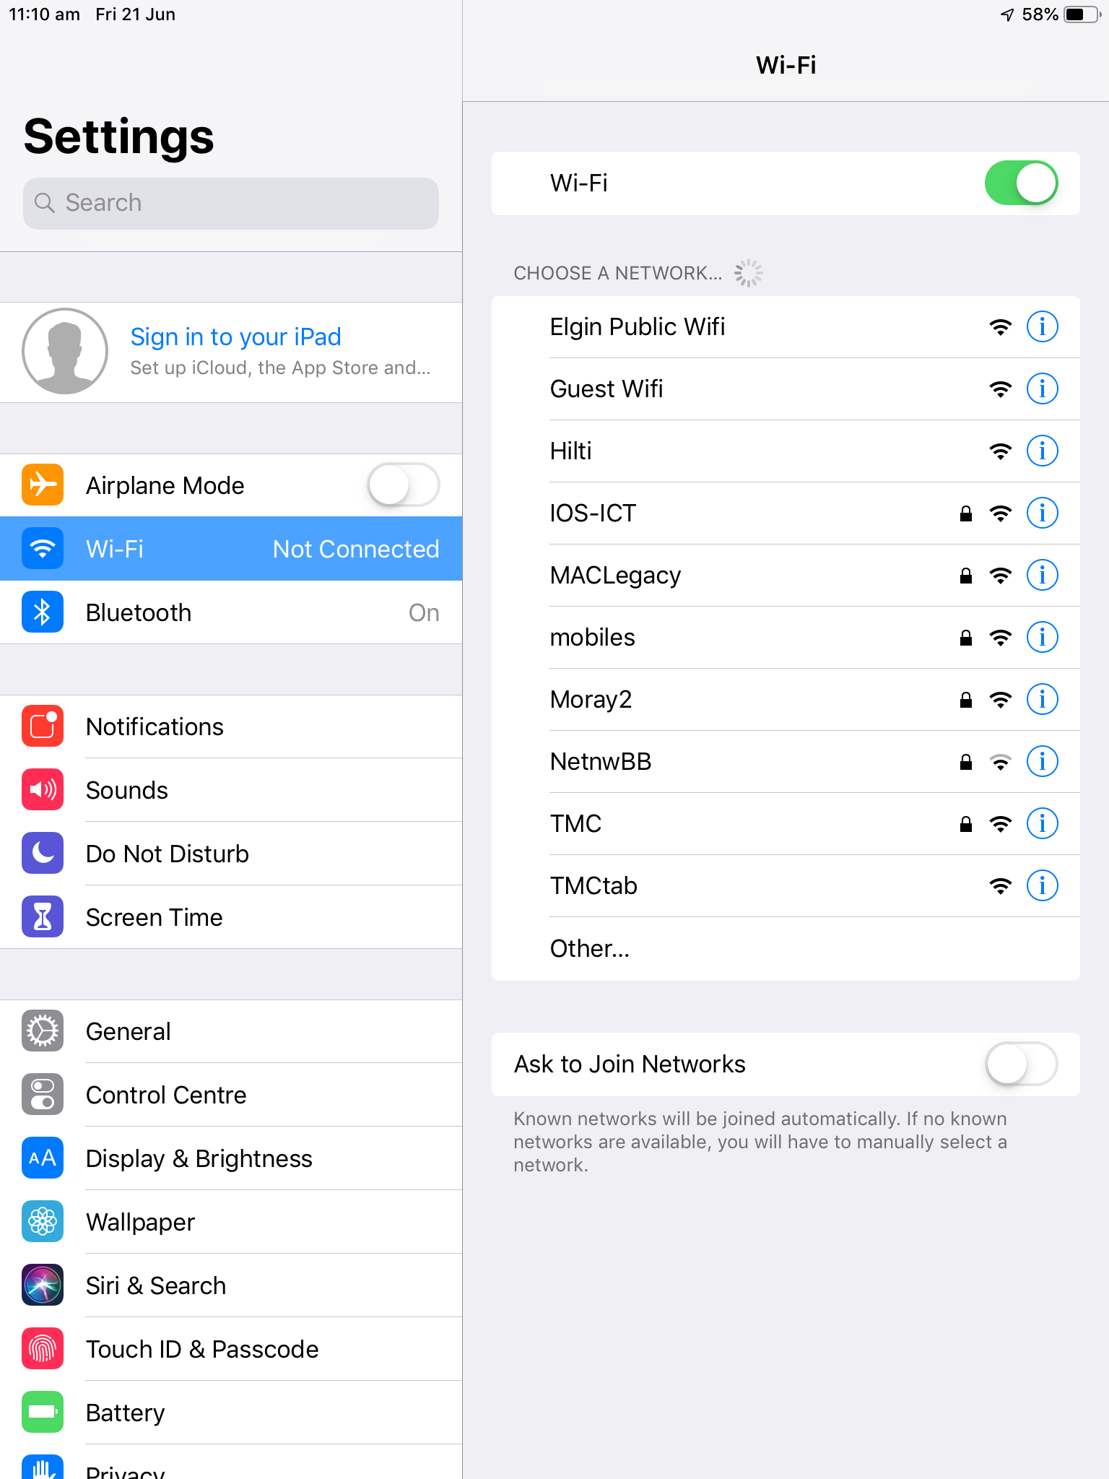

This will then display a list of Wi-Fi network names and you need to click on the IOS-ICT one.
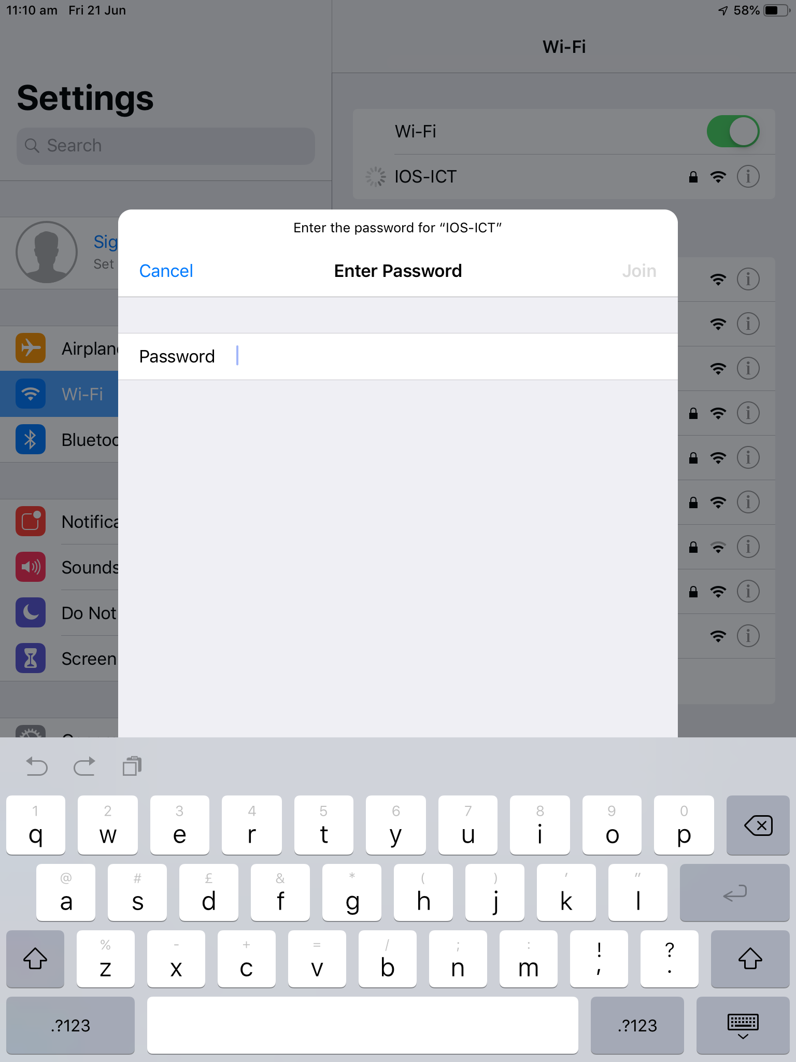

This will ask you for a password which is 5pqr72@nT and click on the Join word in the window.
Once connected you should get the tick next to the SSID name.
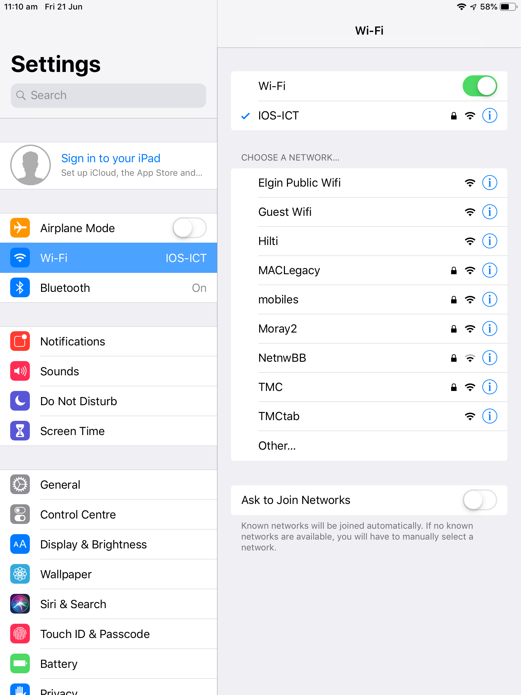

Now press the Home Screen button to get back to home scree and if The Meraki MDM icon is not displayed please swipe screen from right to left until you see the icon as shown

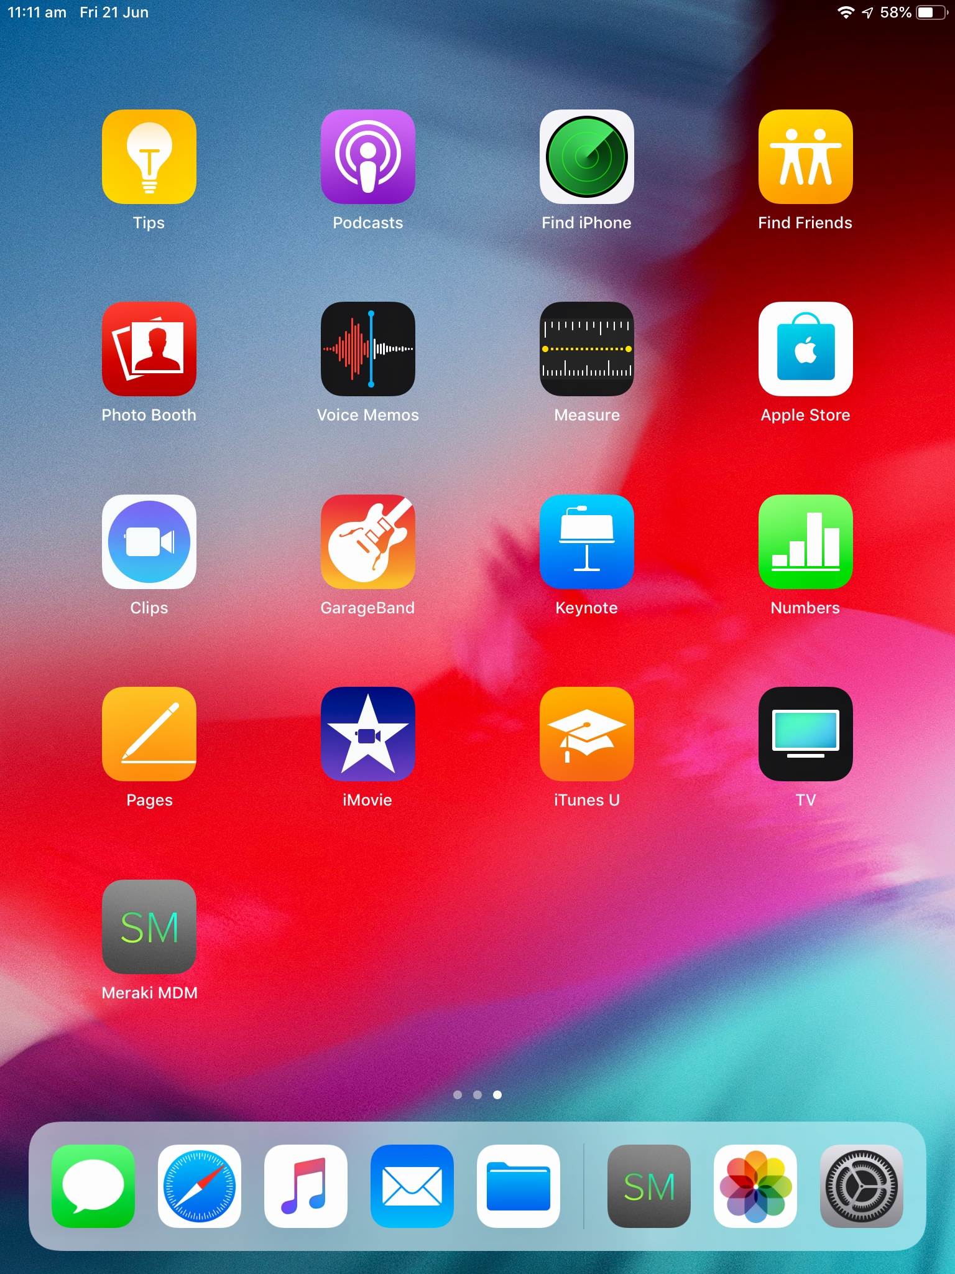

Open app by clicking on it and it will run an auto update until all options are ticked

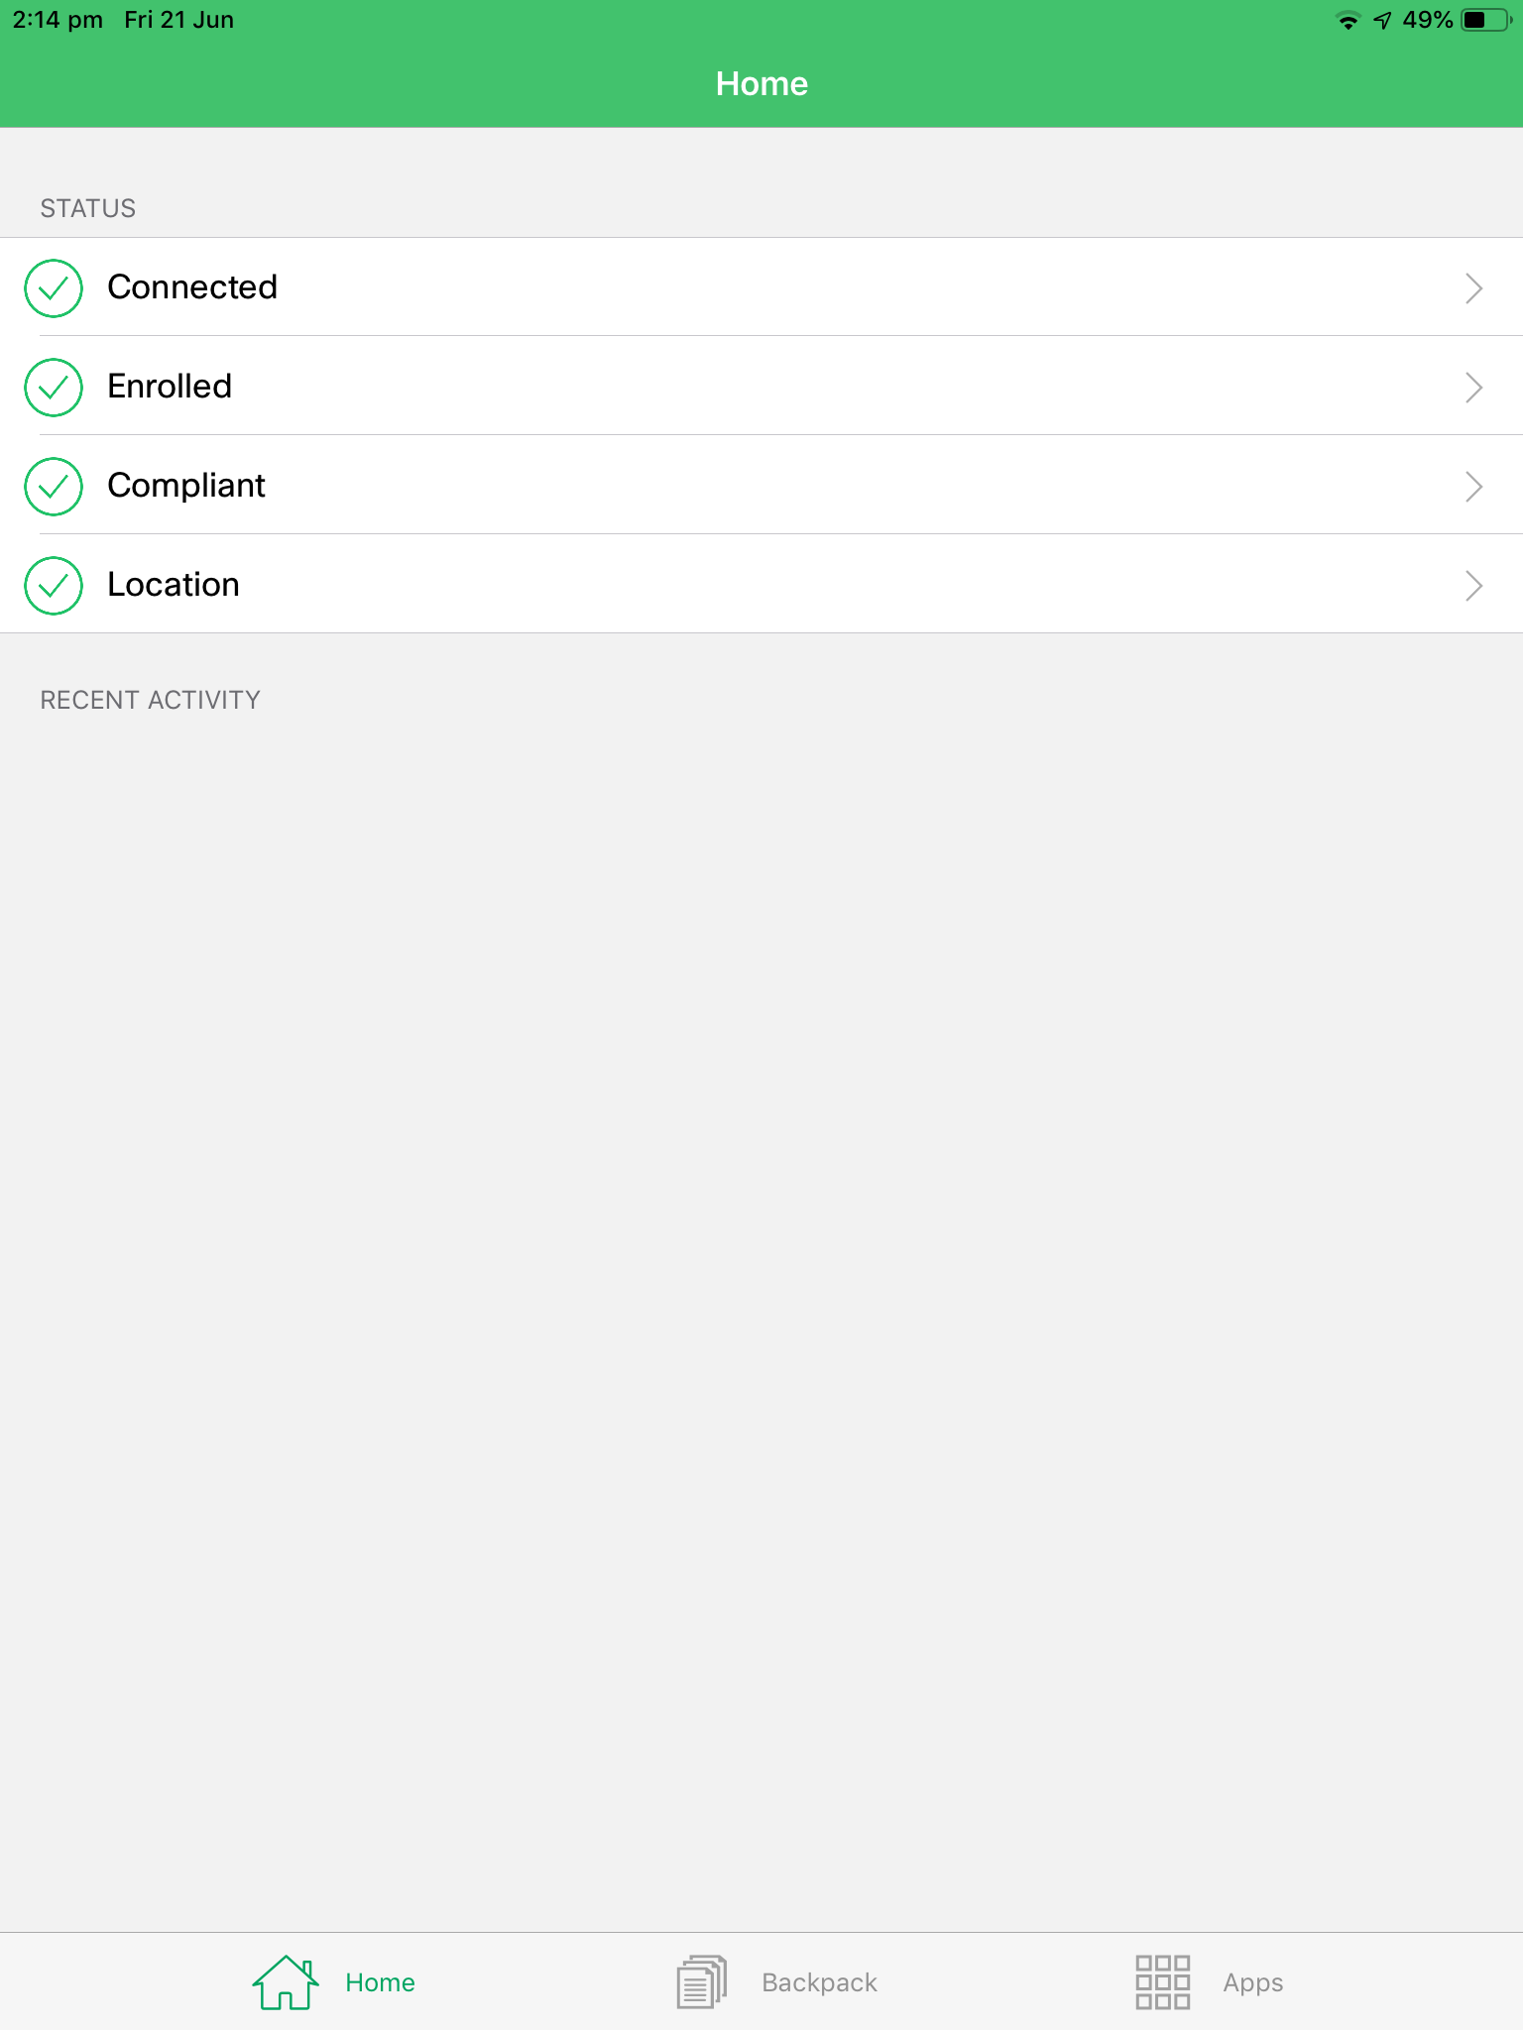

Now go back to home screen and into Settings and Wi-Fi
Click on the i symbol next to the IOS-ICT SSID which will take you to following screen.
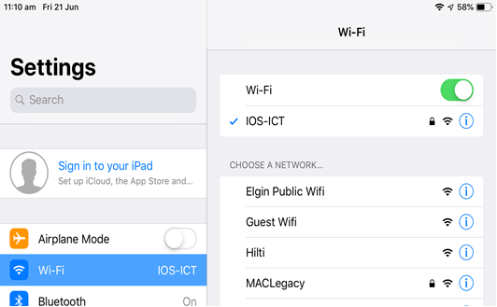
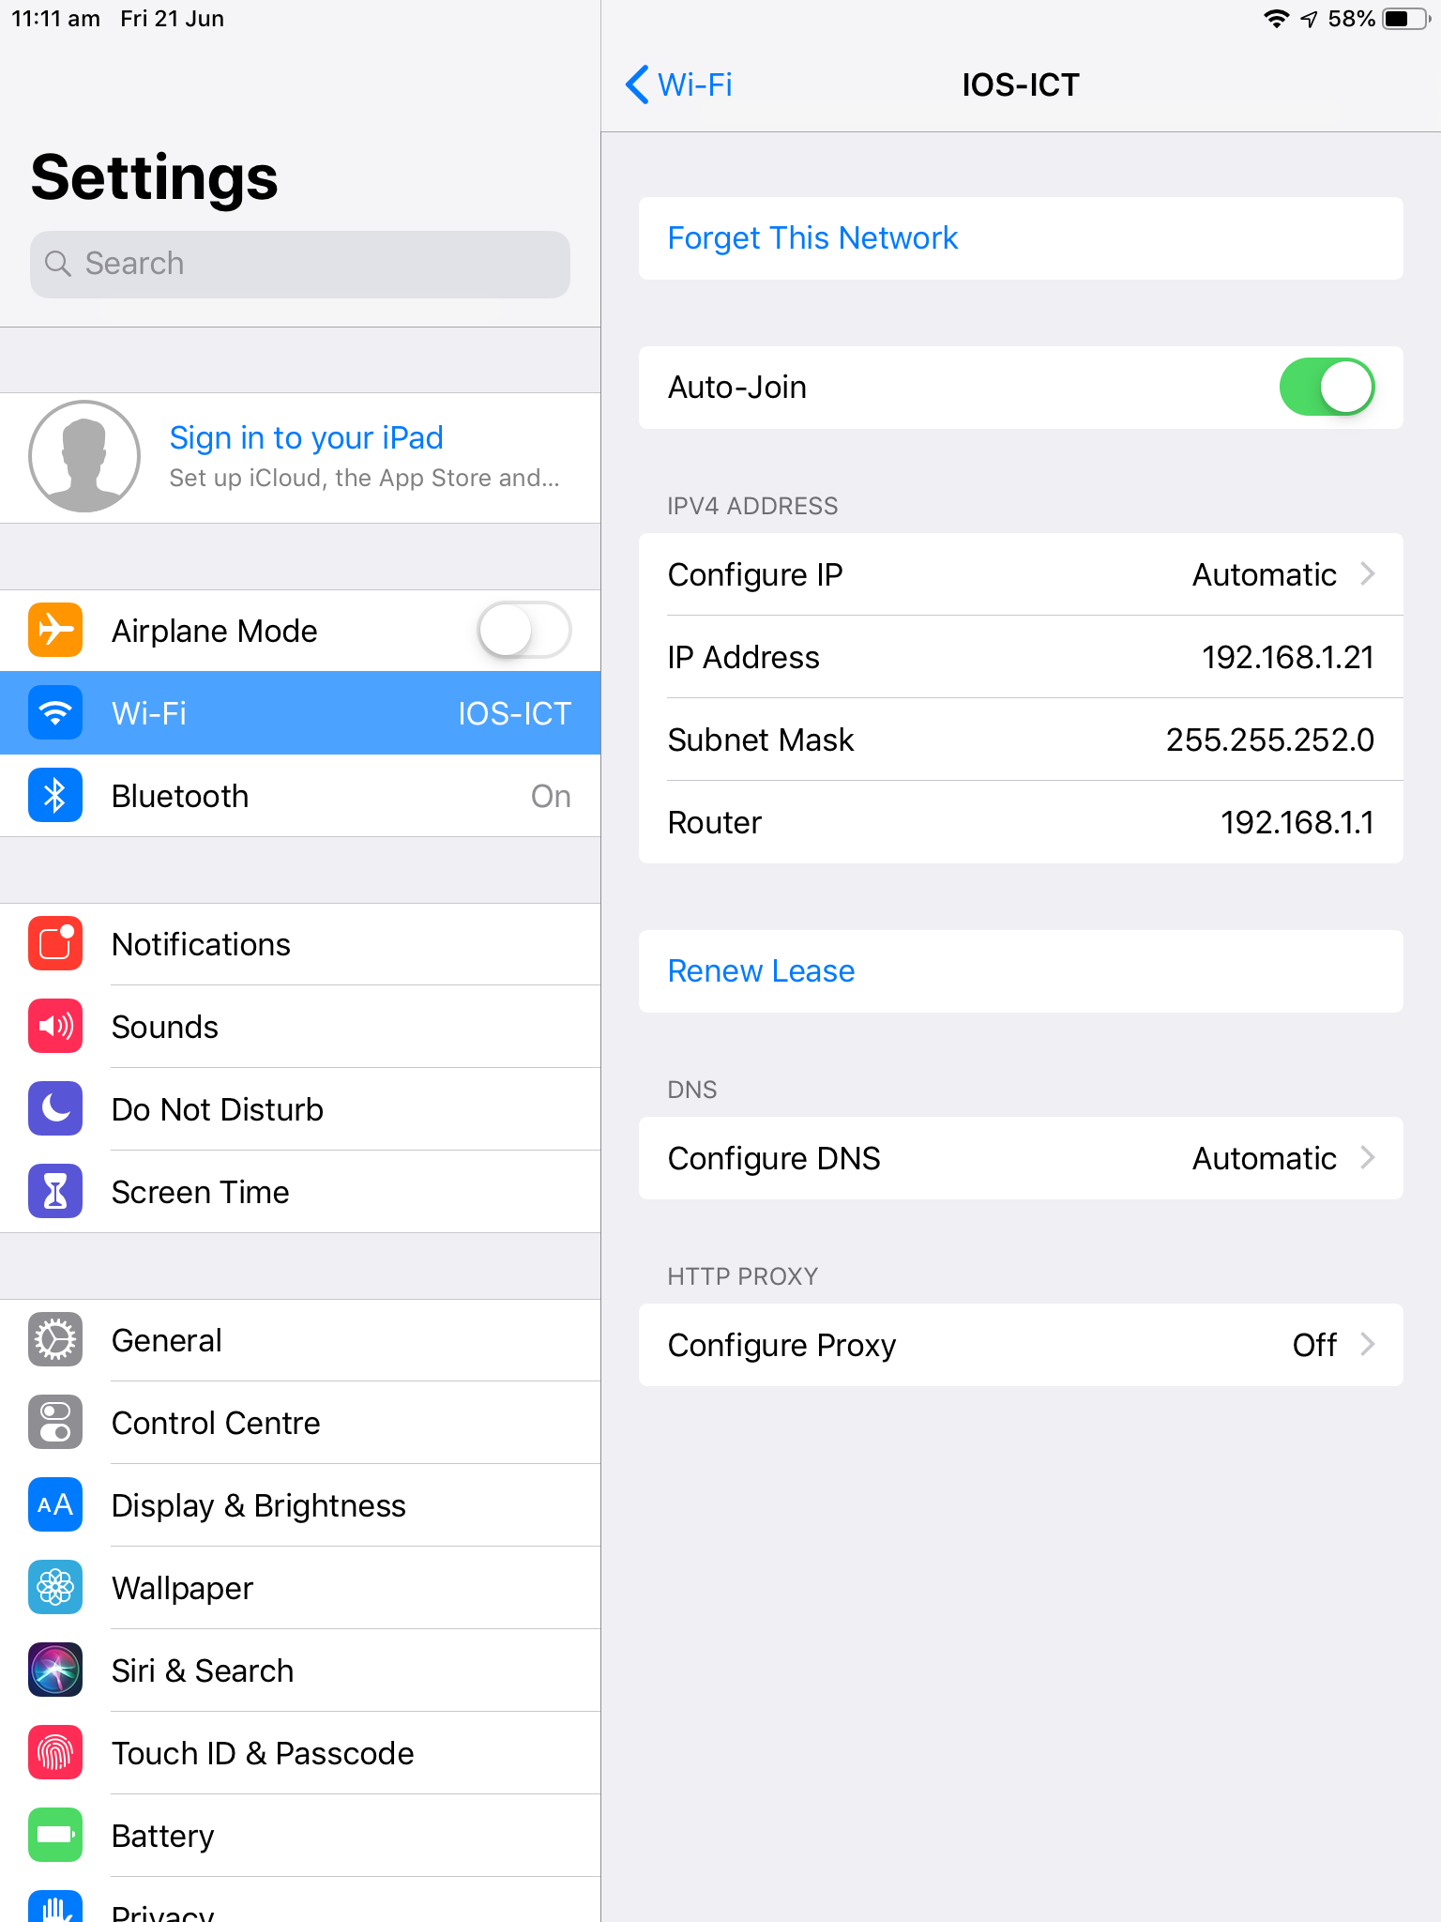

Finally click on Forget this Network.
Your iPad now has the new Certificate installed.

