Names; Date;
Quarrel Woods Observation Record
Since last time we have noticed:

What we think will have changed when we come next time – our predictions;

The weather today is…

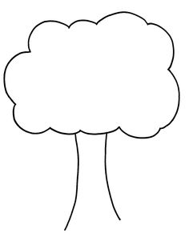
Our Tree-
Use this diagram to show what colours the leaves are on your tree
Key

Collect 20 leaves. What sizes do the leave range from?

What is the ‘average’ size of the leaves? (line them up in height order and measure the middle one)

Describe the tree

What has changed since last time?

What we think will have changed when we come next time –predictions;

In the woods…
We can hear
We can feel
We can smell
We can see

