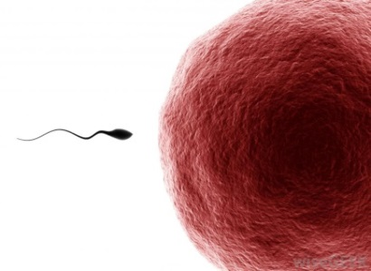
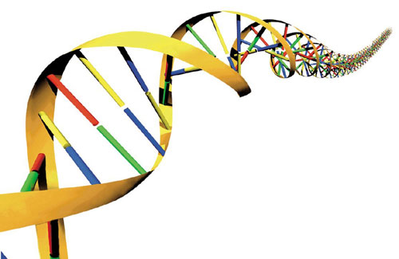
S2 Biology
Reproduction and DNA
Learning log

Name:___________________________
Teacher: _________________________
Learning Intentions

Evaluate how well you understand each learning intention and colour/tick the box |  | red | amber | green
Puberty
1 | Understand the changes that happen to girls and boys in puberty.
Female and male reproductive systems
2 | Understand the position and function of the external female organs.  Vulva, vaginal opening, urethra, clitoris, anus.
3 | State that human eggs are already formed in the ovaries when the embryo is in the uterus.
4 | State that when a girl goes through puberty one egg is released every month from the ovary into the oviduct.  If unfertilised it passes out of the body with the lining of the uterus in the girl’s period.
5 | Label diagram of male to show: testes, scrotum, sperm duct, prostate gland, seminal gland, penis, foreskin, urethra, bladder, anus.  And be able to state the functions of these parts.
6 | Describe the production of sperm in the testis and their journey through the sperm duct and penis
7 | State that many millions of fresh sperm are made through out a male’s life.
8 | Understand that only one sperm is needed to fertilise an egg.
9 | Explain the process of human internal fertilisation (sexual intercourse) - that the penis is placed inside the woman’s vagina, sperm released, and sperm swim towards the egg.
10 | State that fertilisation occurs when a sperm nucleus enters an egg fusing with the egg nucleus.
11 | State that Twins may be Identical: produced from one sperm and one egg or Non-identical: produced from two sperm and two eggs.
Cell Division
12 | State that the nucleus controls all the cells activities
13 | State that cell division results in the increase in the number of cells in an organism.
14 | State that when a cell divides two new identical daughter cells are produced.
15 | State that each daughter cell contains a complete set of chromosomes and so the same genetic information.
16 | Explain why each daughter cell contains a complete set of chromosomes and therefore the same genetic information.
Evaluate how well you understand each learning intention and shade/tick the box |  | red | amber | green
17 | Describe the stages in cell division.
Embryo development and growth
18 | Describe early development: from 1 cell stage to ball of cells.
19 | Describe the increase in length of the foetus
20 | Describe the sequence of development of the baby
Risks to the embryo
22 | State that the development of the embryo can be harmed by some chemicals.
23 | Explain the effect of alcohol, drugs and nicotine on the development of the embryo.
Birth
24 | State how long pregnancy lasts in humans.
25 | Describe how the placenta works.
26 | State which substances can pass through the placenta.
27 | Explain what happens to the placenta after the birth of the baby.
28 | State that when a baby is ready to be born, the mother ‘goes into labour.’
29 | State that labour involves the wall of the uterus contracting, relaxation of the cervix and bursting of the amniotic sac.
30 | State that the contractions push the baby out through the cervix and vagina.
What is DNA
30 | State that DNA is the genetic code of information and it is found in the nucleus of all cells.
31 | State that our DNA is unique to us.
32 | State that only identical twins have exactly the same DNA.
33 | Know the steps involved in extracting DNA from Kiwi fruit.
Evaluate how well you understand each learning intention and shade/tick the box |  | red | amber | green
34 | Identify the DNA part of the material in the test tube.
DNA Profiling
35 | State that a DNA profile is where small parts of a person’s DNA sequence is recorded
36 | State that the UK DNA database contains DNA profiles from the tissues of arrested suspects and tissue found at a crime scene
37 | State that profile of DNA found at a crime scene can be matched with DNA profiles of suspects
38 | Explain that DNA evidence can help police place suspects at the scene of a crime or eliminate innocent people.
Why DNA is useful
39 | State that DNA profiling can be used to identify embryo’s carrying genetic diseases
40 | Describe briefly how PGD could be used to help someone with an inherited disease
41 | Identify the reasons why some of these technologies are not widely used

Summary notes – Use the words in the word bank below to complete the missing words in the summary notes
Word bank
alcohol | fertilisation | placenta | uterus | drugs | vagina | identical | sperm
puberty | crime | testes | penis | scrotum | one | chromosomes | 40
baby | nicotine | oviduct | DNA | oviduct | second | database | cells
foetus | sperm duct | oxygen | ovary | embryo | penis

Summary notes

- The female reproduction organs include the structures _______________ ______________ ____________________ __________________.
- When a girl goes through _________________ one egg is released every month from the ovary into the oviduct.
- The male reproductive organs include the structures _______________ ________________ _________________ ______________.
- _______________ is produced in the testis and they journey through the sperm duct and _______________ during sexual intercourse.
- Only _____ sperm is needed to fertilise an egg.
- When a sperm nucleus enters an egg it fuses with the egg nucleus, This process is called __________________.
- Fertilisation usually happens in the _____________________.
- When a fertilised egg divides each new cell nucleus contains a complete set of ___________________ which are our genetic information.
- A fertilised egg develops first into a ball of ________, then into an _______________ and finally a _________________.
- The developing foetus increases in length most during the ______ trimester.
- The development of embryo/foetus can be affected by chemicals such as _____________, ________________ and ________________.
- A pregnancy lasts for _______ weeks in humans.
- The __________________ allows the developing baby to get sugar and ________________ from its mother blood.
- During Labour the mother gives birth to the ___________ then gives birth to the placenta.
- 1% of our DNA is unique to us apart from ________________ twins who have the same copies of DNA.
- A DNA _____________ is where small parts of a person’s DNA sequence is recorded.
- DNA from a _______________ scene can be used to match with DNA profiles of suspects to place them at the scene of a crime.
- _______ profiles can be used by scientists to identify which disease a person might get and use this knowledge to help them.

