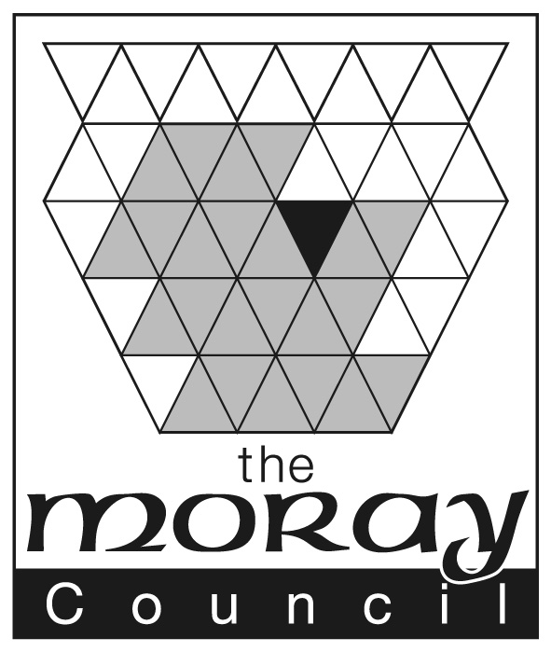

GROUP NAME: | Moray Creativity Conference
CHAIRPERSON: | Mandy Macleod
DATE OF MEETING:  LOCATION:  ATTENDING:  APOLOGIES:  MINUTES: | 06 November 2015  Council HQ, Room 301  Mandy Macleod ESO, Craig Lowther LTO, Karen Lees QIO, Neil Johnston HT BHS, Claire Wood HT Cluny PS, Reni Milburn Principal Officer Economic Development , Amy Cruickshank ESO,  Anne-Marie Ballantyne Admin Support  Sarah Medcraf –Moray Chamber  Anne-Marie Ballantyne
AGENDA |  | ACTION POINT | ACTION BY
- Introductions |  | Introductions were made around the table and a brief description of remits.
- Purpose of Group |  | Moray’s is proposing to hold its first “Creative Conversation Day” for its senior leaders in Education. The focus for the day will be linked to DSYW and Raising Attainment agendas. Employers and partnership agencies will be also invited to attend and take part in the day.
- Formal CLN Bid |  | Mandy explained the background to the bid, circulated a copy of the Creative Learning Network (CLN) funding application and details of the award.
4. Format of Day  Creativity Conference  Moray College  17.03.2016. |  | The format for the day was discussed and the consensus was as follows:-  Morning Session – FOCUS DSYW – HTs, Agencies and Employers  Registration/Coffee (Students to help AMB with registration?)  Welcome Laurence Findlay  Keynote Speaker  Creative Conversations x2  Keynote Speaker  Creative Conversations x2  LUNCH  Afternoon Session – FOCUS ATTAINMENT– HTs and ICS  Welcome  Keynote Speaker  MM looking for young person to speak about going through the Moray Education System and what would have made the difference to them in terms of attainment and achievement.  Closing the attainment gap in Moray – The statistics and variation in terms of just not the lowest 20% but also top 20% and where that sits in Moray. | All discussed  AMB to organise (name badges/Students etc.)  AMB to contact MC re breakout areas for two Creative Conversations area  MM to action with ICS  MM/NJ

- Invitees | Head Teachers – plus bring a colleague or a possible business partner?  Local employers - Johnstons, Diageo, Walkers,  HIE, Nursery/Partners, SDS, Skills Force, UHI, Moray College  Integrated Children Services  Glow blog to be set up and group contribute names for invitation list. | All discussed  MM  AM to e mail link to all group members
- Follow Up | As sustainability is key to this initiatives success, it is planned to develop a series of after school sessions where local creative, design and engineering businesses will give short presentation to education staff followed by facilitated conversations and informal networking. This will create opportunities for education staff; to learn more about the modern workplace which will inform learning and teaching contexts build capacity for improved careers advice and make closer links with local industry. | CL to coordinate
- Evaluation and Sustainability | The group recognised we needed to be more creative in terms of evaluation and indeed we would need to do this as part of the grant conditions.  It was proposed to use Twitter and or paper tweets on back the back of exit passes. | MM to liaise with Stuart McQuaker
- AOCB | A sub group consisting of Mandy Macleod, Craig Lowther, Amy Cruikshank and Anne-Marie Ballantyne will work at pulling some of the action points from this meeting together. MM, CL , AM, AMB  25 November 2015  Associated PR, Press Release and Flyer seen as necessary to promote the event.  It was felt that copies should be sourced for all schools of “Ten Challenges to becoming a truly Creative School in Scotland” | AM to diarise  MM to speak to PR Dept.  MM to contact Angus McNicholl/RM to speak to PR agency  MM to contact publishers
- Date of Next Meeting | December (Anne-Marie to send out doodle poll). | AMB

