Weeks Beginning 22/06/20 & 29/06/20
EARLY

Once you are in the Classical 100 website, click on the ‘Period’
rectangle on left hand side. The final weeks are “Romantic” (1830-1900) and “20th Century”:
https://www.classical100.org/

The pieces of music you may enjoy/recognize are:
Romantic: ‘The Blue Danube’
‘Night on a Bare Mountain’
‘Sorcerer’s Apprentice’
‘Flight of the Bumble Bee’
‘Ride of the Valkyries’
‘Dance of the Sugar Plum Fairy’

20th ‘Viennese Musical Clock’
Century: ‘Troika’
‘Rhapsody in Blue’
‘Nessun Dorma’

Also, don’t forget the NYCOS “Wee Summer Sing”:
https://www.nycos.co.uk/wee-sing/summer

FIRST
https://www.nycos.co.uk/wee-sing/summer
These are still going, as are the NCOS Daily activities:
https://www.youtube.com/playlist?list=PLT03GmRKx8csYL171j4TQOWBrHcfwGoIA
Also, if you fancy creating your own music try these (you will need to use Google Chrome as your web browser for it to work):
https://musiclab.chromeexperiments.com/Experiments

SECOND

‘FEVER’ PERFORMANCE!!! – Monday 22nd June at 2pm
https://www.scottishopera.org.uk/join-in/fever-online/

(You will just need to go over the actions for Song 5….)

“Join us on Monday 22 June at 2pm for a special, live performance of the full show streamed right to your home via YouTube - so make sure to bring your best singing voices, limber up for some excellent dance moves, and join in!
Psst...! Bring along any questions, comments or shout-outs, and we might just be able to give you a special mention...
Fancy a starring role? We'll be sharing a recording of the whole performance on our YouTube channel afterwards - and we'd love for you to be part of it! Just send in your 30-60 second video clips or photographs, and we will put them all together in one mega performance of Fever! Online.
Video/photo upload form: Link coming soon!
Alternatively, you can email your clips to feedback@scottishopera.org.uk”

So, remember to check back on Monday 22 June for the link to the live stream.

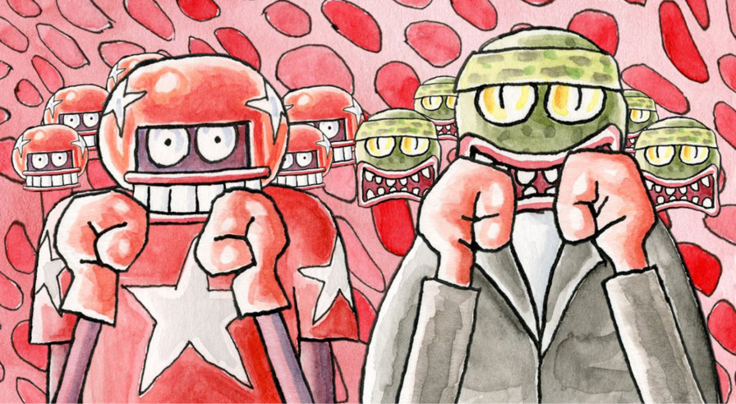

Also afterwards, if you ever fancy creating your own music, try these (you will need to use Google Chrome as your web browser for it to work):
https://musiclab.chromeexperiments.com/Experiments

Have fun, stay safe and I hope that you all have a lovely & relaxing holiday!
I miss you all & I hope that it isn’t too long before we all see each other again
Mrs Taylor xx

