**RECORDER CHALLENGE – HAVANA BY CAMILA CABELLO**

Hi Primary Fives and Sixes,

A lovely summery song for our final recorder challenge. Havana by Camila Cabello combines all the notes you have learnt over the last term. I have put a reminder of notes High G and High F# below.

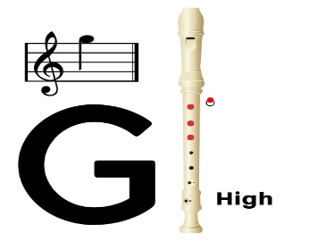

**High G** uses the same fingering as low G but with half the hole covered at the back using your thumbnail if possible. You may need to blow a little harder to get the required sound without overblowing and causing squeaks.

**High F sharp (F#)** can be played by keeping your fingers exactly in the same position as High G but adding on the middle finger of the right hand on the fifth hole.

In **bar 10** of Havana a new rhythm is used called a **triplet.**

A **triplet** is written by putting a “3” over the top of the notes to show that 3 notes should fit in where there would normally only be 2. So in this **example** the “3” over the top of the quavers means that 3 quavers adds up to 2 quavers (1 beat). The triplet is on High E (remember to take your thumb off the back or half hole with your fingernail) and should be played a little faster.

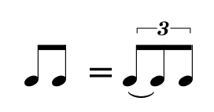

Have fun and enjoy your music making!

Mrs Allan