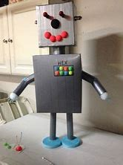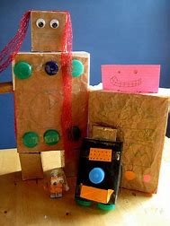

Look around your house for different shapes that you could use to build your robot.

Cuboids – cereal boxes

Cylinders – toilet roll tubes

Cubes – Boxes

Spheres – balls.

Remember to use things that you don’t need anymore. Email me a picture please.