Maths Round-Up June 2020 Name: _____________
#abitofmaths
SC: I can recall things that I have learned so far.
I can apply my knowledge in different ways.
- Write these numbers in order from the smallest to the biggest.  1031, 425, 284, 245, 999, 1099 | 2462  + 316  ------------  ________
- If today is Thursday, what day was it the day before yesterday? | - How many days are there in 3 weeks?
- Write the number 4190 in words. | 8432  - 5760  ----------  _______
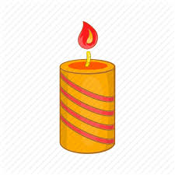  - What shape is this candle and how many faces does it have? | - What is 488 divided by 6?
- Round 1076 to the nearest 100 | - What number is 40  more than 680
- In the number 51,369 what does the 3 stand for? | - Is this statement true or false? Give a reason for your answer.  21 + 33 < 103 - 29
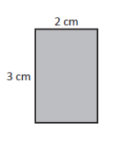  - What is the area of this shape?  6cm  11cm | 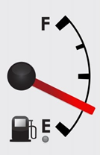  - The dial shows the amount of petrol left in a tank. What fraction of the full tank has been used?
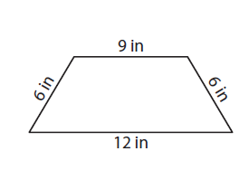  - What is the perimeter of this shape? | - Calculate 432 divided by 10
- What value is the missing number represented by the shape below?  16 + = 29 | 1843  - 576  ---------  ______
- What is the name of this 2D shape? | 9cm x 2 = 10cm + ____ cm
¼ of an hour = ____ min | - Circle the animal that you think is the heaviest  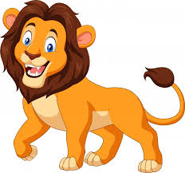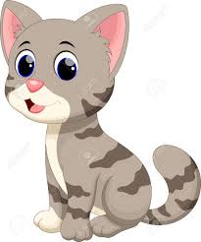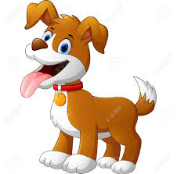
- What do the scales read?  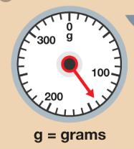 | - Is this statement true or false?  32 > 26
- Which four coins together equal 18p? | 26. How many minutes from 11.05am to 11.45am?
27. I leave home at 10:10 am. I am away for 2 hours and 55 minutes. At what time do I get home? | 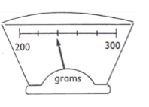  28. What do these scales read?
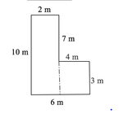  29. What is the total area of this shape? | 30. Write the following as kilograms…  450g

