Number problems
- There are 31 pupils in a class, only 15 have a pencil. How many more pencils does the teacher need to buy so that everyone has their own pencil?

- There were 17 party bags on the table, and 9 spare in the back of mums car. How many party bags were there altogether?

- Mrs Smith was clearing out her cupboard. She found 83 paperclips. Mr Thompson came along and asked to borrow 37. Later that day Mrs Smith found another box in her cupboard containing 78 more paperclips. At the end of that day, how many paperclips were in Mrs Smith’s cupboard?

- On a farm there were 58 lambs born. The farmer sold half of them at market, but bought 71 healthy calves. Altogether how many animals does the farmer now have to feed?

- In January there are 359 pupils in a school. There were 151 pupils in P4-7 and 19 pupils in nursery. In February 3 new p1’s and 9 new P3’s joined the school. What as the total number of pupils in P1-3 in March?

- There are 4 screens at ODEON cinema. In screen two there were 116 customers. Screen three was full with 213 customers. In screen one the numbers were down and only 69 people attended the film. If there were 631 customers in the cinema at that time, how many were in screen 4?

Money and Finance
- I have 20 pence and I buy a pencil for 8 pence. How much do I have left?

- I was given 70 pence, I got 9 pence more. How much do I have now?

- I go to the supermarket to buy an apple for 36 pence. I also want to buy a banana for 42 pence. How much do I need in total?

- I have 86 pence and I want to buy a cake that costs £1.15. How much more do I need?

- I go to the supermarket to buy a drink for £1.10, a sandwich for £2.30 and an apple for 52 pence. I pay with a £5.00 note. How much change do I get?

- I save £3.40 per week. I want to buy a game that costs £19.99. For how many weeks will I have to save to afford the game?

Problem Solving – Measuring Questions
- Tina walked 87m. Joe walked 18m less. How far did Joe walk?

- Clark has a bag of sweets that weighs 90g. Billy has a bag of sweets that weighs double this. How much does Billy’s bag of sweets weigh?

- A van is carrying 800 jars of jam. Each jar weighs 1kg. The driver delivers half of the jars. What is the weight of the jars that are left?

- Ashton swam 64 lengths. Claire swam 86. Joe started later and managed to swim 124 lengths less than Ashton and Claire’s total. How many lengths did Joe swim?

- Be Crafty had 330m of ribbon to give away to celebrate the shops birthday. They gave away 53m in January. They gave away 67m in February. Then in March they gave away 46m. How many metres do they have left to give away?

- Ann is making juice to sell, in order to raise money for charity. She made 650ml of pineapple juice, 425ml of cherry juice and 575ml of apple juice. She sells 500ml of pineapple juice, 350ml of cherry juice and 125ml of apple juice. How many millilitres of juice does she have left to sell?

Data handling questions
- A chart shows that 10 pupils walk to school, 6 pupils cycle and 4 more use the car.
How many people are coming to school?

- One hundred children were surveyed on how they come to school. How many more walkers are there to cyclists?
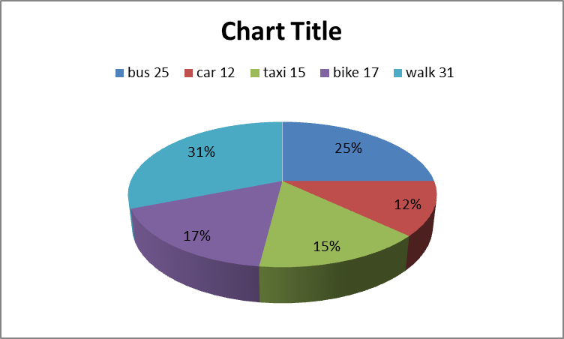

The School lunches for Wednesday are as follows
Dinner | Tally | Total
Option 1 |  | 14
Option 2 |  | 18
Option 3 |  | 7
Packed Lunch |  | 21
Absent |  | 3

- How many seats will the dinner hall need if all the children sit together?

- Out of all the children surveyed how many had a meal made in the canteen instead of a packed lunch?

All Moray schools dinner choices were recorded for the 27th of March 2018.
Dinner | Total
Option 1 | 397
Option 2 | 205
Option 3 | 101
Packed Lunch | 465
Absent | 32

- How many seats would be needed if everyone wanted to sit together?

- On this day 15 people came in late. 7 of these wanted option 1, 8 wanted option 2. 7 people had forgotten their packed lunch. Of these, 3 chose option 3 and 4 chose option 1. What are the new totals for each selection and how many seats will be used if everyone needs a separate seat?

