‘Where am I?” Treasure Hunt
Here are some picture clues to help and to keep you on the right track to find our “Where am I?” location. Have fun!!! If our arrows have faded, then why not redraw them or add some more if it’s very tricky?

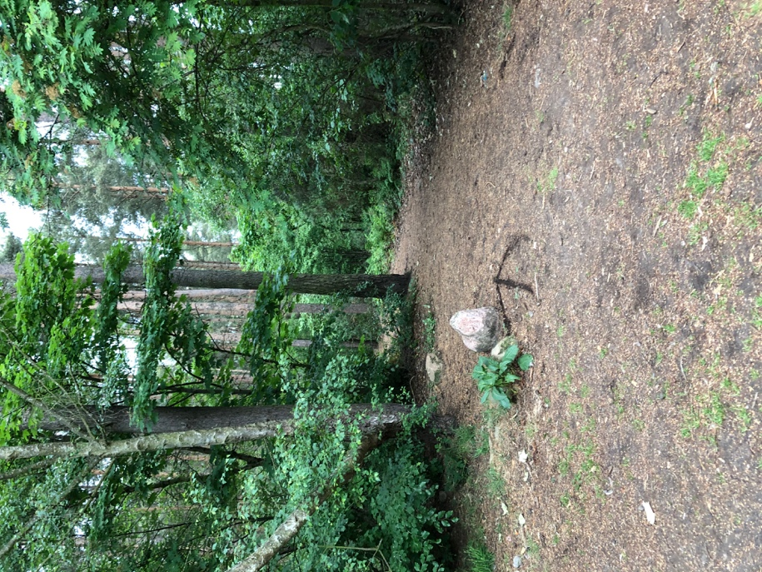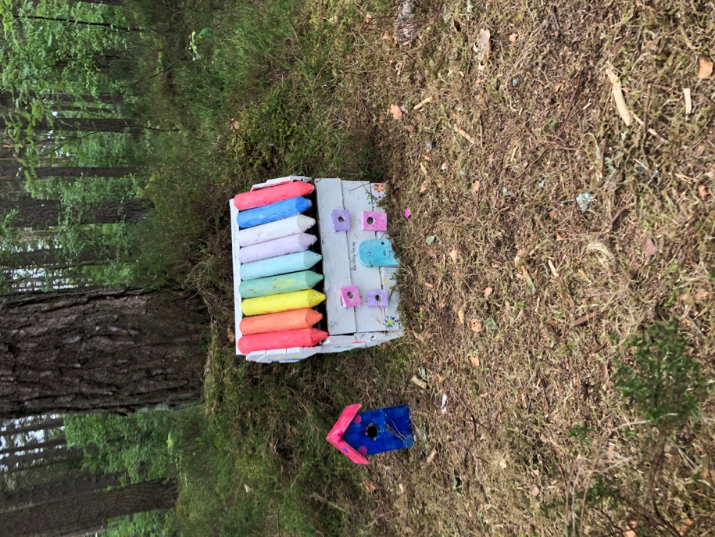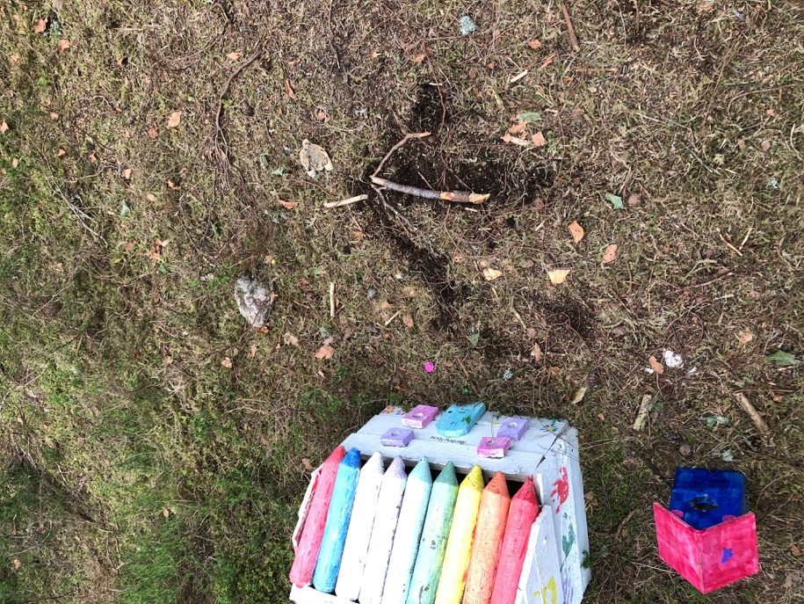
STARTING ARROW FROM THE CARPARK CONTINUE PAST THIS COLOURFUL HOUSE ONE OF OUR ARROWS
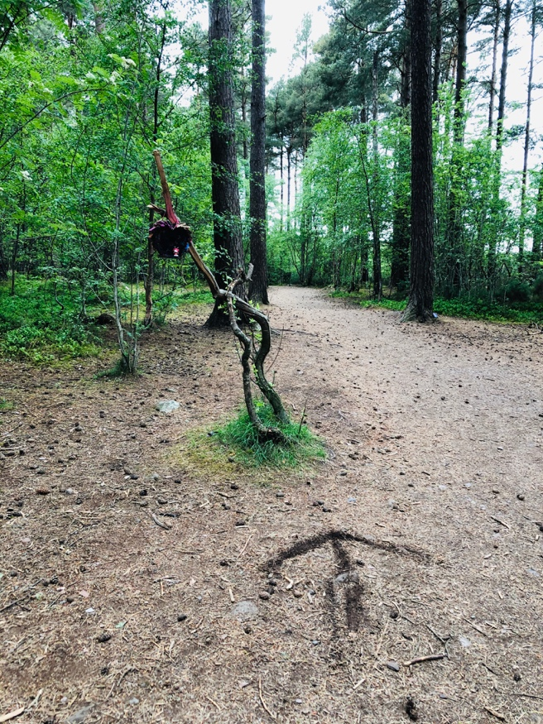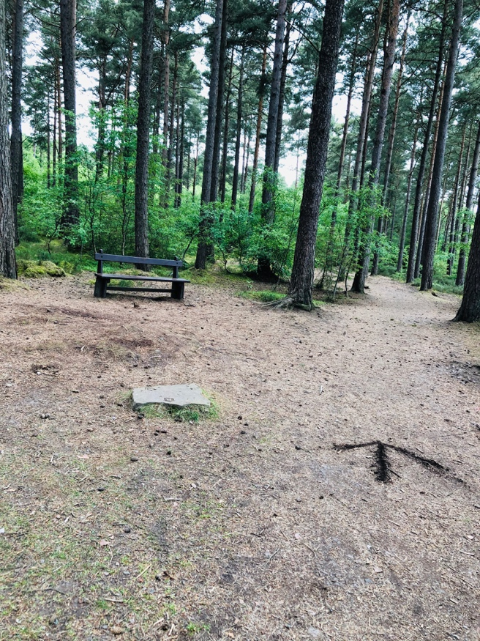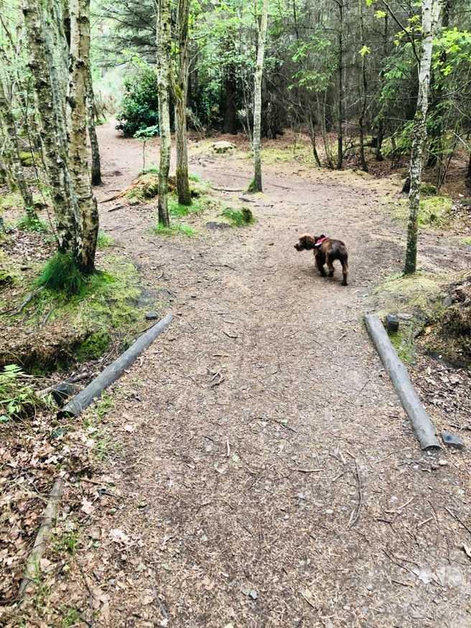
CONTINUE PAST THIS HANGING HOUSE, ANOTHER ARROW BENCH, STONE, ARROW. KEEPING RIGHT FOLLOW SKYE OVER THE “BRIDGE”

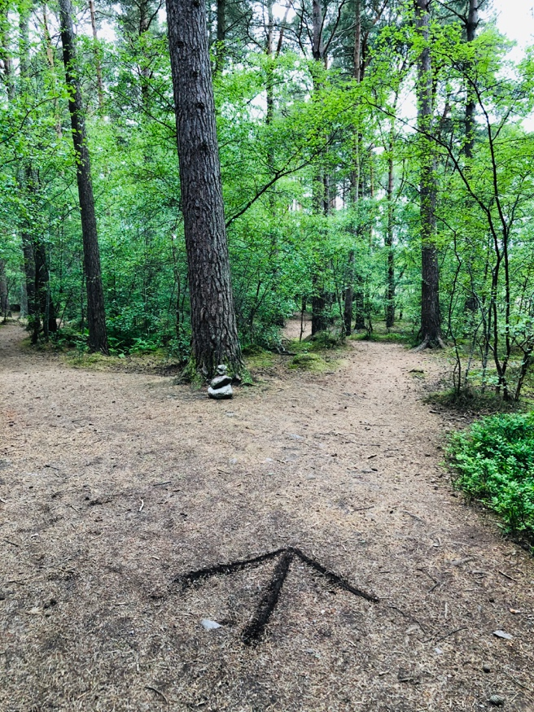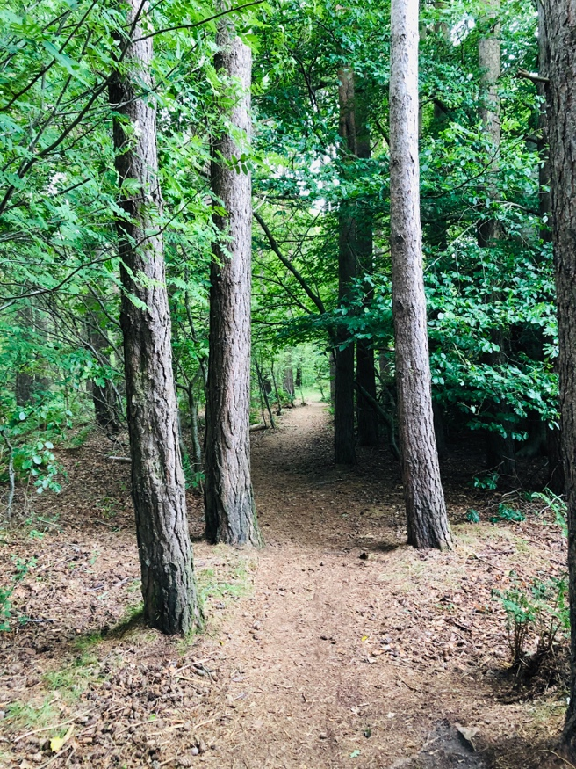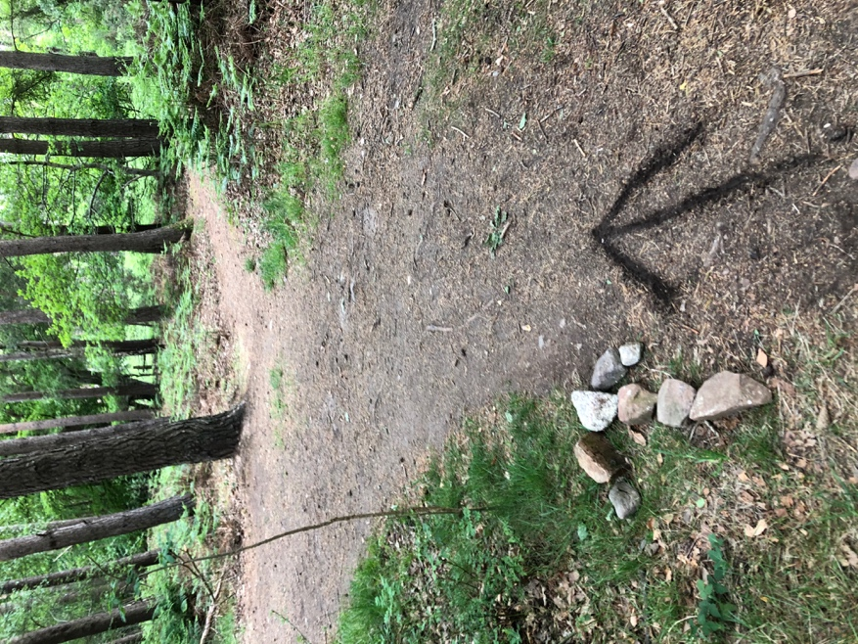
TURN RIGHT AT THE PILE OF STONES THROUGH THESE TREES WATCH OUT FOR OUR ARROWS, STICK RIGHT

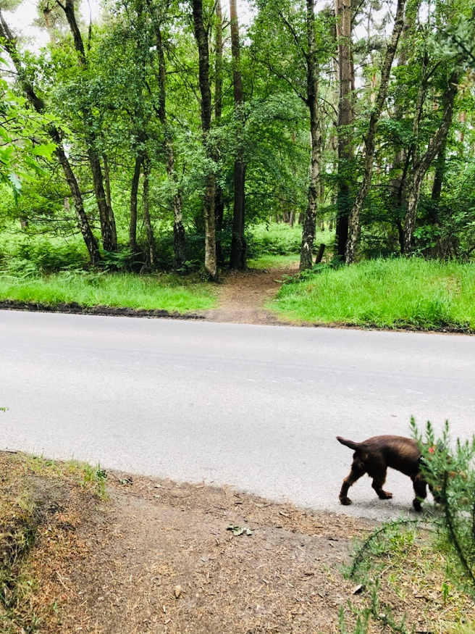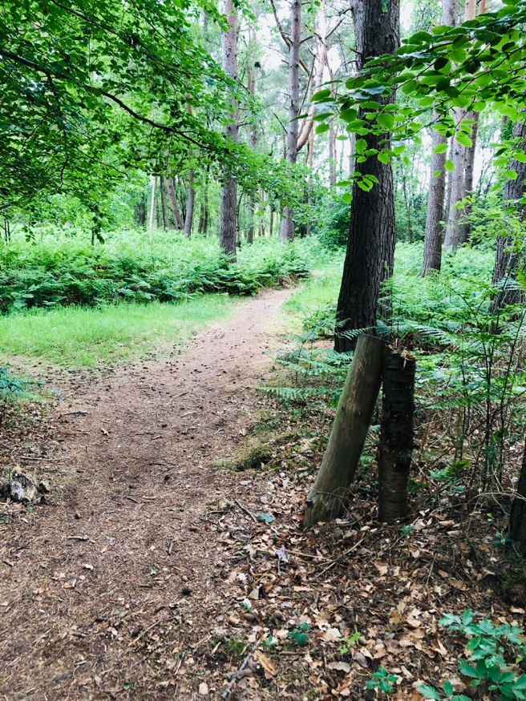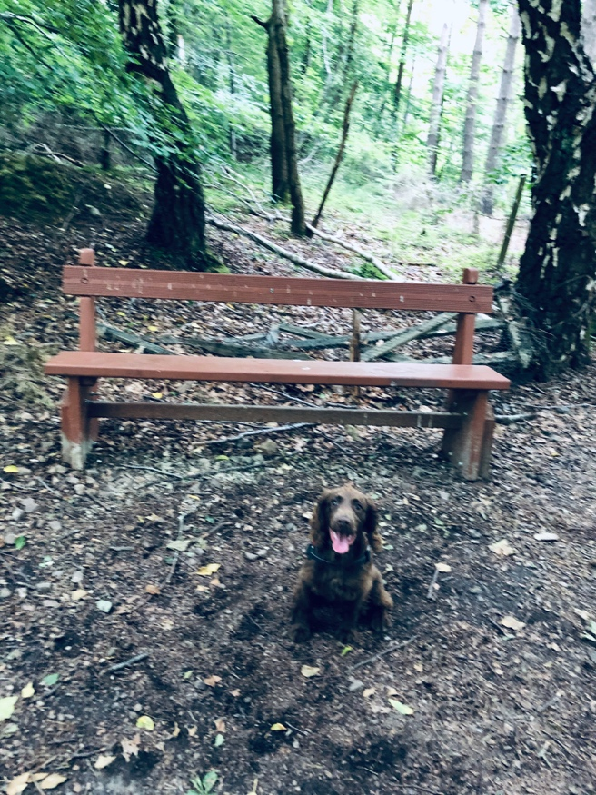
CROSS THE ROAD SAFELYUNLIKE SKYE, FROM PASS THE TWO TREES LIKE LEGS HAVE A REST HERE THEN GO RIGHT UP THE HILL
HERE ON ALWAYS STICK TO THE RIGHT

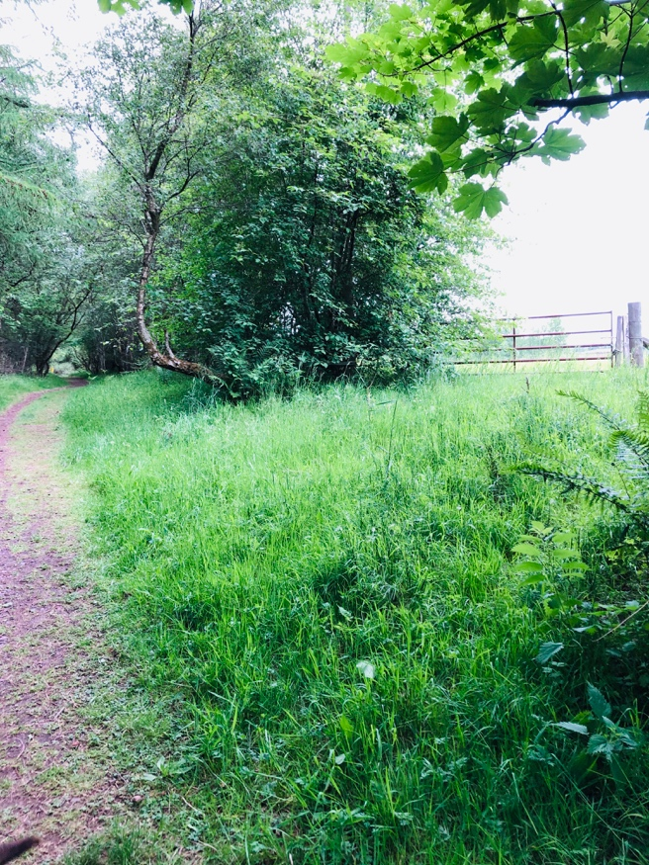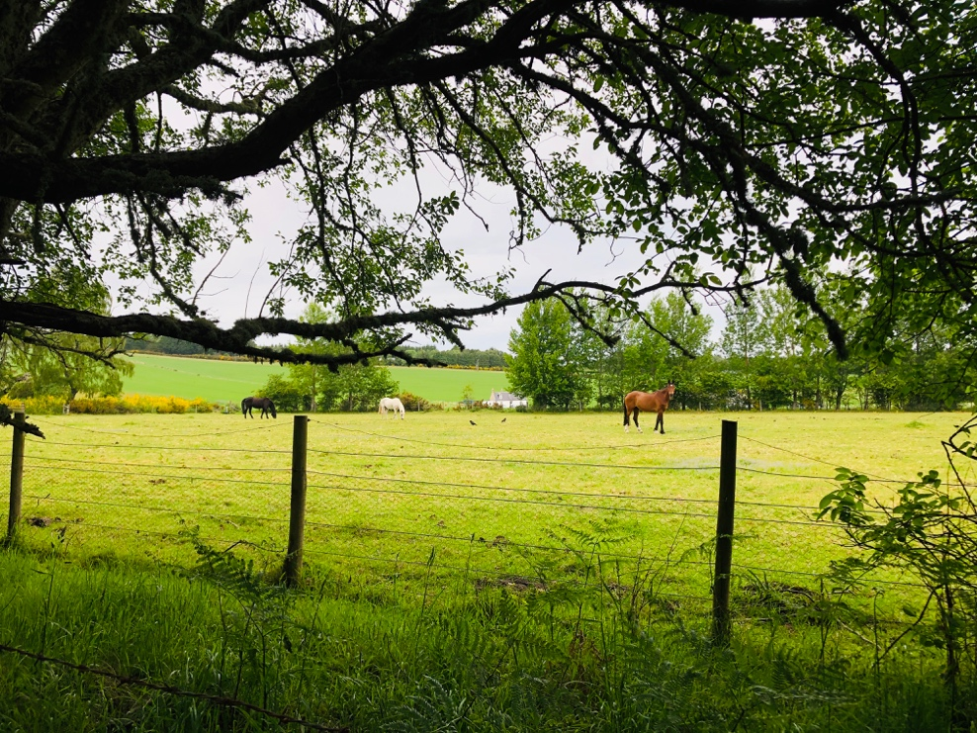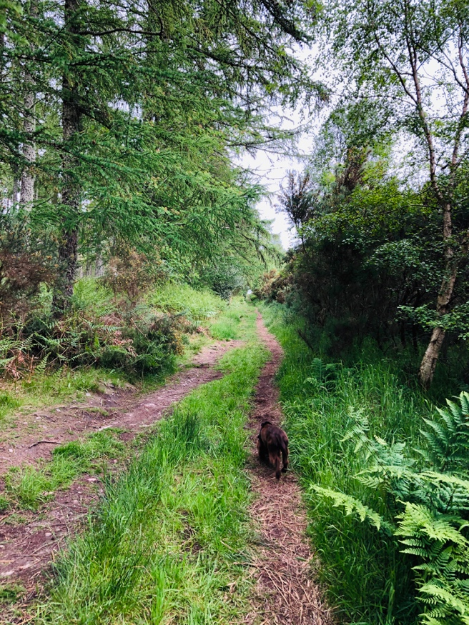
PASS THE GATE ON YOUR RIGHT SAY HELLO TO THE HORSES ON YOUR RIGHT CONTINUE UP THE LONG HILLY PATH

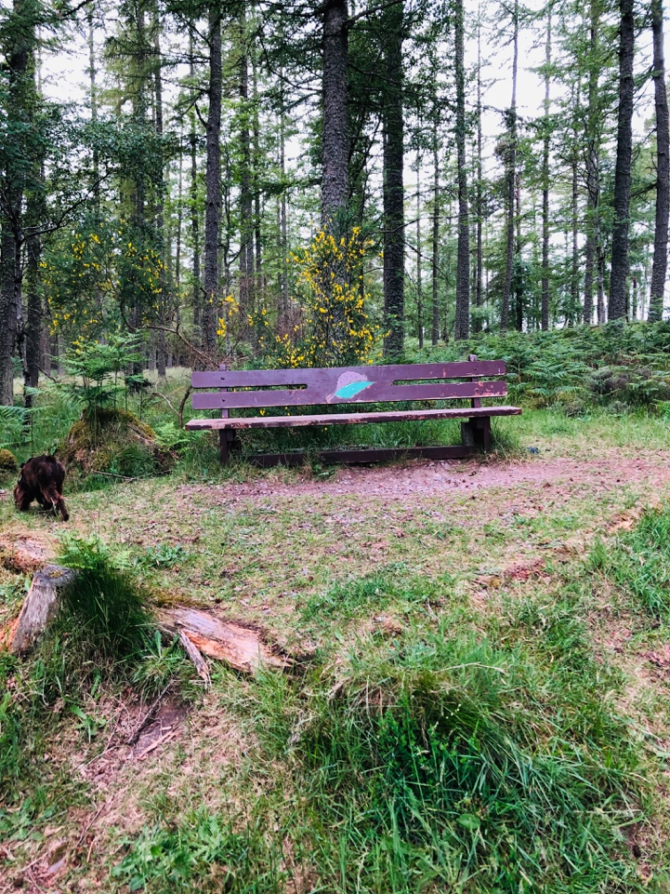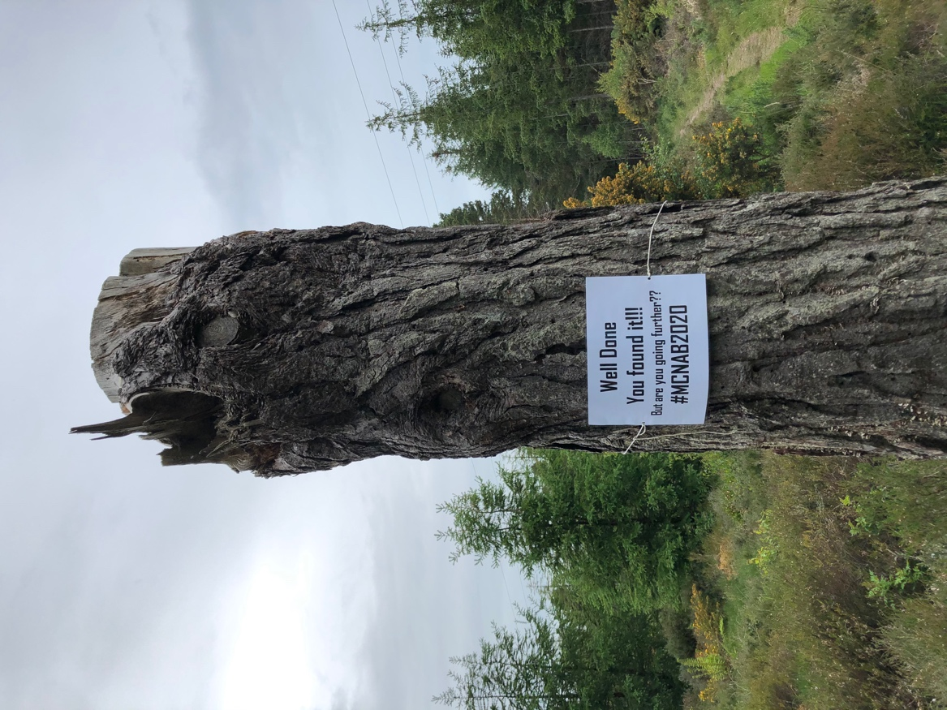
IF THIS BENCH IS ON YOUR LEFT YOUR NEARLY THERE!! YOU MADE IT WELL DONE!!

EXTRA CHALLENGES
CAN YOU KEEP WALKING TO FIND THESE?
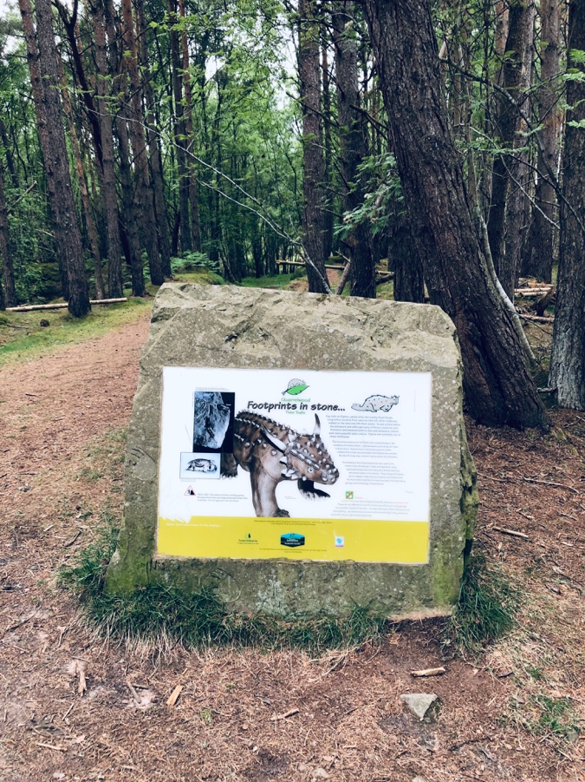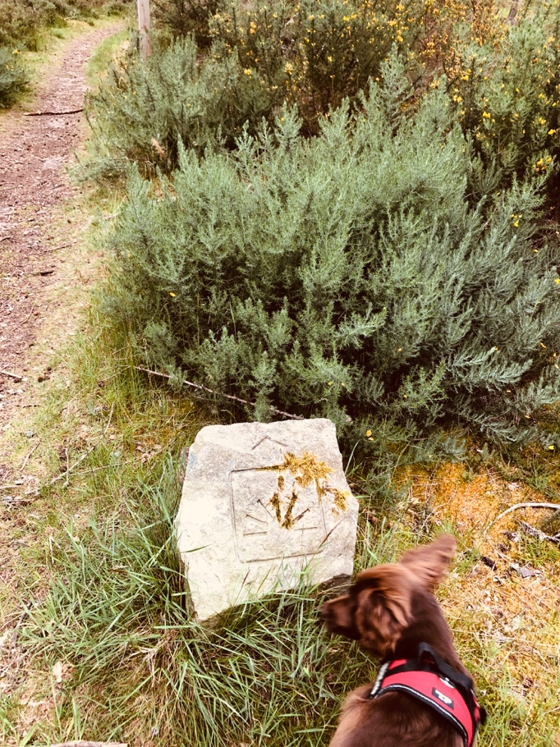
WALK STRAIGHT PAST THIS FOR AN ADVENTURE FIND THIS STONE ON YOUR RIGHT AND FOLLOW
OR TURN LEFT AND FOLLOW THE THE PATH TO THE VIEWPOINT
“RED” WALK TO FIND THE NEXT PICTURE

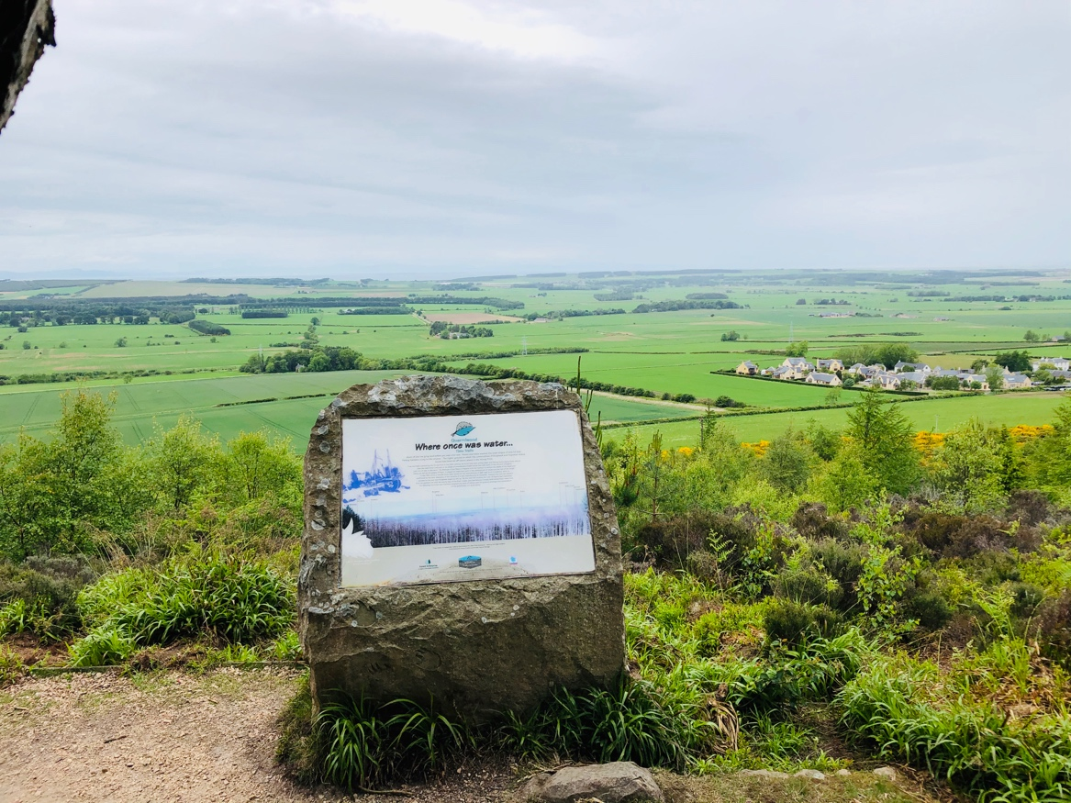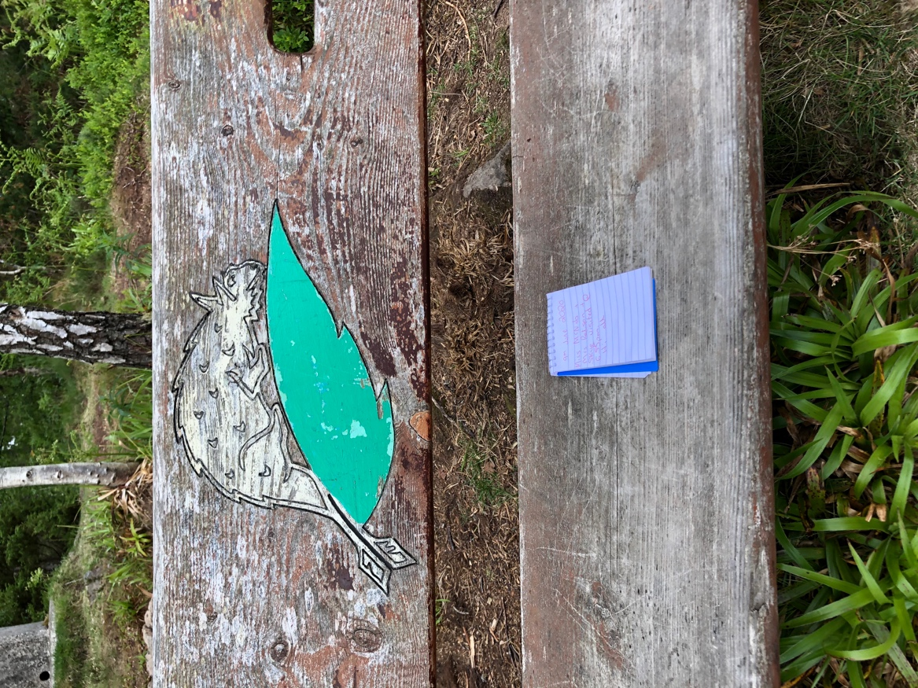
THE VIEWPOINT WE FOUND A LITTLE BOX WITH A PEN AND PAPER

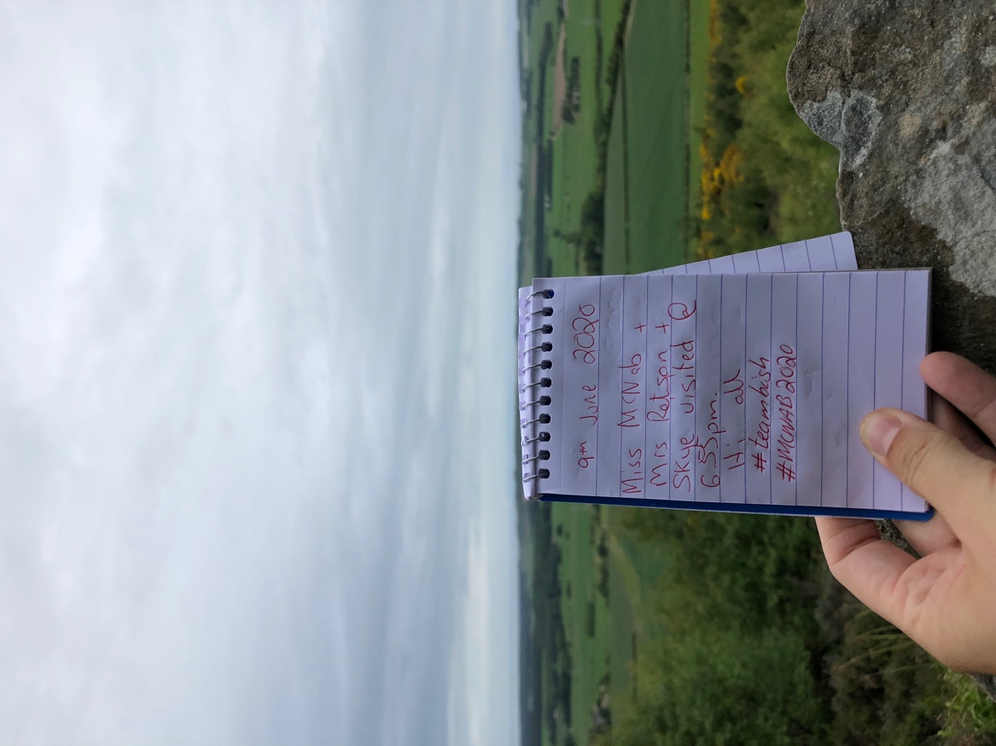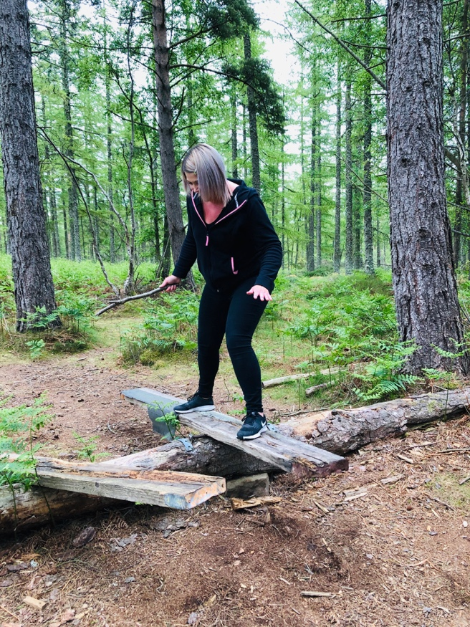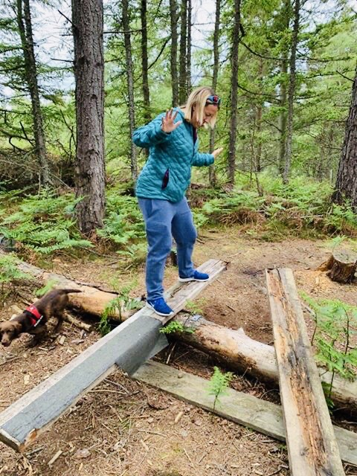
WE LEFT YOU ALL A WEE NOTE, WHY DON’T YOU LEAVE IF YOU FOLLOW THE TRACK DOWN TO YOUR LEFT FROM THE VIEWPOINT YOU WILL COME
A WEE MESSAGE? ACROSS A HOMEMADE SEESAW.. CAN YOU BALANCE AND GET THE WOOD STRAIGHT
LIKE WE HAVE ABOVE? HOW LONG CAN YOU KEEP IT LIKE THAT?? ITS QUITE TRICKY BUT VERY FUN!

