Week Beginning 08/06/20:
EARLY

Watch/ - Once you are in the Classical 100 website, click on the ‘Period’
Listen rectangle on the left-hand side. This week it’s ‘Baroque’ music……
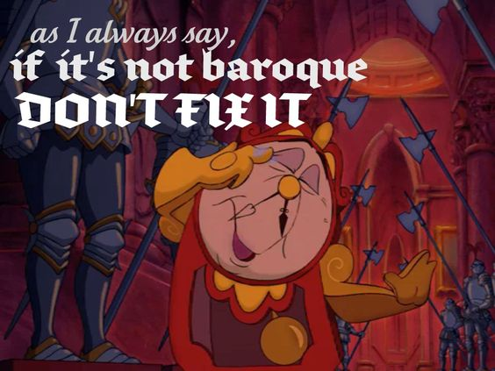

(Sorry, couldn’t resist!!.....)

This week there are lots of examples of music, so have a listen and see which one is your favourite??..
My absolute favourite is “Bach’s Toccata and Fugue”; my Granpa was a church organist and this piece of music is loud, dramatic and fast!! He used to play this in his church.
Traditional organs are unusual instruments in that all that sound is made just from air, the same way that you blow into a recorder to make the sound, only machinery is used rather than breath! You also not only play using your hands but your feet too! (My Nana always said that that was why my Granpa was such a good dancer!!).

Have a look at this clip “Introducing the Pipe Organ:
https://www.youtube.com/watch?v=uRqR9-akXEo

Also, ‘The world’s largest operating instrument’ - the Wanamaker Organ – inside Macy’s department store in Philadelphia!!
https://www.youtube.com/watch?v=98KYMpBx9og

(Imagine listening to that while doing your shopping!!)

Do ‘Baby Shark!’
https://www.youtube.com/watch?v=hSDqYypxfz8

Also, these music games have just started at NYCOS (National Youth Choir of Scotland); “The Wee Summer Sing” – and they are just fantastic!! My favourite so far is ‘Alice the camel’!
Have a look – there is a new one every day!
https://www.nycos.co.uk/wee-sing/summer

FIRST
Listen/ - then do “Ding Dong”:
Watch https://www.youtube.com/watch?v=oby1CGERYJo

Do https://www.youtube.com/watch?v=bM5njpVGwV0
Last one next week!

Also, as that one is quite short, try ‘Clap Hands! Stamp Feet!’, Week 2 Move-it Monday:

https://www.outoftheark.co.uk/ootam-at-home-weekly/

SECOND

Still continuing with our ‘Fever’ production with Scottish Opera:
https://www.scottishopera.org.uk/join-in/fever-online/

…and this week it’s Song 4, “Fight to the Death” - again, don’t worry about the harmonies (unless you want to of course!).
Actions for Song 3, as taught by Alan and Lucy, can also be learned.

- Again, if you fancy doing something completely different afterwards,
try the NYCOS Daily ‘Switch It’ (you will need a small ball/object):

https://www.youtube.com/watch?v=AlTk609Qy9E

