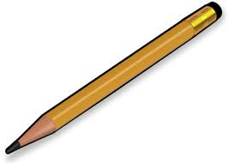
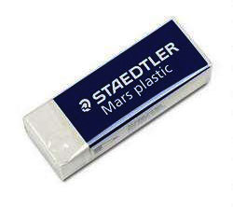
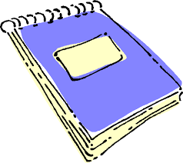
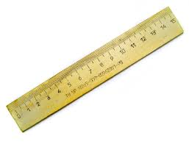

12p
5p
15p
10p
Find the cost of:

1. 2 pencils 2. 3 rubbers

3. A ruler and a pencil 4. A note book and a rubber

5. 2 pencils and a note book 6. A pencil, rubber and ruler

David has 50p

7. How many rulers could he buy?

8. If David bought a note book and a ruler how much change would he get?

9. If David spent exactly 22p what might he have bought?

10. Does David have enough money to buy 1 of all the items?

Money Problems

