HOUSING
- Print
- Add to bookmark

There are lots of different types of buildings for the people of Scotland to live in. Some are suitable for certain needs such as bigger families and disability.

As the population of Scotland is continuing to grow, more and more housing is needed to meet the demand. In this section we look at the different types of housing found in Scotland.

Flats
In Scotland there are lots of flats (apartment blocks). Flats are a very useful type of housing as they can accommodate a lot of people on a relatively small area of land.
Flats are usually fairly small with 1-3 bedrooms suitable for students, young couples, small families and older people (if there is a lift).
Some flats can be very modern, luxurious and big. Others can be older such as the blocks of flats built by the council to house council tenants between 1950 – 1970. Slowly councils are now removing these tall blocks of flats and replacing them with smaller towers of flats (around 3 floors high) or building houses instead.
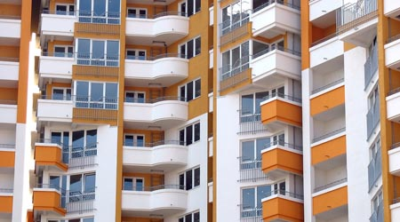
Modern Flats
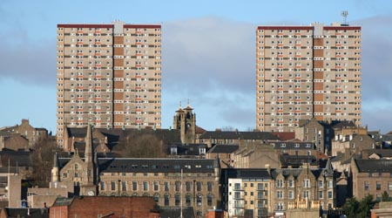
Old Flats
Recently there has been a trend to turn buildings such as warehouses, old schools and churches into flats.

Houses
Houses come in different shapes and sizes in Scotland, the most common being terraced, semi-detached, detached and bungalows.
Terraced
Terraced houses form a row. A row can be made up of 3 houses or even up to 30! The end houses are end-terraced and all the houses in between are mid-terraced.
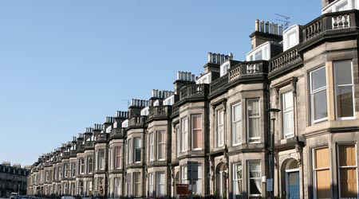
Terraced houses
This was a popular way to build houses in cities and towns as it meant you could build a lot of houses together on a smaller piece of land.
The size of these houses vary from 1-5 bedrooms so they suit a wide range of people.
Semi-detached
These houses are linked to another house at one side. These are a popular choice of house as they can be spacious and have access to the garden from the side.
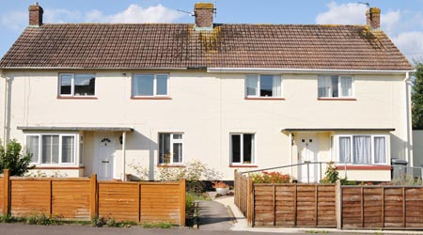
Semi-detached house
Semi-detached houses can greatly vary in size to meet the needs of a variety of people. Semi-detached houses are one of the choices of new builds, so many are being built as a way to fit two homes on a plot of land.
Detached
A detached house is a single house built on a plot of land. The house can be any size, depending on the size of the land.
Detached houses are popular to live in as you don’t have to share any walls with a neighbour, which reduces noise. However this does mean that they are usually more expensive. As with the other houses, they can vary in size but are usually on the bigger side so are more suitable for families.
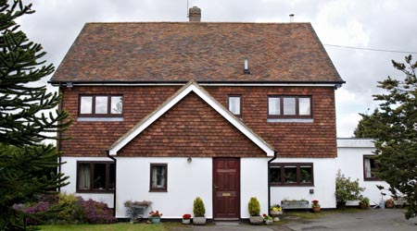
Detached house
Bungalows
Bungalows are a type of house that is built on a single level so there are no stairs to go to another floor. Bungalows tend to be smaller and more suitable for older people or someone who needs wheelchair access, since there are no stairs.
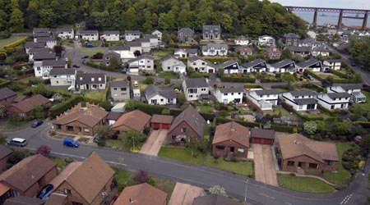
Bungalows
Bungalows can be found in villages, towns, cities and even on their own in the countryside.
These houses tend to be smaller and more suitable for older people or someone who needs wheelchair access, since there are no stairs. Bungalows can be found in villages, towns, cities and even on their own in the countryside.

Cottages
Scotland is home to a lot of beautiful cottages. A cottage is a small house which is usually found in the countryside and small villages. Renting a holiday cottage in the Scottish countryside is very popular amongst tourists.
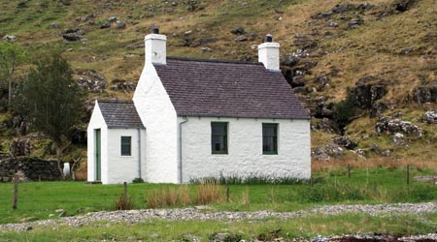
Cottage
A traditional cottage is usually built from rocks found in the countryside and has low ceilings and door frames. They are popular due to being very traditional and historic. Some people buy cottages as a holiday home to provide a retreat from the bustling cities and towns.
Over a hundred years ago, traditional houses, known as a croft houses or blackhouses, used to be a common site in the Highlands and the Hebrides. These buildings were made from dry stone walls and a thatched roof. People and animals used to live in the same house with a partition between them. These houses can be seen at the Skye Museum of Island Life.
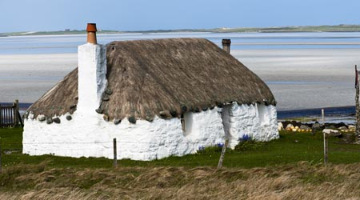
Traditional cottage

Static Caravans
Normal caravans are small trailer homes which can be moved around by being attached to a car. A static caravan remains in one place, usually within a caravan park.
Due to the location of static caravans and not being a strong built house, they are usually kept as holiday homes.
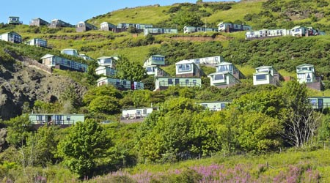
Static Caravans

Mansions
A mansion is a very large detached house. Some historic mansions are owned by wealthy families and have been handed down through the generations. Others are rented out as rather special holiday homes and others such as Arniston House, just outside Edinburgh, are open to the public.
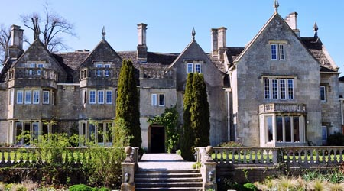
Mansion

Castles
Scotland is famous for its castles. Famous castles such as Edinburgh and Glamis castle were for built for royalty but other castles, such as Blair Castle, were built for noble families.
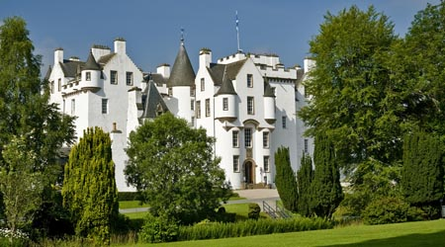
Blair Castle
Today some castles are owned and lived in by wealthy families, others are owned by the National Trust and are open as tourist attractions and some, such as Balfour Castle, are available for holiday bookings.
Other castles have been converted into hotels and host famous people and weddings. Skibo Castle hosted Madonna’s wedding in 2000 and now is an exclusive private members club.
Sadly some castles are in ruins and are just left as they are without anyone looking after them.

Future homes
More and more people are now trying to turn old buildings into new homes, with a growing trend for barn and church conversions. This often costs a lot of money and is a difficult process due to strict planning laws. However, when completed they can be a beautiful and unique home.
People are now also starting to want to build more eco-friendly homes such as building into the side of a hill or underground. These are very unique homes!
Pssst... Secret Facts
Click to unlock!

