Challenge 20/20
You can do these in any order.
1. Look at the labels on clothes. Don’t just look at your own clothes.  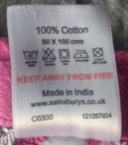  What information do they give?  Copy some out.  Design a piece of clothing and create your own clothing label. | 2. Make some toast for someone at home.  Write out the instructions for how to make toast.  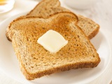  Remember to wash your hands before and afterwards. | 3. Think of someone who lives near to you, who may be feeling lonely.  Write them a letter. Take it to their house and put it through the letterbox.  Remember to wash your hands before and afterwards. | 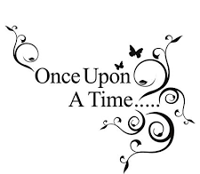  4. Can you think of a story with five sentences? Start each sentence using these sentence starters.  1. Once upon a time…  2. One day…  3. Unfortunately…  4. Luckily…  5. Finally…
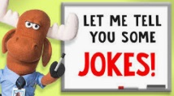  5. Can you make a joke book of good (and terrible) jokes? Think of someone who you could give it to, to cheer them up. | 6. Can you create an A-Z of things that you can see in your house? You may not find something that begins with every letter in the alphabet.  a – apple  b – book  c - carpet | 7. Make an obstacle course for a toy. (car, person, animal).  Put instruction words to show where the toy should go.  E.g. Over, under, around, behind.  Take a picture of it and send it to us. | 8. Look at the word  Coronavirus  How many words can you make using only the letters in the word?
9. Make a paper aeroplane.  Does it fly well?  Write instructions for someone to follow, so that they can make an aeroplane the same as yours. | 10. How many words can you think of, that mean the same as cold? Write each one on a different piece of paper and organise them from the least cold to the most cold. | 11. Write an encouraging message on a piece of paper and put it in your window for other people to read. | 12. Read a story to someone else. It could be to someone younger or someone older.  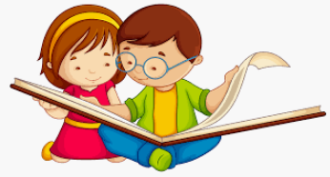
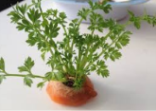  13. If you have a carrot at home, ask an adult to cut off the top. Put it on a saucer of water. Each day look at it and draw and write what you see. | 14. How many words can you make from these parts of words.  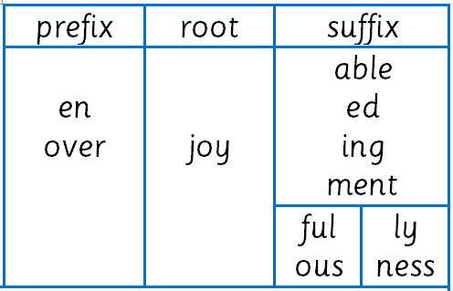  enjoyment | 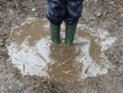  15. What kind of animal would live in a muddy puddle? Create your own animal. Draw a poster about it: what it looks like, what it eats, what it does? | 16. Cut out words and letters from old magazines and newspapers.  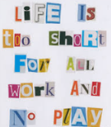  Use them to write a message.
17. Finish this poem.  I can see a ________  And I can see a ______  I can see a _______too!  I can see a ________  And I can see a ______  And I can see a______can you? | 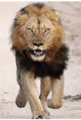  18. Write two similes about this lion.  He is as _______ as a ________.  He ________ like a ________. | 19. Alliteration is where several words in the same sentence start with the same sound.  I kicked the coke can into the cricket cap.  Can you write a sentence with alliteration? | 20. Draw a mind map about your favourite animal.  