**RECORDER CHALLENGE – HARRY POTTER HEDWIG’S THEME – PART 1 & 2**

Hi Primary Fives and Sixes,

How did you get on with part 1 of this challenge? Please do not worry if you are not quite ready for part 2 yet, just give it a go when you feel ready. This is the trickiest part (even for grown-ups) so do not be discouraged if it takes lots and lots of practise. We will learn three new notes this week and three the next to complete the challenge.

High G (see below)

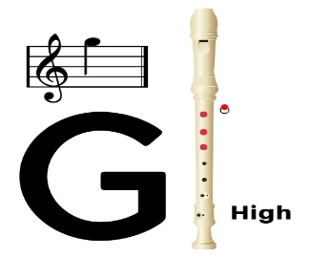

**High G** uses the same fingering as low G but with half the hole covered at the back using your thumbnail if possible. You may need to blow a little harder to get the required sound without overblowing and causing squeaks.

**High F sharp (F#)** can be played by keeping your fingers exactly in the same position as High G but adding on the middle finger of the right hand on the fifth hole.

**High F** is the same as low F but with half the hole covered at the back using your thumbnail again if possible.

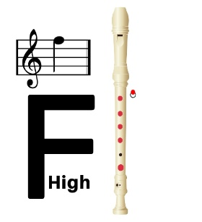

The musical notes to the rest of the song like part 1 are on a separate link to this,

Have fun and enjoy your music making!

Mrs Allan