ART - Victory In Europe Day

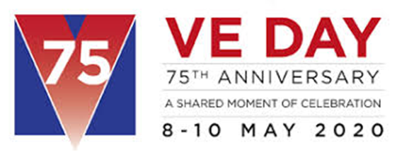

Victory in Europe Day/ VE Day took place on May 8th 1945 (75 years ago) It was a public holiday and a day of celebration to mark the end of World War 2. People held street parties and wore red, white and blue. They danced and sang and there were firework displays. It was a joyful day.

We still celebrate this day on May 8th every year to show that we remember all the brave soldiers and families who suffered in the war.

Art ideas – Choose one of the following

- Paint colourful chalk poppies or bright fireworks on your garden path or the pavement outside your house. You can even make your own outdoor paint
https://www.makeandtakes.com/sidewalk-chalk-paint

- Print off a cute VE day celebration pictures to colour https://www.twinkl.co.uk/resource/ks1-ve-day-colouring-page-t-tp-69696

- Use paint or chalks to make your own celebration firework pictures. It’ll look great on black paper if you have some.

