Australian Animal Fact File

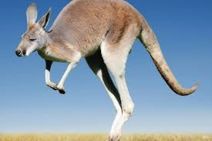



Interesting Facts

1. _______________________________________________
2. _______________________________________________

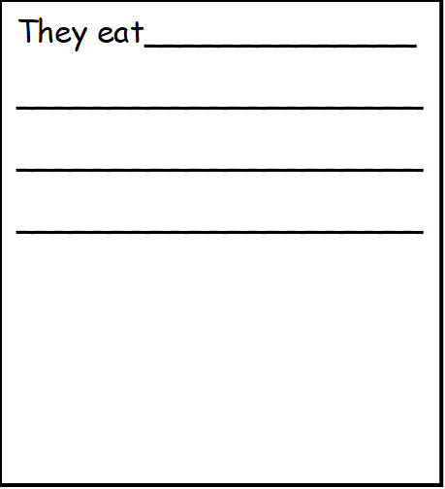

They live______________

_____________________

_____________________

_____________________