Wellbeing pack for Primary School aged children.
This pack was created by Jasmine Donaldson the Home School Link Worker for the Primary Schools Under the Elgin Academy ASG.
In this pack you will find fun, educational and useful resources to work individually on or together with a parent or guardian to help maintain your wellbeing a in the event of school closures during the Coronavirus outbreak. It is likely we will experience a range of emotions during this time and hopefully this pack can help you deal with them. Please don’t hesitate to call or text me on 07817952480 Monday to Thursday should you need further advice.
First of all it’s important for us to understand what the Coronavirus is and how it may affect us so below is a very good link to an informative activity sheet for you to have a look at.

https://drive.google.com/file/d/1Ma8La-kpH3djesvhw0Kon0JvkRWkl3-O/view?fbclid=IwAR0M9d_dm5Tf5NYw0wK9IG-uyB7CaJftj-o8GQ2mFsGZ0XP6GcA5sI5kF6s

Hopefully you have read and understood the information sheet.

Please be reassured that there are lots of people working very hard to help fight against the spread of the Coronavirus and it will get better if we all take the right precautions and wash our hands regularly.

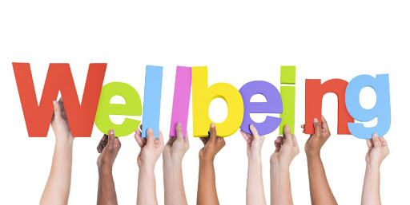
During this time a lot of people will miss their usual routines such as being at school, work and clubs all of which can affect people’s contact with friends and family. Therefore we must be mindful of our wellbeing.

Safe
Healthy Achieving Nurtured
Active
Respected Responsible
Included

You most likely have already heard of
GIRFEC
(Getting it right for every child)
and know of what the SHANNARI indicators are as the Wellbeing Web is often used in schools. To recap...

The GIRFEC approach supports children and young people so that they can grow up feeling loved, safe and respected and can realise their full potential. At home, in school or the wider community, every child and young person should be:

A fun way to explore how your well being is being met in terms of the SHANNARI and the WELLBEING WEB is through the WELL BEING WHEEL GAME which you can find at
https://www.twinkl.co.uk/resource/cfe-p-350-wellbeing-wheel-board-game
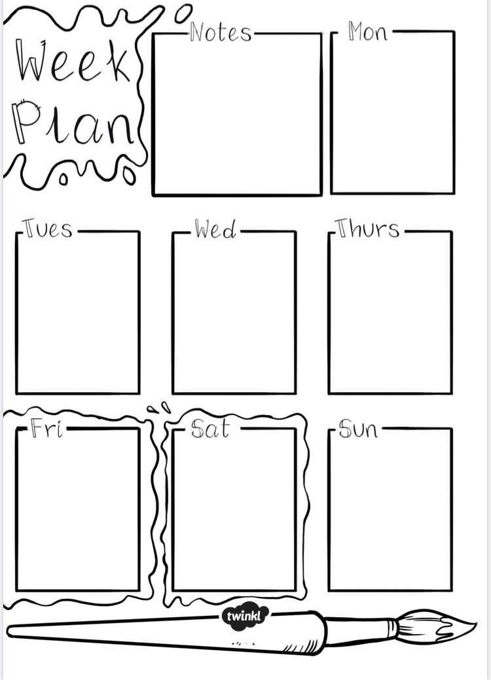
Routines
Changes in routine’s can be difficult so it may be beneficial to plan your week whist you are not in school to help you keep calm and organised.
When you feel worried you could try:
Talking
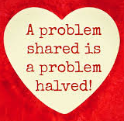
When we are worried it helps to share our concerns with someone we feel comfortable talking to. There is a How Do I feel today work sheet attached at the end of this section to help with discussion.
Deep Breathing
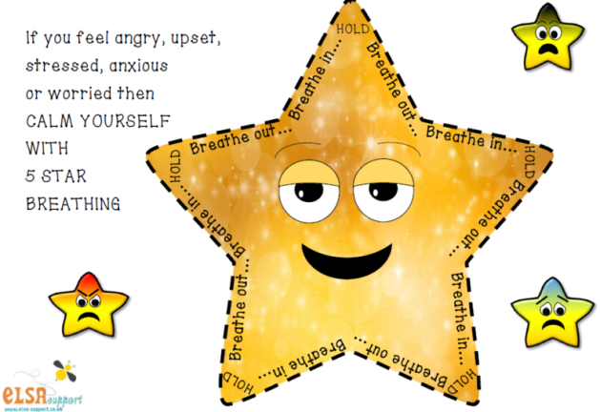
Follow the instructions on the inside of the star. Breath in, hold your breath for a second and exhale.

Getting Creative
Drawing, colouring or writing can all be great ways of expressing yourself. Why not make your own Worry Monster where you can write your worry down for him to gobble up, write a poem, or draw a doodle? The worry monster outline and some mindful colouring can be found at the end of this section.

Doing something you enjoy
Watch a film, read a book, listen to some music, play with Lego and focus on nothing else.

Practice some mindfulness
Close your eyes and imagine yourself somewhere really nice. What can you see, hear, taste, feel and smell?

Having a laugh
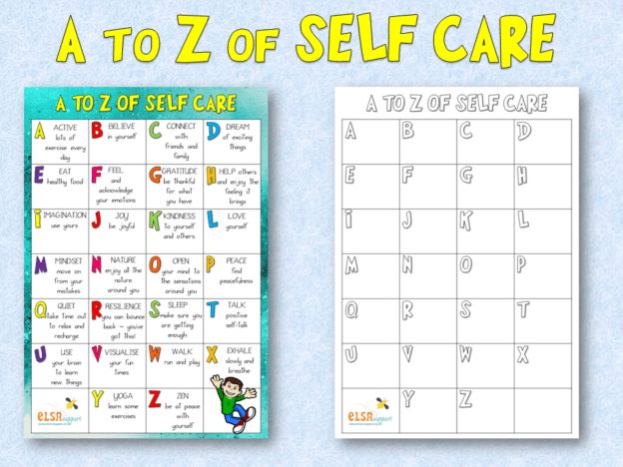
Think of something that makes you giggle, could it be a joke, a funny tune or a silly face?

These are just some ideas you can try to ease your worries but you may already have some of your own... Why not try making an A to Z Self Care poster of your own. You can get help with this at the link below.
https://www.elsa-support.co.uk/a-to-z-of-self-care/
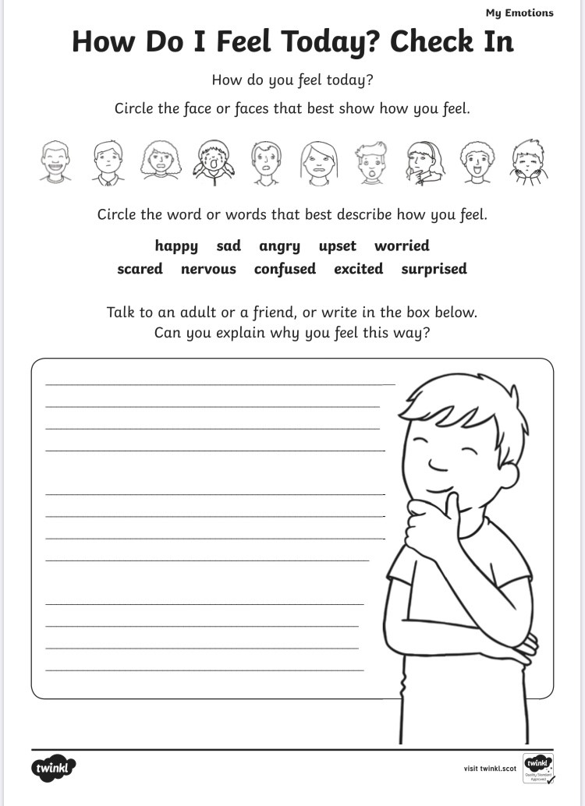
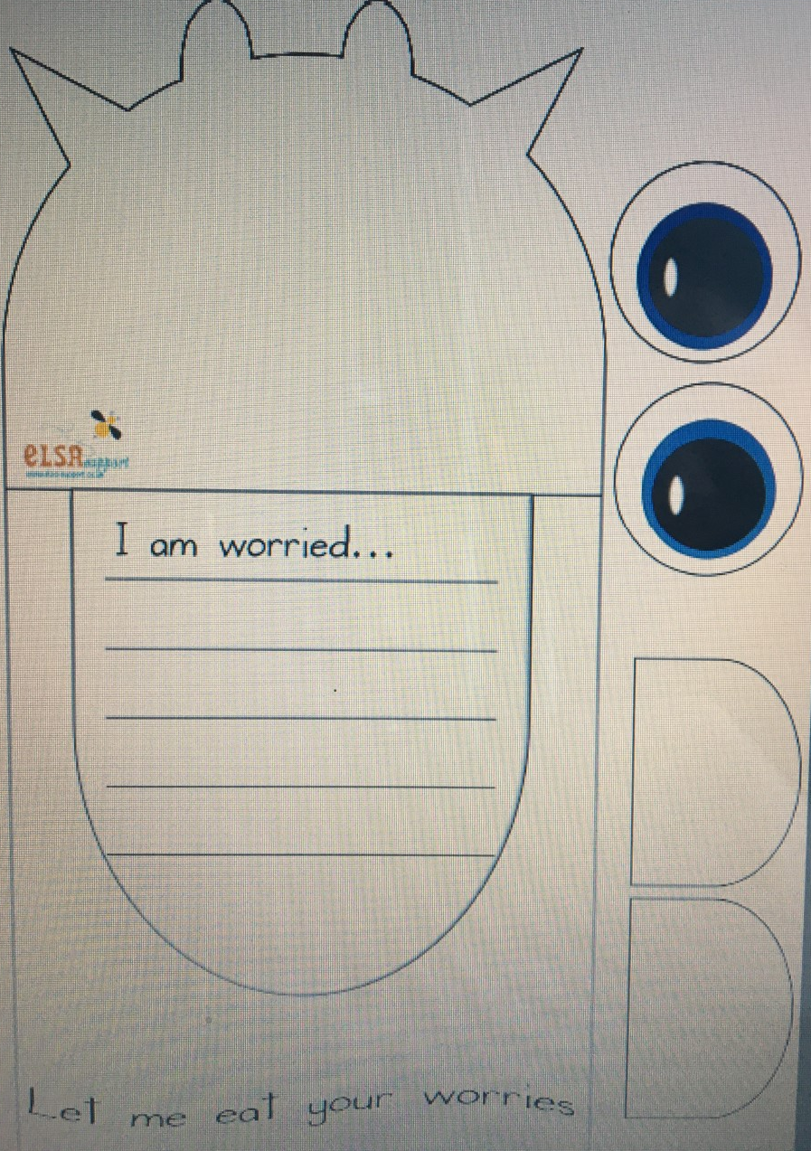
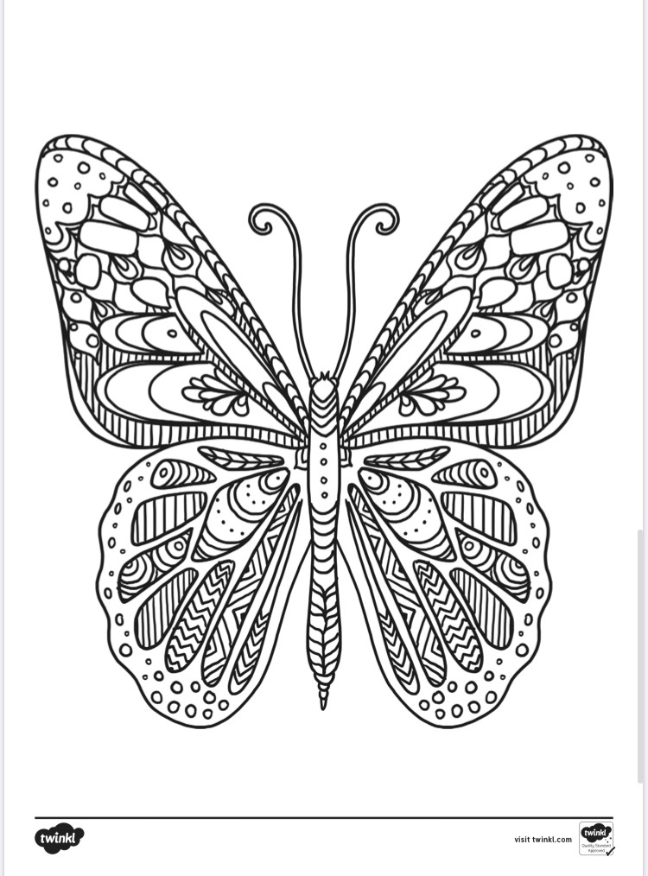
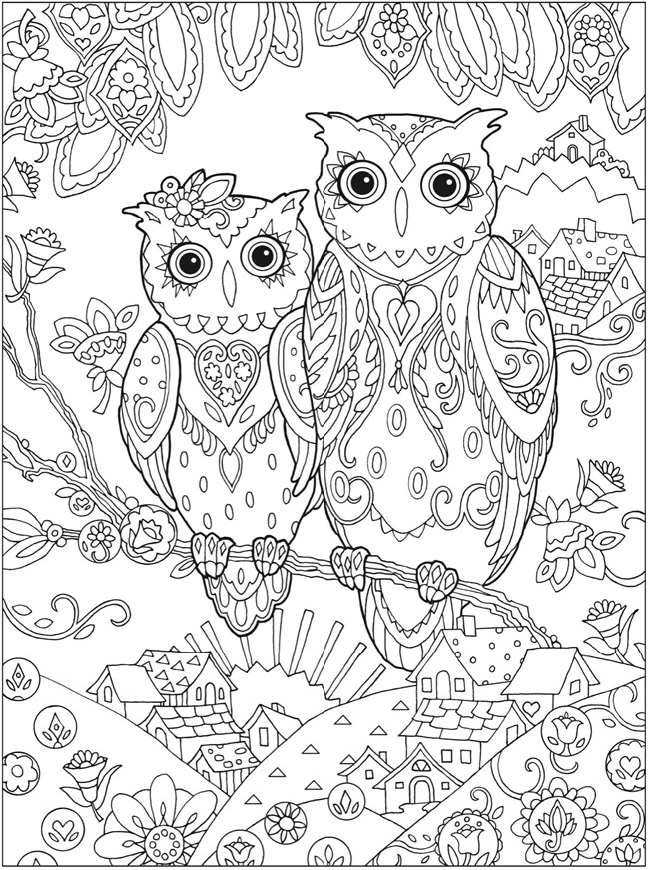

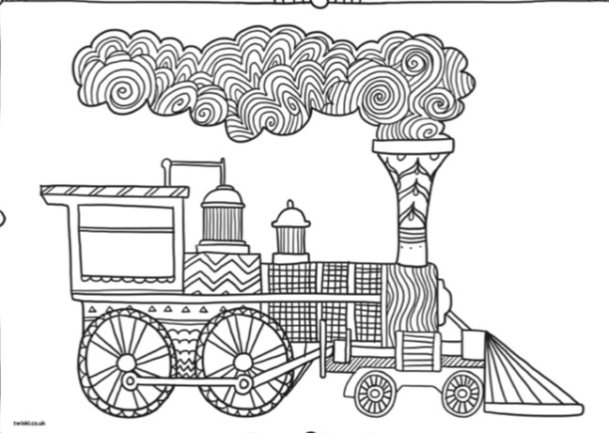
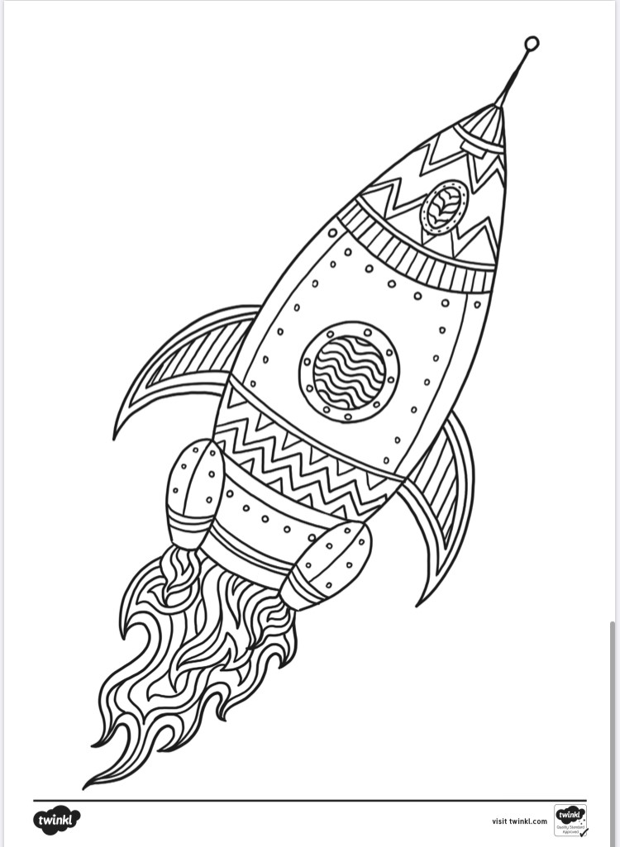

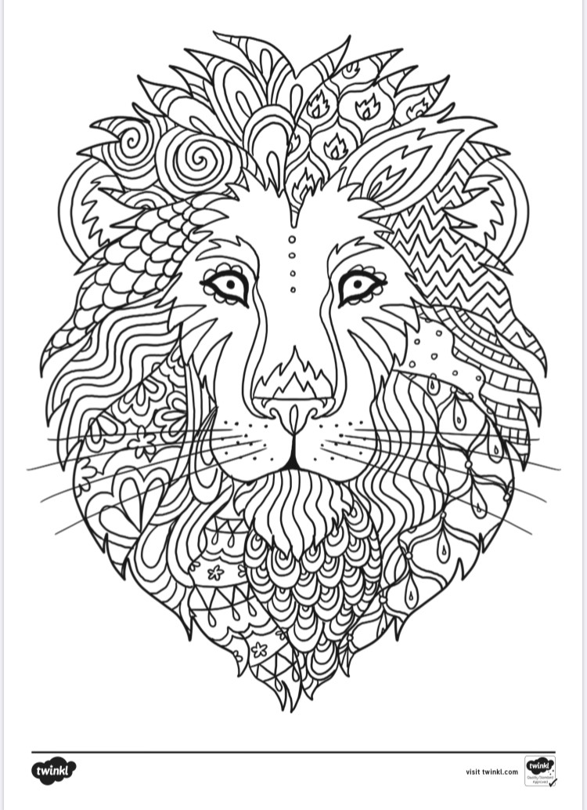
If you feel Sad You could Try...
Remembering what makes you and others around you happy.
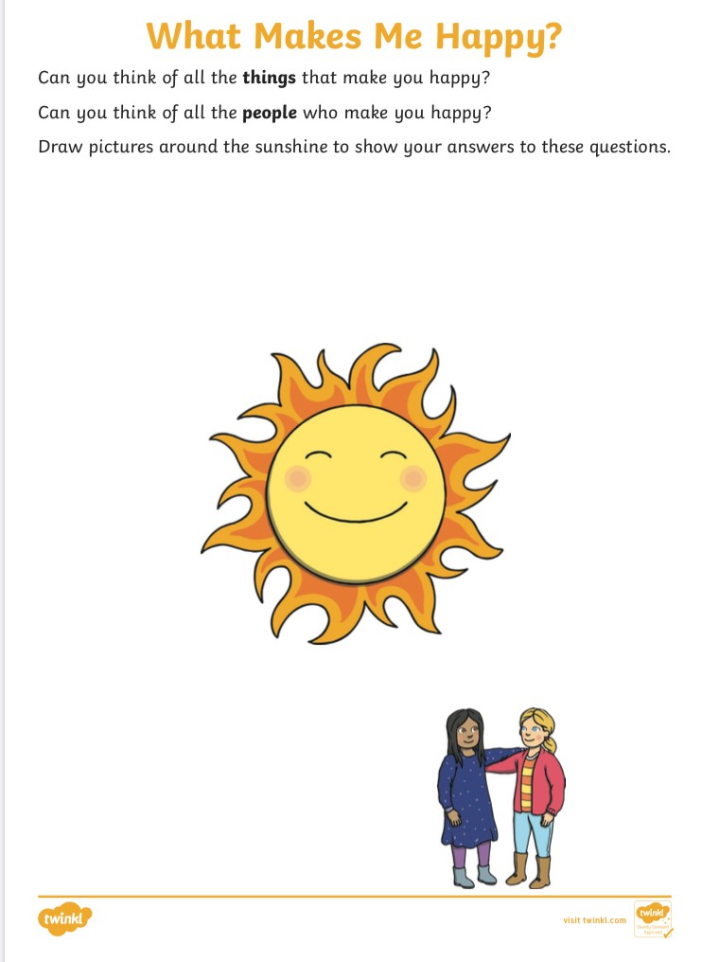
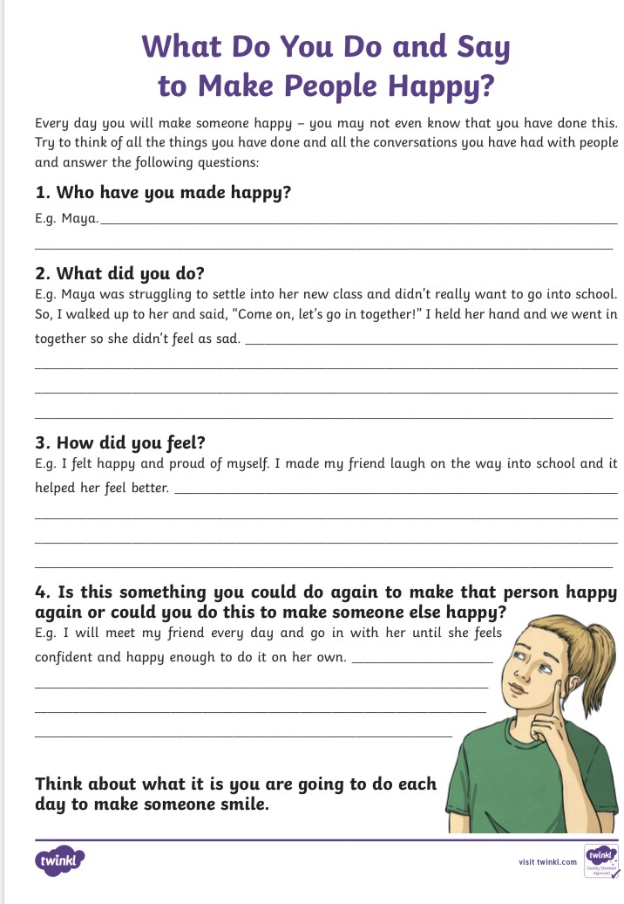
Create your own Battle Cry
Sadness can sometimes feel unstoppable but you don’t have to go through it on your own. You are a team with the people you love and trust so create your battle cry, believe it and shout it out loud! You can overcome this feeling!
These can be used for all sorts of emotions you are feeling such as sadness, anger, scared or when your confidence is low.
Draw your face in the centre and fill out the thought bubbles with you own Battle Cries one has been completed as an example!
I Know I
won’t feel like this forever!

When your confidence is low you could try the following activity...

When it’s Dark Look for Stars!

Write your Strengths on the Stars and see how you shine!
You are a Star!
To finish this pack I want to remind you that all behaviour is a communication and sometimes emotions change due to what is happening around us or because of our thoughts. Emotions can feel good and some can feel bad but regardless it is okay to feel what you are feeling. The important part is that we can help ourselves and each other with these feelings when they get a bit too big.
Remember certain feelings just like the Coronavirus and its effects won’t last forever so it’s important to

Look to a Bright Future
Use the space below to draw and or write the exciting plans you have ahead of you.

