**Second Level Home Learning Pack**

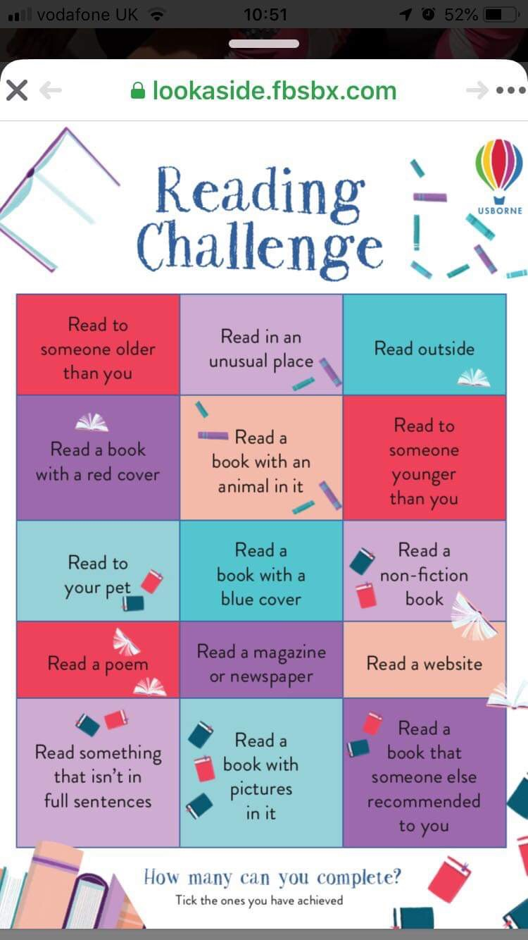 

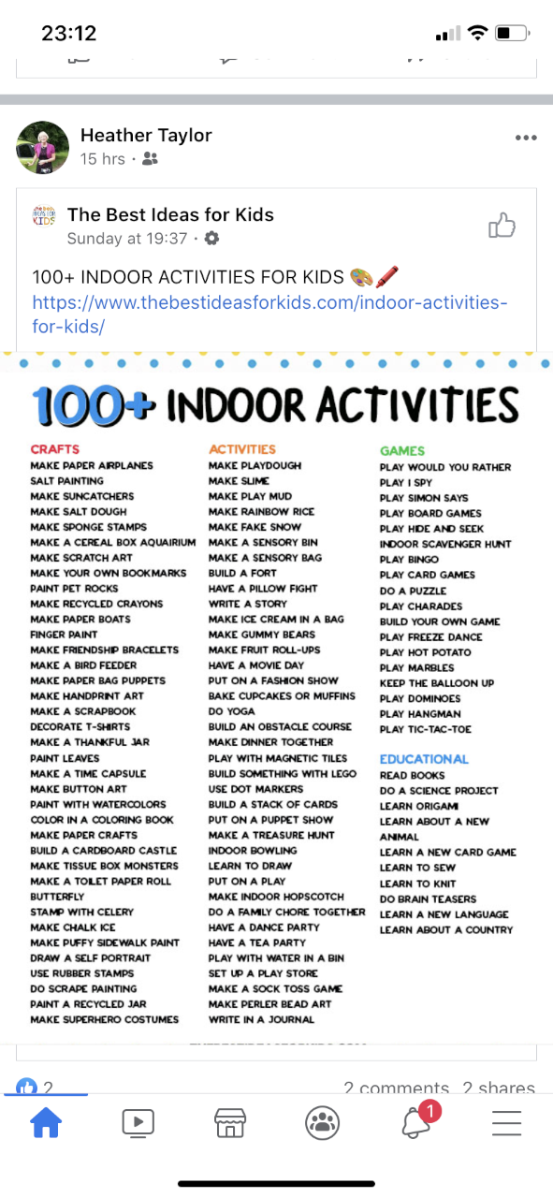

|  |  |  |  |  |
| --- | --- | --- | --- | --- |
| [Image result for household chore](https://www.google.co.uk/imgres?imgurl=https%3A%2F%2Fclip.cookdiary.net%2Fsites%2Fdefault%2Ffiles%2Fwallpaper%2Fpioneer-clipart%2F191129%2Fpioneer-clipart-household-chore-191129-6440041.jpg&imgrefurl=https%3A%2F%2Fclip.cookdiary.net%2Fwallpaper-7342322&tbnid=ooGTtdxImo528M&vet=12ahUKEwi5uNyU3qPoAhUt5IUKHSyVAS4QMyg7egUIARCGAQ..i&docid=7eEo5Wlq8ddcuM&w=1350&h=1941&q=household%20chore&hl=en-GB&safe=vss&ved=2ahUKEwi5uNyU3qPoAhUt5IUKHSyVAS4QMyg7egUIARCGAQ)[Image result for household chore](https://www.google.co.uk/imgres?imgurl=https%3A%2F%2Fwebstockreview.net%2Fimages%2Fchores-clipart.png&imgrefurl=https%3A%2F%2Fwebstockreview.net%2Fexplore%2Fchores-clipart%2F&tbnid=NYblbxzPbOChxM&vet=12ahUKEwi5uNyU3qPoAhUt5IUKHSyVAS4QMygZegQIARA8..i&docid=-iLl7IRCLGe26M&w=694&h=675&q=household%20chore&hl=en-GB&safe=vss&ved=2ahUKEwi5uNyU3qPoAhUt5IUKHSyVAS4QMygZegQIARA8)Help Around The House BINGO! | | | | |
| B | I | N | G | O |
| adult’s choice | make bed | hang up towel | washing up | help cook dinner |
| sweep the path | clean the door handles | water the plants | dust bedroom | tidy away toys |
| hoover | clean room | FREE SPACE | take out the bins | dry the dishes |
| feed pets | set the table | tidy garden | make your own lunch | get or post the mail |
| replace toilet roll when empty | fold clothes | get up and ready without a fuss | make bed | adult’s choice |

Topics

|  |  |  |
| --- | --- | --- |
| P5 | P5/6 and P6 | P6/7 and P7 |
| Ancient Aztecs | Geography | WW2 |
| Primary 5 pupils can create a presentation on the Ancient Aztecs. The presentation can be in any form. Areas that you may wish to research and report on include;   * Who were they? * Where did they come from? * What were they famous for? * Aztec gods * Everyday life * Interesting facts.   <http://www.primaryhomeworkhelp.co.uk/aztecs.html> | Following on from natural disasters P5/6 and P6 are going to explore geography. Pupils would have been able to choose the areas of geography that they would have liked to explore further. This may have included;   * Mountains and their features * Rivers and their features * Read maps * Weather and climate * National parks * Local context * Famous Scottish features * Worldwide features.   Create a presentation (paper/powerpoint/etc) on your chosen area.  <http://www.primaryhomeworkhelp.co.uk/geography/index.html> | So far P6/7 and P7 have investigated the countries involved, important dates / battles, life at home, evacuees and the Blitz, including Anderson Shelters and Billeting. P7 may continue to research and explore the topic in more detail. Possible areas of research may include Rationing, The Blackout, Battle of Britain, D-Day, Weapons and important figures (Churchill, Hitler, Anne Frank). The choice is yours. Whilst we encourage the importance of this knowledge it is the skills of research and completing a presentation that we are focussing on. Include different areas of WW2 or parts that you previously found interesting. The presentation can be in any format you wish.  Useful website  <http://www.primaryhomeworkhelp.co.uk/Britain.html> |

Active Spelling Activities

|  |  |  |  |  |  |  |  |  |  |  |
| --- | --- | --- | --- | --- | --- | --- | --- | --- | --- | --- |
| Noughts & Crosses   |  |  |  | | --- | --- | --- | | noughts | crosses | crosses | | crosses | naughts | crosses | | crosses | naughts | naughts |   Play with a partner. You each choose a spelling word and use this to play noughts and crosses. | Backwards Words  Write your spelling words forwards and then backwards. Write neatly!  Example: where erehw |
| *ABC Order*  First write your spelling words in a list. Then write them in ABC order. To finish, write your  words in reverse ABC order! | Fancy Letters  Fancy Letters  **Write each of your spelling**  **words using fancy letters.**  Your letters can have curly-q’s  or dots, for example. Have fun! |
| Across and Down  Write each of your spelling words across and then down  (starting with the first letter).  *Examples- w h e n f o u r  h o  e u  n r | Bubble Letters  **Write your spelling words in bubble letters**.  After you write your words in bubble letters, colour your words with a crayon or coloured pencil. |
| Other Handed  First write your spelling words the way you usually do it. Then, try writing the list with your other hand! | Acrostic Poem  Choose 5 of your spelling words. Write an acrostic poem for those words. Example: fly  Fun in the sky.  Laps around clouds.  Yelping with glee. |

**Websites and Free Subscriptions to access Learning Resources**

*Early Level – P1, First Level – P2-4, Second Level – P5-7*

**All Areas**

* Learning at Home <http://bit.ly/38SS37q>
* Topmarks <https://www.topmarks.co.uk/> (Educational Online Games)
* The Muddy Puddle Teacher <https://themuddypuddleteacher.co.uk/> (Outdoor Learning)
* Twinkl (1 month free subscription - printable worksheets/ PowerPoints) https://www.twinkl.co.uk/
* TED Ed <https://ed.ted.com/lessons>
* Toy Theater  <https://toytheater.com/>  (Educational Online Games)

**Literacy & Language**

* Oxford Owl <https://www.oxfordowl.co.uk/for-home/>
* BritishCouncil https://www.teachingenglish.org.uk/resources/primary
* BBC <https://www.bbc.co.uk/bitesize/primary>

(Click on your child’s stage Early-P1, First P2-4 and Second P5-7)

* Phonics Play <https://www.phonicsplay.co.uk/>  (Sounds and word blending)
* Duolingo <https://www.duolingo.com/welcome> (Languages)
* BBC Learning <http://www.bbc.co.uk/schools/websites/4_11/site/literacy.shtml>
* Oxford Owl Literacy and Numeracy

<https://www.oxfordowl.co.uk/welcome-back/for-home/reading-owl/kids-activities>

* <https://www.lovereading4kids.co.uk/kids-zone/>
* <https://www.doorwayonline.org.uk/literacy/>
* https://www.scottishbooktrust.com/50-word-fiction
* <https://www.roythezebra.com/>
* <http://www.letters-and-sounds.com/>

**Maths & Numeracy**

* SumDog  <https://www.sumdog.com/user/sign_in>
* BBC  <https://www.bbc.co.uk/bitesize/primary>

(Click on your child’s stage Early-P1, First P2-4 and Second P5-7)

Top Marks <https://www.topmarks.co.uk/>

Digital Maths Worksheets <https://www.math-aids.com/>

* <https://www.countonus.org.uk/resources/>
* <https://www.doorwayonline.org.uk/number/>
* <https://pages.sumdog.com/>
* <http://www.snappymaths.com/>
* <http://www.maths-games.org/>
* <https://www.mathsweek.scot/activities>
* <https://www.khanacademy.org/>
* <https://nrich.maths.org/>

**Health & Wellbeing**

* Go Noodle <https://www.gonoodle.com/>
* Cosmic Yoga <https://www.cosmickids.com/>
* <https://www.thinkuknow.co.uk/>
* <https://roadsafety.scot/learning/>
* <https://www.foodafactoflife.org.uk/>

**Science/Outdoor Learning**

* National Geographic Kids <https://kids.nationalgeographic.com/>
* Mystery Science <https://mysteryscience.com/>
* The kids should see this <https://thekidshouldseethis.com/>
* Crash course kids  <https://www.youtube.com/user/crashcoursekids>  (Science videos)
* Paw Print https://www.pawprintbadges.co.uk/challenge-packs-6-c.asp Challenge Packs
* Nature Detectives <https://naturedetectives.woodlandtrust.org.uk/naturedetectives/>
* <https://wowscience.co.uk/>
* <http://www.bbc.co.uk/schools/websites/4_11/site/science.shtml>
* <https://www.tigtagworld.co.uk/mindmap/#/modules/>

**Project Based Learning**

* DK Find Out <https://www.dkfindout.com/uk/>
* Scholastic Learn at Home <https://classroommagazines.scholastic.com/support/learnathome.html>

(20 days of projects for reading, thinking and growing- broken down in to stages)

**Computing and Coding**

* SCRATCH  https://scratch.mit.edu/
* Blockly <https://blockly.games/>
* Be Internet Legends –
* E-Safety and Digital Games <https://beinternetlegends.withgoogle.com/en_uk/interland>

**Touch Typing**

* <https://www.speedtypingonline.com/games/type-the-alphabet.php>
* <http://bigbrownbear.co.uk/learntotype/>
* <https://www.bbc.co.uk/bitesize/topics/zf2f9j6/articles/z3c6tfr>

**Arts & Crafts**

* Red Ted Art <https://www.redtedart.com/>
* The Imagination Tree <https://theimaginationtree.com/stay-at-home-survival-guide/>
* (Various play based activities- daily break down of activities and resources)
* The Artful Parent <https://artfulparent.com/>

**YouTube Channels for Home Learning**

English

* [The Alphablocks](https://www.youtube.com/channel/UC_qs3c0ehDvZkbiEbOj6Drg) are living letters who appear in wonderful videos to help your children learn about phonics and develop their reading skills.
* [KidsTV123](https://www.youtube.com/playlist?list=PL1F93C67B4CA81D04) has a large playlist of phonics videos that children can watch.
* [Fairy Tales and Stories for Kids](https://www.youtube.com/channel/UCOPzf8kf-FUDs32E7F2wGdg) has lots of animated stories to enjoy. Can your children retell the story to you after they have watched one of the videos?
* BBC Teach has [a playlist of English videos](https://www.youtube.com/playlist?list=PLcvEcrsF_9zLFRmY3lcxn9-dzOjTwdohq) to teach your children about punctuation and stories. It also includes ideas for writing, songs and more.
* CBeebies have [a playlist of their Bedtime Stories](https://www.youtube.com/playlist?list=PLoOc9M0VgduON_PbVYOlgjeLPyN_0VHlk), in which people read popular children’s books. Why not record your own version on a mobile device?
* [Watch this collection of book trailers](https://www.youtube.com/playlist?list=PL0A3EC21903A84659) from Scholastic. Could you make a trailer for one of your favourite books?

Maths

* [The Numberblocks channel](https://www.youtube.com/channel/UCPlwvN0w4qFSP1FllALB92w) has lots of great videos to help younger children learn about numbers, addition and subtraction.
* [The Numberjacks](https://www.youtube.com/channel/UCWKuiktSh-V3E4ysPU0VC3Q) are a group of superhero numbers who appear in educational videos that cover thinking skills, problem solving and maths.
* [The Singing Walrus](https://www.youtube.com/playlist?list=PLt7Se3SAnZY7l09Oc51Lau2SFsqfDkEuM) has lots of songs to teach children about numbers and counting.
* [Hopscotch](https://www.youtube.com/playlist?list=PLQ9tM66CfklyxJqDujIZZjJOkqfHaISKo) has songs to help your children with counting.
* Mr DeMaio creates fantastic educational videos, including [this playlist of songs](https://www.youtube.com/watch?v=9XzfQUXqiYY&list=PLb7Q5jsm9eh_fdDPQmVpyp4XRu-raUbHc) to help your children learn their multiplication tables.
* Laugh Along and Learn also have [a collection of Times Tables songs](https://www.youtube.com/playlist?list=PLaSZ7kwwxKqWrWI-I0xs8ugp5fspBZjW7) that your children can sing!
* [This playlist from Happy Learning English](https://www.youtube.com/playlist?list=PLLF_mZmNqOn267GdMHTbPTI6rG6GCQnEY) has some times tables songs, as well as videos about shapes and measurements.
* [Math & Learning Videos 4 Kids](https://www.youtube.com/user/CommonCore4Kids) have a wide range of videos about different maths topics.
* [This playlist from BBC Teach](https://www.youtube.com/playlist?list=PLcvEcrsF_9zJHmkbzAFRFZuEypPhcj8Ov) explores how maths is used in different areas of life and work. It also includes videos about number, measure and shape concepts.

Science

* [Happy Learning English](https://www.youtube.com/playlist?list=PLLF_mZmNqOn25pLFQkhJBl6gxHeKyB0Mo) has a large collection of videos about humans, animals and plants.
* [Learn about amazing animals](https://www.youtube.com/playlist?list=PLQlnTldJs0ZQNDwnQlIStNF9LwoSAM7aF) with this playlist from National Geographic Kids.
* Hopscotch produce many educational videos. [This playlist](https://www.youtube.com/playlist?list=PLQ9tM66Cfklw6R_oGIE0BkGndyQWWPuwM) has songs about habitats, the continents, oceans and planets.
* [Operation Ouch](https://www.youtube.com/channel/UCQJDFI9j8UeNoqra37p5OkA/featured) produce educational videos about the human body.
* [Homeschool Pop](https://www.youtube.com/playlist?list=PLNmq_T1B9ljIWyhaewUc8-3oivWLwSTcL) has put together a collection of videos that cover a wide range of Science topics.
* [SciShow Kids](https://www.youtube.com/user/scishowkids) has a wide range of Science videos that answer different questions about the world.
* [Science Max](https://www.youtube.com/channel/UCbprhISv-0ReKPPyhf7-Dtw/featured) carries out huge science experiments. Could your children try similar experiments, but on a smaller scale, at home?

Geography

* Learn about the continents around the world [with this playlist](https://www.youtube.com/playlist?list=PLQlnTldJs0ZTpajSmiZIgrXCy9lgTOlnO) from National Geographic Kids.
* [BBC Teach](https://www.youtube.com/playlist?list=PLcvEcrsF_9zKxYSbFe_DMWK_VO2phjBjL) has a playlist that can help your primary children to learn about different geographical concepts.
* [This playlist from Kids Learning Tube](https://www.youtube.com/playlist?list=PLmIHwWY0hiuyj_aLDh-2kBnF4aiUGFVZh) is full of videos to teach your children about countries around the world.

History

* [The Horrible Histories channel](https://www.youtube.com/channel/UCUNYSwNARexFwxXp3oPAtvg) has some funny videos and entertaining songs that children can use to learn about different periods from history.
* [This playlist from Happy Learning English](https://www.youtube.com/playlist?list=PLLF_mZmNqOn2xlFdMBzINK94XHExu-Y9M) has some animated history videos.
* [Clarendon Learning](https://www.youtube.com/playlist?list=PLyqf1JCzOf_lebjpcvYeBOEa8WXej7Kpt) has a large playlist of history videos for children.

Art

* [Art for Kids Hub](https://www.youtube.com/user/ArtforKidsHub) has an enormous range of ‘How to Draw’ videos and art / craft ideas.
* [5-Minute Crafts Play](https://www.youtube.com/channel/UC57XAjJ04TY8gNxOWf-Sy0Q) shares craft ideas, experiments and tricks that you can try together.
* Disney Junior also has a playlist of videos [from their Art Attack series](https://www.youtube.com/playlist?list=PL10E32CC356CF96F2).
* [Easy Kids Craft](https://www.youtube.com/channel/UCEG2kLhJoFJD1dxVR8-h7HA) has lots of enjoyable craft activities that you can complete.
* [Free School](https://www.youtube.com/playlist?list=PLXB5R79dmFB6HpWbgpF8-3aXPqVb_rbj5) has a playlist of videos that can teach your children about famous artists from history.

Music

* [RelaxDaily](https://www.youtube.com/user/relaxdaily/featured) has an extensive collection of calming music that your children can play as part of mindfulness activities, or when they are working on other educational tasks.
* [Kidz Bop](https://www.youtube.com/user/KidzBopKids) produce child-friendly versions of popular songs. Can your children learn some of the lyrics or dance along with the moves shown in the videos?
* [Classical Kids Storytime](https://www.youtube.com/playlist?list=PLKE-6SvGvUrLx9BDg02qj7QqBmGQTzetF) features children’s stories that are accompanied by classical music.
* Free School has playlists to teach your children about [Beethoven](https://www.youtube.com/playlist?list=PLXB5R79dmFB7sABLwJNEAva7oGBHndbce) and [Mozart](https://www.youtube.com/playlist?list=PLXB5R79dmFB7eXBozzRUtxQmsJjqCX4Kb).

PE

* The Body Coach has [a great playlist of ‘5 Minute Move’ videos](https://www.youtube.com/playlist?list=PLyCLoPd4VxBuxu3sLztrvWFehzv-LnR2c). These provide short workouts to get your kids moving!
* [Little Sports](https://www.youtube.com/channel/UCTIwFB4ciFi5ZCIu-VlwaOg/featured) has videos featuring a variety of exercises to help your children stay active at home.
* [GoNoodle](https://www.youtube.com/playlist?list=PLAwOTEJXH-cPrrCO1gNivWbklks_Bkiqw) has videos that teach your children different dance workouts.
* Try different yoga and mindfulness activities with [these videos from Cosmic Kids Yoga](https://www.youtube.com/user/CosmicKidsYoga).
* [Footy Pups](https://www.youtube.com/channel/UCPEU0-Q1XvF4khh6aC2JSmA/featured) shares videos to get younger children interested in exercise and to learn different football skills.

More

* National Geographic Kids have a playlist of videos that [teach children how different things work](https://www.youtube.com/playlist?list=PLQlnTldJs0ZR-L-KtbBtm1WgPjmxiDuWi).
* TheLearningStation has [a playlist of songs to use as Brain Breaks](https://www.youtube.com/playlist?list=PLh-1JU15_Ti6lupVpfIrLNKb8Pef-jabS), when your children need a refresh and recharge before they continue their learning.
* [Messy Hands](https://www.youtube.com/channel/UCUEd_B2TkfmpCg_6-H0dHZA/featured) has a selection of easy recipes and cooking videos to try with your children.
* Discuss what is happening around the world by watching [this playlist of videos](https://www.youtube.com/playlist?list=PLk2uTpq_0-GWHwJD7HDIG5WYr3R1z8hyM) from CBBC’s Newsround programme.
* Homeschool Pop has [a playlist of timers](https://www.youtube.com/playlist?list=PLNmq_T1B9ljINeZSozXZm23M_3FG2Kz2W) to use when you would like children to complete a task within a set amount of time!
* [Mike’s Home ESL](https://www.youtube.com/user/misteurflo) has plenty of games, teaching tips, songs and warm-up activities that you can use with your children!
* [Teachers Hub](https://www.youtube.com/channel/UCxsd-g3cleTVHRqTy9rnBZQ) also has a variety of games and songs that you can try together.

**Numeracy and Mathematics**

The work listed below are areas the pupils have completed in the last academic year. However concepts often get forgetting so don’t be alarmed if your child is finding it difficult. The P5, P6 and P7 is a very approximate guide. At school we do not label any work as P5/P6/P7 work. We prepare work for pupils that stretches their learning. On this document we have labelled it P5, P6 and P7 to give parents and carers an approx. guide. If your child needs more supportive learning please do that. For example, if they are in P7 but finding that part too challenging take them back a little before working forward again. If the work is too challenging they will not learn and potentially become more resistant to future learning. We also encourage pupils to do sums in the way they feel best. We then find it helpful to share different ways of doing sums with each other to learn different ways. We encourage accuracy and pace.

|  |  |  |  |  |  |
| --- | --- | --- | --- | --- | --- |
| **Area** | **P5 (approx)** | **P6 (approx)** | | **P7 (approx)** | **Suggestions and ideas** |
| Place Value | Thousands | Ten Thousands | | Hundred thousand and beyond | * Attendance of venues * Read out figures * Write down figures |
| Addition/  subtraction | 1 digit digit to 4 digit numbers | Up to 5 digit numbers | | Up to 7 digit numbers | * Pupils can use materials to support * Add/sub figures from recipes/ comparing attendances |
| Multiplication | 1 digit x 1 digit.  1 digit x 2 digit.  1 digit x 3 digit. | 1 digit x 4 digit.  1 digit x 5 digit. | | 1 digit x 6/7 digits and beyond  2/3 digit.  2/3 digit x 2/3 digit | * Lego is a good way to practise multiplication * Multiplication is used across most areas of numeracy. Practise recall of 1 -10 times tables. |
| Division | 2 digit by 1 digit  3 digit by 1 digit | 4 digit by 1 digit  2/3/4 digit by 2 digit | | Up to 7 digit by 1 digit  3/4/5 digit by 2/3/4 digit | * Sharing sweets. * Use the term sharing as this makes it easier. * A variety of ways to do these sums. Any allowed if correct. |
| Bar Charts | Read bar charts.  May be able to create a simple bar chart. | Create independent bar chart. | | Create more complex bar charts. For example different information on the one chart. Pupil’s fav sport but also split into girls and boys. | * Contact people to ask them question through social media/text. Compile answer. * Look at bar graphs online to ask questions. |
| Length | Measure in cm | Measure in cm and metres | | Measure in mm, cm and m | * Measure objects in the house. * Cut a length of string/wool/etc the length of a metre. |
| Volume |  | Measure volumes of objects (cuboids/cubes)  Alter different sizes. | | | * Can be done with measure * Measure length, breadth and height. Then multiply these 3 together. * Calculator could be used. * Measure boxes/room/etc. |
| Decimals |  | Introduce 1 d.p  Ex – 2.3 | | Introduce 2 d.p  Ex – 2.34 | * Could add/sub/multiply these * Could do with measure. * Sometimes pupils find 2 d.p easier due to money. If so they can do 2 d.p but speak about example of 1 d.p |
| Fractions | Fractions of amount  Halves, quarters,  tenths | Fractions of amounts  Fifths, Thirds  Equivalent fractions | | Fractions of amounts  Sixths  Sevenths  Equivalent fractions (more complex).  Simplify fractions.  Order fractions. | * Baking/cooking * Fraction of money * Sales online * Pizza * Cake |
| Percentages |  |  | | Percentage of amount | * Look at sales on websites |
| Area | Measure rectangles and squares | Create shapes of different areas. | | Compound shapes | * Measure carpet/table space * Measure garden space * Pupils could create a shape(s) that is the area given. Area might be 20cm2 for example and pupil creates this with different types of shapes |
| Perimeter | Measure in metres | Measure in different measurements | | Measure perimeter of compound shapes | * Use with area * Measure length and breadth of garden, carpet, room, etc. |
| Time | Half past/quarter to/ quarter past  Time events | Read the time analogue and digital. | | Read Timetables  Add time on. Time is 17.43. What is the time 5hr 46 mins later? | * Tell time with clocks in house * Compare analogue and digital times * What will time be when dinner is ready? * Look at time tables * What time will it be if we finished journey to inverness, Aberdeen, etc |
| Coordinates | Plot points when given a coordinate | | | | * Battleships * Map work |
| Shape 2D / 3D | Name a range of different 2D and 3D shapes. | | Compare shapes and use mathematical language to describe differences  Face/Vertices/etc | | * Identify shapes in house * Discuss shapes differences |
| Word based problems | Pupils should tackle relevant questions that are in a word format. | | | | * Primaryresources.co.uk |

You could use whiteboard or scrap paper to do any sums.

Pupils can use materials to support if possible

Try to discuss jobs these skills/knowledge would be used in.

Using a calculator is fine if the main focus is not add, sub, etc. For example they could use a calculator to do area as the main learning is how to work out the area not how to do the multiplication.