**First Level Home Learning Pack**

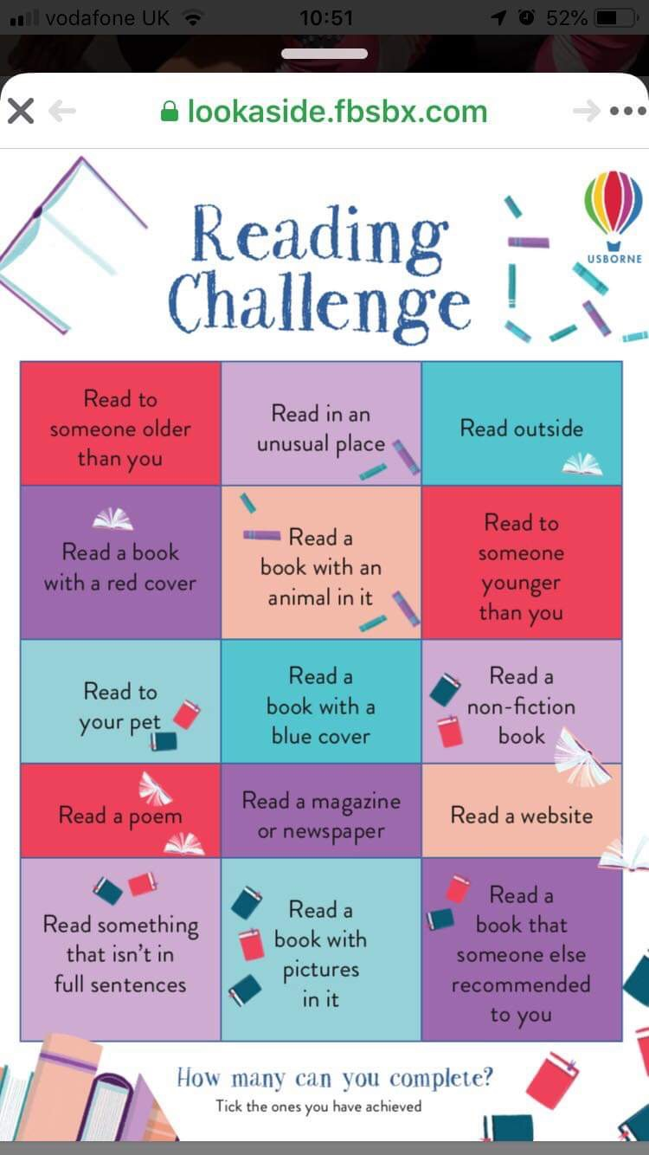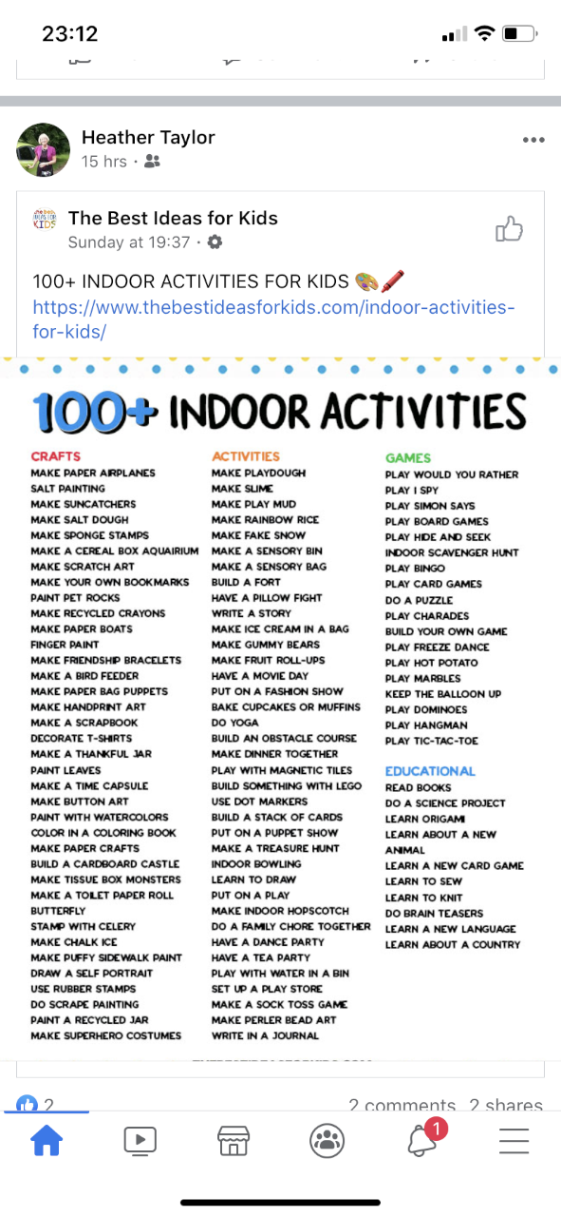

|  |  |  |  |  |
| --- | --- | --- | --- | --- |
| [Image result for household chore](https://www.google.co.uk/imgres?imgurl=https%3A%2F%2Fclip.cookdiary.net%2Fsites%2Fdefault%2Ffiles%2Fwallpaper%2Fpioneer-clipart%2F191129%2Fpioneer-clipart-household-chore-191129-6440041.jpg&imgrefurl=https%3A%2F%2Fclip.cookdiary.net%2Fwallpaper-7342322&tbnid=ooGTtdxImo528M&vet=12ahUKEwi5uNyU3qPoAhUt5IUKHSyVAS4QMyg7egUIARCGAQ..i&docid=7eEo5Wlq8ddcuM&w=1350&h=1941&q=household%20chore&hl=en-GB&safe=vss&ved=2ahUKEwi5uNyU3qPoAhUt5IUKHSyVAS4QMyg7egUIARCGAQ)[Image result for household chore](https://www.google.co.uk/imgres?imgurl=https%3A%2F%2Fwebstockreview.net%2Fimages%2Fchores-clipart.png&imgrefurl=https%3A%2F%2Fwebstockreview.net%2Fexplore%2Fchores-clipart%2F&tbnid=NYblbxzPbOChxM&vet=12ahUKEwi5uNyU3qPoAhUt5IUKHSyVAS4QMygZegQIARA8..i&docid=-iLl7IRCLGe26M&w=694&h=675&q=household%20chore&hl=en-GB&safe=vss&ved=2ahUKEwi5uNyU3qPoAhUt5IUKHSyVAS4QMygZegQIARA8)Help Around The House BINGO! | | | | |
| B | I | N | G | O |
| adult’s choice | make bed | hang up towel | washing up | help cook dinner |
| sweep the path | clean the door handles | water the plants | dust bedroom | tidy away toys |
| hoover | clean room | FREE SPACE | take out the bins | dry the dishes |
| feed pets | set the table | tidy garden | make your own lunch | get or post the mail |
| replace toilet roll when empty ☺ | fold clothes | get up and ready without a fuss | make bed | adult’s choice |

Complete a personal project on one (or more) of the following topics

|  |  |
| --- | --- |
| CASTLES | EMERGENCY SERVICES |
| FARMING | A SCOTTISH ARTIST |
| OCEANS | A SCOTTISH KING OR QUEEN |
| LIGHTHOUSES | EGYPTIANS/ROMANS |
| CONSERVATION | THE HUMAN BODY |

Active Spelling Activities

|  |  |  |  |  |  |  |  |  |  |  |
| --- | --- | --- | --- | --- | --- | --- | --- | --- | --- | --- |
| Noughts & Crosses   |  |  |  | | --- | --- | --- | | noughts | crosses | crosses | | crosses | naughts | crosses | | crosses | naughts | naughts |   Play with a partner. You each choose a spelling word and use this to play noughts and crosses. | Backwards Words  Write your spelling words forwards and then backwards. Write neatly!  Example: where erehw |
| *ABC Order*  First write your spelling words in a list. Then write them in ABC order. To finish, write your  words in reverse ABC order! | Fancy Letters  Fancy Letters  **Write each of your spelling**  **words using fancy letters.**  Your letters can have curly-q’s  or dots, for example. Have fun! |
| Across and Down  Write each of your spelling words across and then down  (starting with the first letter).  *Examples- w h e n f o u r  h o  e u  n r | Bubble Letters  **Write your spelling words in bubble letters**.  After you write your words in bubble letters, colour your words with a crayon or coloured pencil. |
| Other Handed  First write your spelling words the way you usually do it. Then, try writing the list with your other hand! | Acrostic Poem  Choose 5 of your spelling words. Write an acrostic poem for those words. Example: fly  Fun in the sky.  Laps around clouds.  Yelping with glee. |

|  |
| --- |
| COMPLETE THE LEGO CHALLENGES |

**Websites and Free Subscriptions to access Learning Resources**

*Early Level – P1, First Level – P2-4, Second Level – P5-7*

**All Areas**

* <https://childmind.org/coping-during-covid-19-resources-for-parents/>
* Learning at Home <http://bit.ly/38SS37q>
* Topmarks <https://www.topmarks.co.uk/> (Educational Online Games)
* The Muddy Puddle Teacher <https://themuddypuddleteacher.co.uk/> (Outdoor Learning)
* Twinkl (1 month free subscription - printable worksheets/ PowerPoints) https://www.twinkl.co.uk/
* TED Ed <https://ed.ted.com/lessons>
* Toy Theater  <https://toytheater.com/>  (Educational Online Games)

**Literacy & Language**

* Oxford Owl <https://www.oxfordowl.co.uk/for-home/>
* BritishCouncil https://www.teachingenglish.org.uk/resources/primary
* BBC <https://www.bbc.co.uk/bitesize/primary>

(Click on your child’s stage Early-P1, First P2-4 and Second P5-7)

* Phonics Play <https://www.phonicsplay.co.uk/>  (Sounds and word blending)
* Duolingo <https://www.duolingo.com/welcome> (Languages)
* BBC Learning <http://www.bbc.co.uk/schools/websites/4_11/site/literacy.shtml>
* Oxford Owl Literacy and Numeracy

<https://www.oxfordowl.co.uk/welcome-back/for-home/reading-owl/kids-activities>

* <https://www.lovereading4kids.co.uk/kids-zone/>
* <https://www.doorwayonline.org.uk/literacy/>
* https://www.scottishbooktrust.com/50-word-fiction
* <https://www.roythezebra.com/>
* <http://www.letters-and-sounds.com/>
* <https://www.getepic.com/>

**Maths & Numeracy**

* SumDog  <https://www.sumdog.com/user/sign_in>
* BBC  <https://www.bbc.co.uk/bitesize/primary>

(Click on your child’s stage Early-P1, First P2-4 and Second P5-7)

Top Marks <https://www.topmarks.co.uk/>

Digital Maths Worksheets <https://www.math-aids.com/>

* <https://www.countonus.org.uk/resources/>
* <https://www.doorwayonline.org.uk/number/>
* <https://pages.sumdog.com/>
* <http://www.snappymaths.com/>
* <http://www.maths-games.org/>
* <https://www.mathsweek.scot/activities>
* <https://www.khanacademy.org/>
* <https://nrich.maths.org/>

**Health & Wellbeing**

* <https://www.twinkl.co.uk/resource/nz-pe-20-fitness-bingo>
* Go Noodle <https://www.gonoodle.com/>
* Cosmic Yoga <https://www.cosmickids.com/>
* <https://www.thinkuknow.co.uk/>
* <https://roadsafety.scot/learning/>
* <https://www.foodafactoflife.org.uk/>
* https://lifeliveit.redcross.org.uk

**Science/Outdoor Learning**

* National Geographic Kids <https://kids.nationalgeographic.com/>
* Mystery Science <https://mysteryscience.com/>
* The kids should see this <https://thekidshouldseethis.com/>
* Crash course kids  <https://www.youtube.com/user/crashcoursekids>  (Science videos)
* Paw Print https://www.pawprintbadges.co.uk/challenge-packs-6-c.asp Challenge Packs
* Nature Detectives <https://naturedetectives.woodlandtrust.org.uk/naturedetectives/>
* <https://wowscience.co.uk/>
* <http://www.bbc.co.uk/schools/websites/4_11/site/science.shtml>
* <https://www.tigtagworld.co.uk/mindmap/#/modules/>

**Project Based Learning**

* DK Find Out <https://www.dkfindout.com/uk/>
* Scholastic Learn at Home <https://classroommagazines.scholastic.com/support/learnathome.html>

(20 days of projects for reading, thinking and growing- broken down in to stages)

**Computing and Coding**

* SCRATCH  https://scratch.mit.edu/
* Blockly <https://blockly.games/>
* Be Internet Legends –
* E-Safety and Digital Games <https://beinternetlegends.withgoogle.com/en_uk/interland>

**Touch Typing**

* <https://www.speedtypingonline.com/games/type-the-alphabet.php>
* <http://bigbrownbear.co.uk/learntotype/>
* <https://www.bbc.co.uk/bitesize/topics/zf2f9j6/articles/z3c6tfr>

**Arts & Crafts**

* Red Ted Art <https://www.redtedart.com/>
* The Imagination Tree <https://theimaginationtree.com/stay-at-home-survival-guide/>
* (Various play based activities- daily break down of activities and resources)
* The Artful Parent <https://artfulparent.com/>
* <http://wildfreeandcrafty.com/2020/03/15/free-online-art-lessons-for-kids/>
* <https://artprojectsforkids.org/>
* <https://kidsartuk.com/>
* <http://www.deepspacesparkle.com>
* <http://www.paintedpaperart.com>

**YouTube Channels for Home Learning**

Literacy

* [The Alphablocks](https://www.youtube.com/channel/UC_qs3c0ehDvZkbiEbOj6Drg) are living letters who appear in wonderful videos to help your children learn about phonics and develop their reading skills.
* [KidsTV123](https://www.youtube.com/playlist?list=PL1F93C67B4CA81D04) has a large playlist of phonics videos that children can watch.
* [Fairy Tales and Stories for Kids](https://www.youtube.com/channel/UCOPzf8kf-FUDs32E7F2wGdg) has lots of animated stories to enjoy. Can your children retell the story to you after they have watched one of the videos?
* BBC Teach has [a playlist of English videos](https://www.youtube.com/playlist?list=PLcvEcrsF_9zLFRmY3lcxn9-dzOjTwdohq) to teach your children about punctuation and stories. It also includes ideas for writing, songs and more.
* CBeebies have [a playlist of their Bedtime Stories](https://www.youtube.com/playlist?list=PLoOc9M0VgduON_PbVYOlgjeLPyN_0VHlk), in which people read popular children’s books. Why not record your own version on a mobile device?
* [Watch this collection of book trailers](https://www.youtube.com/playlist?list=PL0A3EC21903A84659) from Scholastic. Could you make a trailer for one of your favourite books?

Maths

* [The Numberblocks channel](https://www.youtube.com/channel/UCPlwvN0w4qFSP1FllALB92w) has lots of great videos to help younger children learn about numbers, addition and subtraction.
* [The Numberjacks](https://www.youtube.com/channel/UCWKuiktSh-V3E4ysPU0VC3Q) are a group of superhero numbers who appear in educational videos that cover thinking skills, problem solving and maths.
* [The Singing Walrus](https://www.youtube.com/playlist?list=PLt7Se3SAnZY7l09Oc51Lau2SFsqfDkEuM) has lots of songs to teach children about numbers and counting.
* [Hopscotch](https://www.youtube.com/playlist?list=PLQ9tM66CfklyxJqDujIZZjJOkqfHaISKo) has songs to help your children with counting.
* Mr DeMaio creates fantastic educational videos, including [this playlist of songs](https://www.youtube.com/watch?v=9XzfQUXqiYY&list=PLb7Q5jsm9eh_fdDPQmVpyp4XRu-raUbHc) to help your children learn their multiplication tables.
* Laugh Along and Learn also have [a collection of Times Tables songs](https://www.youtube.com/playlist?list=PLaSZ7kwwxKqWrWI-I0xs8ugp5fspBZjW7) that your children can sing!
* [This playlist from Happy Learning English](https://www.youtube.com/playlist?list=PLLF_mZmNqOn267GdMHTbPTI6rG6GCQnEY) has some times tables songs, as well as videos about shapes and measurements.
* [Math & Learning Videos 4 Kids](https://www.youtube.com/user/CommonCore4Kids) have a wide range of videos about different maths topics.
* [This playlist from BBC Teach](https://www.youtube.com/playlist?list=PLcvEcrsF_9zJHmkbzAFRFZuEypPhcj8Ov) explores how maths is used in different areas of life and work. It also includes videos about number, measure and shape concepts.

Science

* [Happy Learning English](https://www.youtube.com/playlist?list=PLLF_mZmNqOn25pLFQkhJBl6gxHeKyB0Mo) has a large collection of videos about humans, animals and plants.
* [Learn about amazing animals](https://www.youtube.com/playlist?list=PLQlnTldJs0ZQNDwnQlIStNF9LwoSAM7aF) with this playlist from National Geographic Kids.
* Hopscotch produce many educational videos. [This playlist](https://www.youtube.com/playlist?list=PLQ9tM66Cfklw6R_oGIE0BkGndyQWWPuwM) has songs about habitats, the continents, oceans and planets.
* [Operation Ouch](https://www.youtube.com/channel/UCQJDFI9j8UeNoqra37p5OkA/featured) produce educational videos about the human body.
* [Homeschool Pop](https://www.youtube.com/playlist?list=PLNmq_T1B9ljIWyhaewUc8-3oivWLwSTcL) has put together a collection of videos that cover a wide range of Science topics.
* [SciShow Kids](https://www.youtube.com/user/scishowkids) has a wide range of Science videos that answer different questions about the world.
* [Science Max](https://www.youtube.com/channel/UCbprhISv-0ReKPPyhf7-Dtw/featured) carries out huge science experiments. Could your children try similar experiments, but on a smaller scale, at home?

Geography

* Learn about the continents around the world [with this playlist](https://www.youtube.com/playlist?list=PLQlnTldJs0ZTpajSmiZIgrXCy9lgTOlnO) from National Geographic Kids.
* [BBC Teach](https://www.youtube.com/playlist?list=PLcvEcrsF_9zKxYSbFe_DMWK_VO2phjBjL) has a playlist that can help your primary children to learn about different geographical concepts.
* [This playlist from Kids Learning Tube](https://www.youtube.com/playlist?list=PLmIHwWY0hiuyj_aLDh-2kBnF4aiUGFVZh) is full of videos to teach your children about countries around the world.

History

* [The Horrible Histories channel](https://www.youtube.com/channel/UCUNYSwNARexFwxXp3oPAtvg) has some funny videos and entertaining songs that children can use to learn about different periods from history.
* [This playlist from Happy Learning English](https://www.youtube.com/playlist?list=PLLF_mZmNqOn2xlFdMBzINK94XHExu-Y9M) has some animated history videos.
* [Clarendon Learning](https://www.youtube.com/playlist?list=PLyqf1JCzOf_lebjpcvYeBOEa8WXej7Kpt) has a large playlist of history videos for children.

Art

* [Art for Kids Hub](https://www.youtube.com/user/ArtforKidsHub) has an enormous range of ‘How to Draw’ videos and art / craft ideas.
* [5-Minute Crafts Play](https://www.youtube.com/channel/UC57XAjJ04TY8gNxOWf-Sy0Q) shares craft ideas, experiments and tricks that you can try together.
* Disney Junior also has a playlist of videos [from their Art Attack series](https://www.youtube.com/playlist?list=PL10E32CC356CF96F2).
* [Easy Kids Craft](https://www.youtube.com/channel/UCEG2kLhJoFJD1dxVR8-h7HA) has lots of enjoyable craft activities that you can complete.
* [Free School](https://www.youtube.com/playlist?list=PLXB5R79dmFB6HpWbgpF8-3aXPqVb_rbj5) has a playlist of videos that can teach your children about famous artists from history.

Music

* [RelaxDaily](https://www.youtube.com/user/relaxdaily/featured) has an extensive collection of calming music that your children can play as part of mindfulness activities, or when they are working on other educational tasks.
* [Kidz Bop](https://www.youtube.com/user/KidzBopKids) produce child-friendly versions of popular songs. Can your children learn some of the lyrics or dance along with the moves shown in the videos?
* [Classical Kids Storytime](https://www.youtube.com/playlist?list=PLKE-6SvGvUrLx9BDg02qj7QqBmGQTzetF) features children’s stories that are accompanied by classical music.
* Free School has playlists to teach your children about [Beethoven](https://www.youtube.com/playlist?list=PLXB5R79dmFB7sABLwJNEAva7oGBHndbce) and [Mozart](https://www.youtube.com/playlist?list=PLXB5R79dmFB7eXBozzRUtxQmsJjqCX4Kb).

PE

* The Body Coach has [a great playlist of ‘5 Minute Move’ videos](https://www.youtube.com/playlist?list=PLyCLoPd4VxBuxu3sLztrvWFehzv-LnR2c). These provide short workouts to get your kids moving!
* [Little Sports](https://www.youtube.com/channel/UCTIwFB4ciFi5ZCIu-VlwaOg/featured) has videos featuring a variety of exercises to help your children stay active at home.
* [GoNoodle](https://www.youtube.com/playlist?list=PLAwOTEJXH-cPrrCO1gNivWbklks_Bkiqw) has videos that teach your children different dance workouts.
* Try different yoga and mindfulness activities with [these videos from Cosmic Kids Yoga](https://www.youtube.com/user/CosmicKidsYoga).
* [Footy Pups](https://www.youtube.com/channel/UCPEU0-Q1XvF4khh6aC2JSmA/featured) shares videos to get younger children interested in exercise and to learn different football skills.

More

* National Geographic Kids have a playlist of videos that [teach children how different things work](https://www.youtube.com/playlist?list=PLQlnTldJs0ZR-L-KtbBtm1WgPjmxiDuWi).
* TheLearningStation has [a playlist of songs to use as Brain Breaks](https://www.youtube.com/playlist?list=PLh-1JU15_Ti6lupVpfIrLNKb8Pef-jabS), when your children need a refresh and recharge before they continue their learning.
* [Messy Hands](https://www.youtube.com/channel/UCUEd_B2TkfmpCg_6-H0dHZA/featured) has a selection of easy recipes and cooking videos to try with your children.
* Discuss what is happening around the world by watching [this playlist of videos](https://www.youtube.com/playlist?list=PLk2uTpq_0-GWHwJD7HDIG5WYr3R1z8hyM) from CBBC’s Newsround programme.
* Homeschool Pop has [a playlist of timers](https://www.youtube.com/playlist?list=PLNmq_T1B9ljINeZSozXZm23M_3FG2Kz2W) to use when you would like children to complete a task within a set amount of time!
* [Mike’s Home ESL](https://www.youtube.com/user/misteurflo) has plenty of games, teaching tips, songs and warm-up activities that you can use with your children!
* [Teachers Hub](https://www.youtube.com/channel/UCxsd-g3cleTVHRqTy9rnBZQ) also has a variety of games and songs that you can try together.

**Numeracy and Mathematics**

Listed below are areas of work pupils have completed in the last academic year. However, concepts often get forgotten so don’t be alarmed if your child is finding it a bit tricky. This is a very approximate guide for P2, P3 and P4 pupils. At school, we do not label any work as being specifically for P2/P3/P4. We prepare work for pupils which should stretch their learning. On this document we have labelled areas as P2, P3 and P4 only to give parents and carers a guide. If your child needs more supportive learning please do that. For example, if they are in P4 but finding that part too challenging, take them back a little before working forward again. If the work is too challenging they will not learn and potentially become more resistant to future learning. We also encourage pupils to do sums in the way they feel best. We then find it helpful to share different ways of doing sum with each other to learn different ways. We encourage accuracy and pace.

|  |  |  |  |  |
| --- | --- | --- | --- | --- |
| **Area** | **P2 (approx)** | **P3 (approx)** | **P4 (approx)** | **Suggestions and ideas** |
| Place Value | Hundreds, Tens and Ones | Hundreds | Thousands | * Read out figures * Write down figures |
| Addition/  subtraction | 1 digit to 2 digit  2 digit to 2 digit no carrying/carrying (addition only)  Number bonds to 10/20  Doubling and halving numbers | I digit to 3 digit numbers  No carrying/ carrying  Number bonds to 10/20  Doubling and halving numbers | 1 digit to 4 digit numbers  No carrying/carrying  Number bonds to 10/20  Doubling and halving numbers | * Pupils can use materials to support * Add/subtract numbers (e.g. dice, house number, telephone numbers) * Online games (e.g. Hit the Button) |
| Multiplication | Beginning to have an awareness - Counting in 2s,5s and 10s | 1 digit x 1 digit  X tables practise (2, 3, 4, 5 and 10 x tables)  1 digit x 2 digit through chimney sums. | Practise times tables (2, 3, 4, 5, 10)  1 digit x 1 digit.  1 digit x 2 digit | * Lego is a good way to practise multiplication * Multiplication is used across most areas of numeracy. Practise recall of 1 -10 times tables. * Skip counting * Online games (e.g. Hit the Button) |
| Division | Linked to fractions of amounts – sharing an amount equally between 2 or 4 | Sharing equal amounts  Linking x tables facts with division facts e.g. 2 x 4 = 8 so 8 divided by 4 = 2. | Sharing equal amounts  2 digit by 1 digit | * Sharing items equally. * Use the term sharing as this makes it easier. * A variety of ways to do these sums. |
| Length | Estimate and measure length in metres  Comparison of length | Measure in cm | Measure in cm  Measure in m | * Measure objects in the house. * Cut a length of string/wool/etc the length of a metre. * Arranging items according to length |
| Weight | Estimate and measure weight in kgs  Comparison of weight | Due to be covered in term 4 | Due to be covered in term 4 | * Weigh objects in the house. * Baking/cooking * Looking at weights on food packaging |
| Volume/capacity | Due to be covered in term 4 | Due to be covered in term 4 | Due to be covered in term 4 | * Water play with different containers * Look at packaging * Baking/cooking |
| Fractions | Fractions of shapes  Fractions of amounts  Halves, quarters  Using concrete materials to find a fraction of an amount | Fractions of a shape.  Fractions of an amount  Halves, quarters, fifths  tenths  Simple equivalent fractions. | Fractions of a shape  Fractions of amounts  Halves, quarters, fifths  tenths  Simple equivalent fractions. | * Baking/cooking * Fractions of money * Sales online * Pizza * Cake |
| Angles and symmetry | Due to be covered in Term 4 | Recognise right, obtuse, acute angles  Identify and create symmetrical patterns. | Recognise right, obtuse, acute angles  Identify symmetrical patterns  Complete number sequences | * Identify symmetry in your environment – go on a symmetry hunt in the garden/ house. |
| Area | N/A | Due to be covered in term 4. | Measure rectangles and squares  Multiply length x breadth | * Measure carpet/table space * Measure garden space |
| Money | Just starting  Coin recognition  Writing amounts of money  Making a value of an amount in different ways with coins.  Calculating the total of two items | Recognises all notes and coins to £50  Make values in different ways using notes and coins.  Calculate the total of two items to £1  Convert pence to pounds and pence. | Due to be covered in term 4 by P4W | * Make up price lists for items of food in the house. * Role play at shops with real money |
| Information  Handling | Due to be covered in term 4 | Carry out a simple survey.  Record the results using tally marks.  Present and organise data using pictograms, bar charts, Carroll and Venn diagrams.  Read information from pictograms, bar charts, Carroll and Venn diagrams. | Due to be covered in term 4 by P4W | * Surveys of traffic out the window, the family’s favourite sweets etc, * Family votes on favourite movies/ foods/songs etc and create a tally/bar graph/questionnaire |
| Perimeter | Due to be covered in term 4 | Due to be covered in term 4. | Measure in cm of standard shapes | * Use with area * Measure length and breadth of garden, carpet, room, etc. |
| Time | Months and seasons of a year.  Using calendars – monthly, weekly etc  Am and pm  Sequence events in a day.  O’clock, half past, quarter past - analogue | Read simple timetables  Calendars  O’clock/ half past/ quarter past  Time events  Order months in relation to the Seasons of a year. | Half past/quarter to/ quarter past  5 minute intervals  Time events  Read simple timetables  Calendars | * Tell time with clocks in house * What time will dinner be ready? * Look at timetables/calendars – eg how many Mondays are in this month? * How many months/weeks till my birthday? * Create a weekly timetable |
| Coordinates | Due to be covered in term 4 | Plot points when given a coordinate. | Write coordinates of given points  Plot points when given a coordinate | * Battleships * Treasure maps |
| Shape 2D / 3D | Name a range of different 2D and 3D shapes.  Identify different features of 2D and 3D shapes – 2D - corners and sides  3D - faces, edges, vertices  Tessellation | Name a range of different 2D and 3D shapes.  Identify number of faces, edges, vertices  Tessellation | Name a range of different 2D and 3D shapes.  Identify number of faces, edges, vertices | * Identify shapes in house * Everyday objects – tins, food boxes etc * Discuss the differences in shapes * Create art using different shapes and explore which shapes fit together. |
| Patterns and relationships | Patterns using colour, shape, size and numbers  Odd and even numbers  Fact families | Patterns using colour, shape, size and numbers  Fact families | Patterns using colour, shape, size and numbers  Fact families  ` | * Looking for patterns in the environment * Relationships between addition/subtraction facts |
| Word based problems | Pupils should tackle relevant questions that are in a word format. | | | * Primaryresources.co.uk |

You could use whiteboard or scrap paper to do any sums.

Pupils can use materials to support, if required.

Try to discuss jobs that these skills/knowledge would be used in.

You could use a calculator to check answers to bigger sums, when completed.