LI: We are learning to use symmetry in art.

LC: Our Names.

SC: I can identify the line of symmetry.

I can follow the instructions.

I can colour my name following the line of symmetry.

* Fold paper in half – landscape.
* Place folded edge nearest you on the table. This will be the bottom of your paper.
* Write your name in bubble writing, filling the page (as best you can).
* Make sure that your letters touch the bottom of your paper so that there is paper connecting once you cut out your letters.
* Keeping your paper folded, cut around your name VERY CAREFULLY and NEATLY!
* An adult may cut out any inserts for you using an art knife.
* Colour your names with a horizontal line of symmetry (at the bottom of your letters).

**Some examples…**

[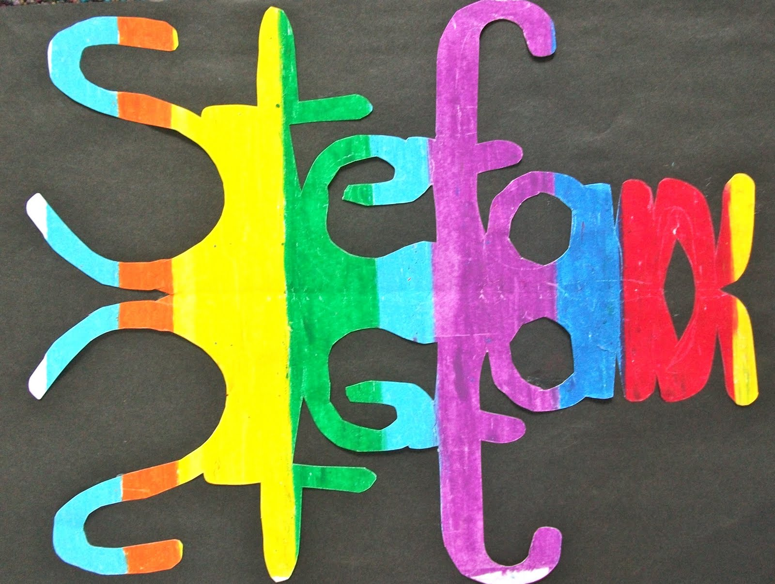](http://www.google.co.uk/url?sa=i&rct=j&q=&esrc=s&source=images&cd=&cad=rja&uact=8&ved=2ahUKEwiH3Oag2ergAhUvDGMBHfuZDrYQjRx6BAgBEAU&url=http://debhstfrancis.blogspot.com/2011/02/art-using-reflection-and-symmetry.html&psig=AOvVaw3s_0BRymDQwWJUkbCx7MoV&ust=1551864805657101)

**[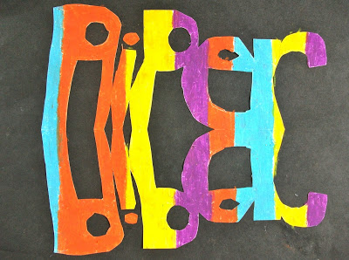](http://2.bp.blogspot.com/_TNByLD0Jpac/TVDTIjeludI/AAAAAAAAAW0/H7YKxqCN_24/s1600/DSCF1333.JPG)**

**[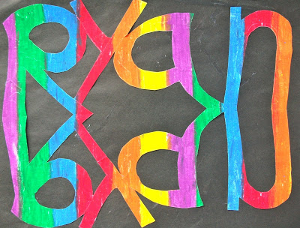](http://4.bp.blogspot.com/_TNByLD0Jpac/TVDTHyDelQI/AAAAAAAAAWk/mnVjxC28RlM/s1600/DSCF1331.JPG)**

**[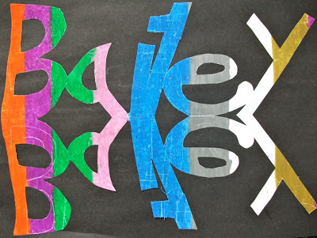](http://1.bp.blogspot.com/_TNByLD0Jpac/TVDTHguQ3ZI/AAAAAAAAAWc/i-5A4KcnQCk/s1600/DSCF1330.JPG)**