DYW – 2019/202

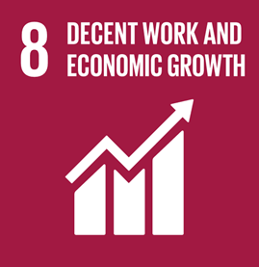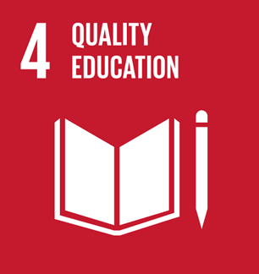

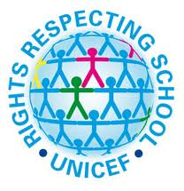

Article 29 (goals of education)

Education must develop every child’s personality, talents and abilities to the

full. It must encourage the child’s respect for human rights, as well as respect for their parents, their own and other cultures, and the environment.

To learn about this Article/Goal, we have been: