Article of the month:

January 2020

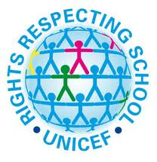

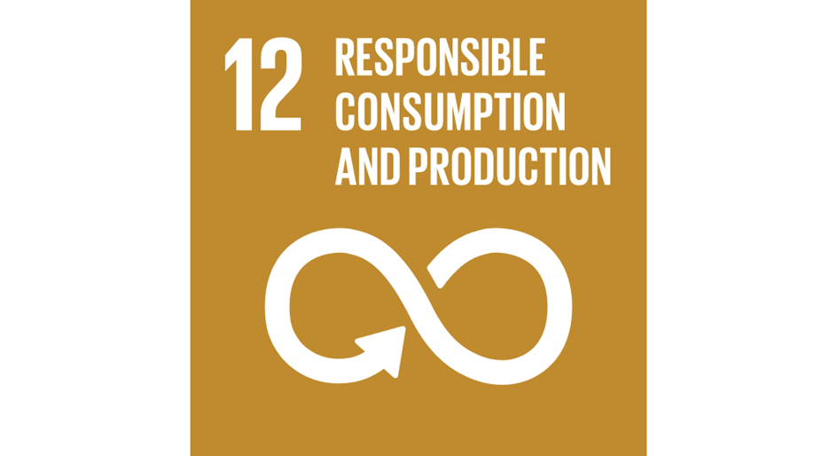

Article 12 (respect for the views of the child)

Every child has the right to express their views, feelings and wishes in all matters affecting them, and to have their views considered and taken seriously. This right applies at all times, for example during immigration proceedings, housing decisions or the child’s day-to-day home life.

To learn about this Article/Goal, we have been: