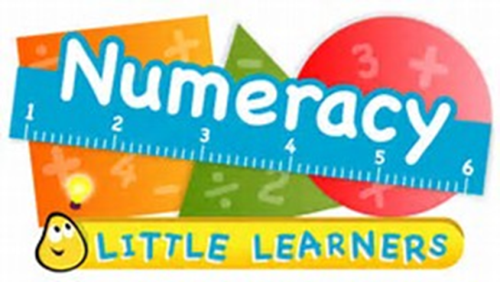
P2 - Numeracy Home learning

September
Activity Card 1  Place Value  Doubles to 10 | Activity Card 2  Basic facts  5 Plus | Activity Card 3  Basic facts  Pairs to 10
Activity Card 4  Basic Facts  Subtraction Facts to 10 | Activity Card 5  Basic Facts  Snap | Task 6  Place Value  Make teen numbers with the cards
Play a board game  Monopoly, snakes and ladders, etc | Flashcards  Use the cards to do quick recall, add numbers (2, 5, 10) on/away from the card being held up | Your choice!  Let me know what you create please as I’m looking for lots of ideas
Resources
You will need a set of playing cards and a dice to carry out the above games.
PLEASE see our class blog for ideas for number activities!
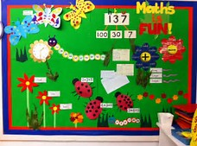
The listed activities will help further reinforce practical activities being taught in class. Please support your child in selecting and carrying out these tasks. Have fun!

Supporting Numeracy at Home using Technology

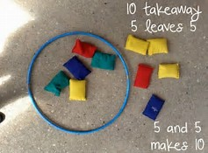
Websites

Number Jacks - Cbeebies number stories on YouTube
http://www.topmarks.co.uk/maths-games/
http://www.mrcrammond.com/
https://nrich.maths.org/primary
https://www.khanacademy.org

