**Numeracy**

Parent Information Booklet

Alves Primary School

2018

ALVES PRIMARY SCHOOL



ALVES IS ACE!

**A**mbition **C**onfidence **E**mpathy

The aim of this booklet is to help parents understand and use numeracy accurately and confidently while supporting with number work out of school.

Contents

Number Knowledge 3

Number Identification 3

Number Word Sequences and Order FNWS/ BNWS 3

Grouping and Place Value 3

Basic Number Facts 4

A note about recording thinking and the written method 4

Number Strategies 6

Commutative Law 6

Skip counting in 2’s, 5’s & 10’s 6

Partitioning & Recombining 6

Make 10 to add 9/compensation 6

Stages of counting 7

Emergent 7

One-to-One Counting 7

Counting from One on Materials 7

Counting from One by imaging 8

Advance Counting (Counting On) 8

Supporting Numeracy at Home using Technology 8

Websites 8

Definitions 9

P1 - Numeracy Home learning 12

September 12

Bibliography 12

# Number Knowledge

Knowledge describes what we want children to be able to recall without having to think about it. Examples of number knowledge:

## Number Identification

* Understand ordinal names from first to tenth, etc
* Read numeral sequences to at least ten.
* Sequence numeral forwards and backwards altering the start number.
* represent numbers using numerals, words, symbols, object, etc
* Recognise numbers and say number surrounding that number.
* Identify missing numbers in a sequence.

## Number Word Sequences and Order FNWS/ BNWS

* Recite number word sequences forward & backwards to 10, 20, 50, 100, etc.
* Build an awareness of the numbers just before and just after given numbers Can be done in 1’s, 10’s, 100’s, etc
* Recite numbers sequences fowards and backwards by ones, tens, hundred, etc. Start and stop at a range of numbers.
* Count the number of jumps forward and backwards from one number to another. For example How many jumps from 23 to 37.
* Say the next 2, 3, 4 numbers in a number word sequence.

## Grouping and Place Value

* Be able to see at a glance how many there are in small collections and add number names to this visual representation.
* Count and copy clapping sequences (up to 5 claps).
* 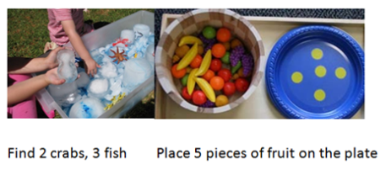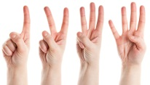Use finger patterns to represent number values. Represent finger patterns in different ways. How many ways can they make 3, 4, 5, 8, etc on their fingers. Try to do this without looking at fingers.
* Use a wide range of collections to make small sets
* Combine more than 2 visual patterns.

## Basic Number Facts

* [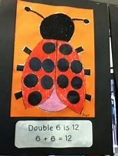](https://www.bing.com/images/search?view=detailV2&ccid=49qkhzbf&id=80DCA12649568D9194FF3F58CEB790A488E470FB&thid=OIP.49qkhzbfMhDtpr4pHYkXzAAAAA&mediaurl=https://lh5.googleusercontent.com/--W7SrLmQr6c/T8_N5uAnwlI/AAAAAAAAALk/4GJ-o_PQoKw/s640/blogger-image-161546974.jpg&exph=480&expw=360&q=ladybug+basic+facts+to+5&simid=608003973939989926&selectedIndex=31&adlt=strict)Count a range of items into a different sized sets. Know that the last number counted tells the size of the set. The number in a set stays the same unless items are taken away or added.
* Recall addition facts to 5, 10, 20.
* Recall subtraction facts to 5, 10, 20.
* Recall double facts to 10, etc
* Recall halves to 10, etc
* Recall multiples of ten facts that add to 100.

## A note about recording thinking and the written method

Linking children’s thinking to written recording helps children become LITERATE in numeracy.

* Written recording is a tool that helps a child think, communicate and reflect.
* From the earliest stage we can help children build meaning through recording their ideas in pictures, diagrams, words, and symbols.
* Encourage children to make pictures and jottings as a way to share their mental processes with you and each other.
* First we can record FOR children and talk through their thinking with them - then they can move on to recording for themselves.
* Talking about number sentences and linking this to verbal problems helps children develop an understanding of reading and writing in numeracy.
* Discussing symbols and their meaning and reading number sentences together helps children develop the vocabulary they need in numeracy.

Examples of pupils thinking, written down.

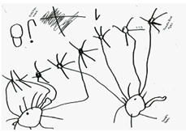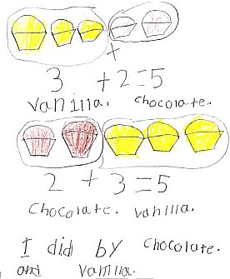

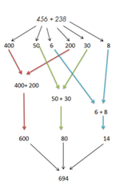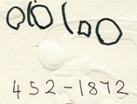

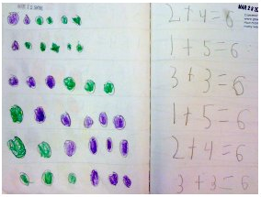

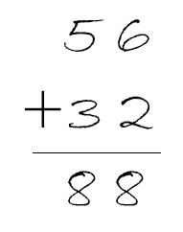**Children should not be exposed to standard written algorithms (sometimes known as chimney sums) until they can use part-whole mental strategies to solve number problems. If they are exposed to working forms too early, this restricts ability and motivation to use mental strategies and can inhibit their development of number sense. You might recognise this method from when you were at school.**

# Number Strategies

Strategy describes the mental processes children use to estimate and solve problems. Some examples of number strategies:

## Commutative LawCommutative Law

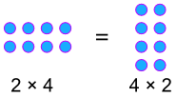The Law that says you can swap numbers around and still get the same answer when you add. 

Or when you multiply.

## Skip counting in 2’s, 5’s & 10’s

"Skip Counting" is counting by a number that is not 1

Example: We Skip Count by 2 like this: 2, 4, 6, 8, 10, 12, 14, 16, 18, 20, ...

Learning to "Skip Count" helps you:

* count many things quickly
* learn your multiplication tables

## Partitioning & Recombining

|  |  |  |  |  |  |  |  |  |
| --- | --- | --- | --- | --- | --- | --- | --- | --- |
| 349 | is made up of | |  |  |  | | --- | --- | --- | | hundreds | tens | ones | | 3 | 4 | 9 | |

**Partitioning**

Partitioning is when we break the number apart:

349  ⇒  300 + 40 + 9

**Recombining**

So 349 is **recombined** into 3 hundreds, 4 tens and 9 ones, in other words:

300 + 40 + 9  ⇒  349

## Make 10 to add 9/compensation

When a number is close to ten we can "borrow" from the other number so it reaches ten.

**Example: 9 + 7**

9 is only 1 away from 10

so take 1 from the 7: 9 + 1 + 6

and give it to the 9: 10 + 6 = 16

Think "9 plus 1 is 10 ... 7 less 1 is 6 ... together that is 16"

**Example: 8 + 5**

8+2=10, so let’s take 2 from the 5: 8 + 2 + 3

and give it to the 8: 10 + 3 = 13

# Stages of counting

These are strategies children generally progress through as they develop their understanding of counting.

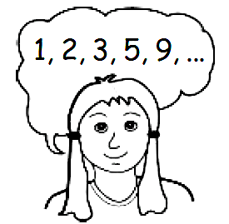

## Emergent

Pupils at this stage are unable to consistently count a given number of objects because they lack knowledge of counting sequences and/or the ability to match things in one-to-one correspondence.

## 

## One-to-One Counting

This stage is characterised by pupils who can count and form a set of objects up to ten but cannot solve simple problems that involve joining and separating sets, like 4+3=.

## Counting from One on Materials

Given a joining or separating of sets problem, pupils at this stage rely on counting physical materials, like their fingers. They count all the objects in both sets to find an answer, as in “Five lollies and three more lollies. How many lollies is that altogether?”.

## Counting from One by imaging

This stage is also characterised by pupils counting all the objects in simple joining and separating problems. Pupils at this stage are able to image visual patterns of the objects in their mind and count them.

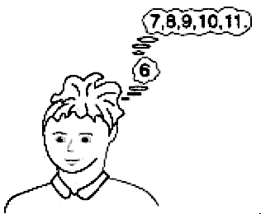

## Advance Counting (Counting On)

Pupils are at this stage understand that the end number in a counting sequence measures the whole set and can relate the addition or subtraction of objects to the forward and backward number sequences by ones, tens, etc. For example instead of counting all objects to solve 6+5, the pupil recognises that “6” represents all six objects and counts on from there: “7, 8, 9, 10, 11.”

# Supporting Numeracy at Home using Technology

## Websites

<http://www.topmarks.co.uk/maths-games/>

<http://www.mrcrammond.com/>

<https://nrich.maths.org/primary>

<https://www.khanacademy.org>

# Definitions

**Addition:** Finding the total value of two or more numbers. Denoted by the symbol +.

**Array:** A pictorial representation to help children understand multiplication and division. Typically shown as rows of dots, For example 2x3 can be show as

2 rows of 3 dots.

**Bridging through 10:** A mental method of adding two numbers to get a total greater than 10. Pupils are taught to count on to 10 and then add the remainder of the number onto the ten. For example 7+9 bridging from 7 requires 3, which leaves 6 (from the original 9) 10+6 =16.

**Calculation:** Working out the amount or number of something, usually by using one of the four operations. We read this from left to right.

**Commutative Law:** Addition and multiplication have the property of commutativity – when two numbers are added or multiplied, this can be done in any order and the same answer will be obtained. For example 3+2=5, 2+3=5 and 4X6=24, 6x4=24. Subtraction and division are not commutative.

**Concrete materials:** Learning tools which may support your child to visually understand and practically carry out a calculation. For examples numicon, tens frames, arrow cards, counters, cubes, etc.

**Digit:** A digit is a numerical symbol (1, 2, 3, 4, 5, 6, 7, 8, 9, 10). A number is made up of digits.

**Division:** the process of dividing a number into parts. It can also have a remainder if its not in equal parts (known as having a remainder). This is denoted by the symbol ÷.

**Estimate:** When a pupil uses their knowledge of number/quantities to make an educated/sensible guess when estimating.

**Even Numbers:** All numbers that are equally divisible by 2. Even numbers always end with a 0, 2, 4, 6 or 8.

**Finding the Difference:** This is a way of carrying out subtraction calculations by finding the numerical difference between two numbers. To solve the number sentence 47-34=? we would say find the difference between 34 and 47. This is taught using a number line to count on from the smaller number to the bigger number.

**Fraction:** A fraction is a number which represents part of a whole. It can be represented using a numerator and a denominator.

**Greater than ˃ and less than ˂:** Symbols used to show the relative size of numbers. The wide end of the symbol always faces the larger number 25˃14.

**Inverse Operations:** The calculation which is opposite to a given calculation. Addition is the inverse of subtraction and multiplication is the inverse of division. For the calculation 4+3=7 the inverse operation would be 7-4=3.

**Mental method:** Calculations and word problems carried out mentally with no need to write down any working out.

**Multiplication:** Finding how many altogether in a given number of equal sized groups. This is represented with the symbol x.

**Multiplication fact:** The answer to a multiplication calculation. For example 3x3=9 gives the multiplication fact 9.

**Number bonds:** Pairs of numbers that add up to a specific number. For example number bonds to 10 are 9+1=10, 5+5=10, 3+7=10 and so on. Children are taught these bonds early on as they help calculations skills and also show patterns that are repeated for other number bonds to 20 or 100.

**Number facts:** Basic addition, subtraction, multiplication and division facts that children should learn to recall instantly to support more complex and mental calculations.

**Number Line:** A visual representation of numbers along a horizontal line. Can start at zero or can represent a set of numbers from elsewhere in the number system. This is used to support counting, place value and calculation skills.

**Number sequence:** An arrangement of numbers and symbols. 3+4=7 is an addition number sentence, 7-3=4 is a subtraction number sentence, 3x5=15 is a multiplication number sentence and 15÷3=5 is a division number sentence.

**Number square:** A set of numbers written in a square format. Often used with numbers from 1-100. It teaches number sequences and patterns as well as basic addition and subtraction.

**Numicon:** A teaching aid consisting of plastic tiles with holes which represent the numbers 1-10 and can be used to teach place value, ordering and calculations.

**Odd Number:** All whole numbers which are not exactly divisible by 2. Odd numbers always end in 1, 3, 5, 7 or 9.

**One to one counting:** Accurately counting an object one at a time.

**Operation:** The four mathematical operations are **addition** (+), **subtraction** (-), **multiplication** (X) and **division** (**÷**).

**Ordering:** Putting numbers in the correct order according to size. Ascending order goes smallest to largest, descending from Largest to smallest. Ordering also involves using the **greater than** (˃), **less than** (˂) and **equals** (=) symbols.

**Ordinal Numbers:** Numbers which indicate order – 1st, 2nd, 3rd, 4th and so on.

**Partitioning:** Partitioning is to divide a number into the individual values of its digits. It helps children to understand the values of these digits. For example 782 can be partitioned into 700+80+2.

**Place Value:** The value of all the digits in a number. For example, in the number 627, the digit 6 is worth six **hundreds**, the digit 2 is worth two **tens** and the digit 7 is worth seven **ones**.

**Product:** The product of two numbers is the result achieved when they are multiplied together.

**Recombining:** This is the opposite of partitioning. Recombining is putting the original place value digits back together to make the original number. For example 400+30+8 recombined is 438.

**Rounding numbers:** Adjusting digits up or down to the nearest tens, hundreds, thousands number etc. This is done to make calculations easier.

**Sharing:** This is the terminology used to discuss early division. This is the very early stage of sharing items into equal groups.

**Subtraction:** Taking one number away from another number, finding the difference between the two. Denoted by the symbol -.

**Sum:** The result of adding two numbers together. Sum means to add only.

**Tally mark:** Tally marks are used to represent how many times (frequency) that a certain things e.g marks occur within a set of data. We use this for daily lunches, how many children at school today, likes/dislikes of a story, etc.

**Whole numbers:** A number which contains no fractions or parts of a whole number such as a decimal number.

**Word Problems:** A mathematical calculation in words. Pupils are taught to elicit key vocabulary, draw/make the problem, write it as a calculation and discuss strategies explored.

**Written Method:** This is a way of carrying out a calculation which is done on paper rather than entirely mentally.

# P1 - Numeracy Home learning

## September

|  |  |  |
| --- | --- | --- |
| **Number Word Sequences**  Recite forward number word sequences between  0-10 then 0-20 | **Number Word Sequences**  Recite backward number word sequences 10-0 then 20-0. | **Estimating**  Guessing quantities in a jar, box, etc before counting exact amounts. |
| **Grouping & Place Value**  Play dominoes, cards, fastest finger, tens frames games. | **Number Identification**  Flashcards – quick recall  Order numerals (altering start number) | **Basic facts**  Recall addition facts to 5 using five frames. |
| **Grouping & Place Value**  Subitise – match numerals and patterns using cards. | **Number Identification**  Number Line - identify 1 number before and numbers after a given number.  Lay numerals out and take one away – identify missing numeral | **Time**  Days of the week,  Months of the year &  Seasons song  (YouTube) |
| **Resources**  Number Line 0-10 & 0-20  Subitising Cards  Tens Frame packs  Five frame cards | | |

*PLEASE see our class blog for ideas for number activities!*

[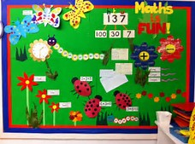](http://www.bing.com/images/search?view=detailV2&ccid=OSxku506&id=8B0917F86843159D4768FD58E75446D08C3E3608&q=numeracy+in+early+years&simid=608027122690821383&selectedIndex=29&adlt=strict)The listed activities will help further reinforce practical activities being taught in class. Please support your child in selecting and carrying out these tasks. Have fun!

# Bibliography

Kirsten Mackay *Highland Numeracy Blog* [online] 3rd September 2018 <https://highlandnumeracyblog.wordpress.com>

New Zealand Government *nzmaths .*[online] September 3rd 2018 <https://nzmaths.co.nz/>

Rod Pierce *Maths is fun* [online] September 3rd 2018 <https://www.mathsisfun.com>