**Emerging Literacy**

Early Years - Parent Information Booklet

Alves Primary School

2018

ALVES PRIMARY SCHOOL



ALVES IS ACE!

**A**mbition **C**onfidence **E**mpathy

**Definitions**

**Phoneme:** the smallest unit of sound that distinguishes one word from another. An example would be the ‘ssss’ sound in at the beginning of the word sit (not the letter name, but the sound).

**Grapheme:** this is the written form (the letter) of the phoneme (sound). For example, if you orally say ‘a’ sound at the beginning of ‘apple’ or ‘ant’ then you would write an ‘a’. The written letter is a grapheme.

**Diagraph:** two letters that represent one sound. For example the ‘sh’ sound in sh-o-p, shop.

**Trigraph:** three letters that represent one sound. For example the ‘igh’ sound in n-igh-t, night.

**Split Diagraph:** a split digraph is similar to a digraph (two letters that make one sound), however it is ‘split’ by a consonant. Example: the i-e sound in the word ‘smile’ or the a-e sound in the word cake.

**Segment:** is when you split a word up into its phonemes (sounds). This is when you ‘sound out a word’. For example c-a-t, t-a-n, b-u-s, p-o-t, etc.

**Blending:** is when you push the phonemes (sounds) together to make a word.

For example d-o-g blended d, do, dog.

**Syllables:** a unit of pronunciation having one vowel sound, with or without surrounding consonants, forming the whole or a part of a word; for example, there are two syllables in *water* and three in *inferno*.

**Alliteration:** the occurrence of the same letter or sound at the beginning of adjacent or closely connected words. For example big bouncy ball, etc.

**Rhyme:** is the correspondence of sound between words or the endings of words, especially when these are used at the ends of lines of poetry.

**Onset-rime:** The "onset" is the initial phonological unit of any word (e.g. c in cat) and the term "rime" refers to the string of letters that follow, usually a vowel and final consonants (e.g. at in cat). Not all words have onsets.

bag, sag, tag, gag or pan, tan, can, van

**Word Boundaries:** refers to the beginning of one word and the start of another. The children are encouraged to listen to oral sentences and identify how many words were spoken.

**Tricky Words:** Tricky words, often also called high frequency sight words, are commonly used words that young children are encouraged to remember as a whole by sight, so that they can automatically recognise these words in print without having to use any strategies to decode.

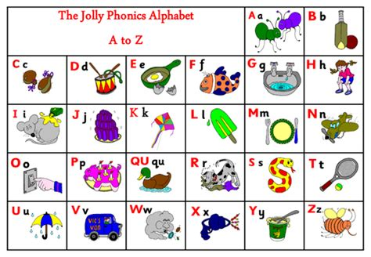

**Wordless Books - Support Guide**

**Reading wordless books with your child increases vocabulary and reading comprehension.**

Here are a few things you can do while engaging your child in wordless books;

*What do you see in this picture?

*What is happening to the main character?

*Who is in the story?

*where does this story take place?

*What is the weather, season, day?

*Is there anything unusual or familiar about the setting?

*What sorts of things do people do in a place like this? Setting may be a bank or hairdressers and discussions can develop from this.

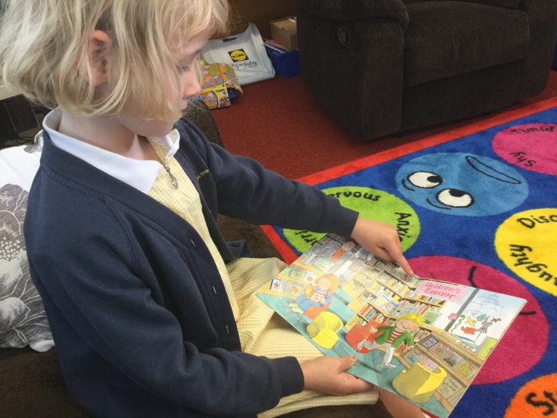*What do you think he, she, it wants?

*What is the character thinking?

*What is the character feeling? Why?

*What will happen next?

*What do you think should happen next?

*What is the character going to do next?

*What choices could the character make?

Your child will be given a parent guide booklet along with each Oxford Reading tree book they bring home. Instructions for each book will be included.

Questioning your child before, during and after reading promotes higher order thinking/reasoning about the texts they engage with.

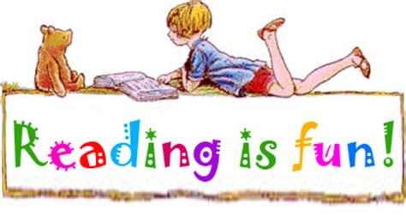**Supporting your child with their**

**Class Reading book**

**Things I can do to support my child during reading are……**

* Model how to read the story using a range of voices
* Read in tandem or my turn your turn
* Discuss vocabulary – alternative words salon, hairdressers, barbers, etc
* Discuss what happens in the story (beginning, middle, end)
* Question Master - Who are the main characters? Setting? Plot?
* Hunt for different types of punctuation used
* Identity letter sounds and matching names
* Segment words bed (b-e-d)
* Blend words c, ca, cat (cat)
* Identify beginning, middle & end sounds in CVC words
* Make up rhyme words
* How many words in the sentence? retell the sentence and use a fist punch to show full stop
* Break words into syllables
* Play I-Spy with tricky words
* write out the sentences and get your child to order them
* Show the action to sounds discussed in a text
* Write out a sentence and see if they can spot it in story

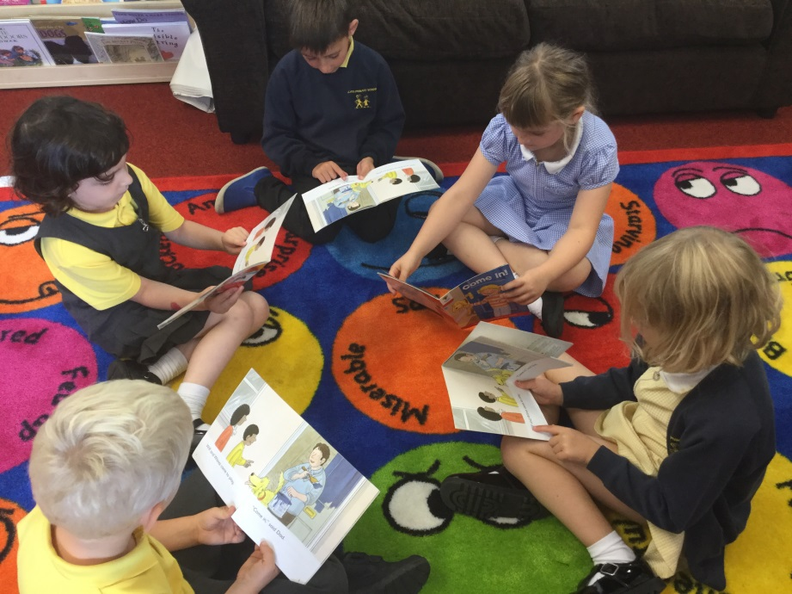

**Jolly Phonics**

Phonics refers to the process of teaching children how to read, through hearing/distinguishing sounds with our ears, splitting words into their sounds orally, teaching phonemes (sounds) and then linking these phonemes to their graphemes (the written letter).

Each phoneme/sound has a picture, song and action.

Your child will be taught 3 phonemes (sounds) per week. Please encourage your child to practise the sound and actions at home (including previous taught sounds to keep the learning bubbling!). The actions are on the reverse of the mini sound flashcards sent home. You can use the mini sound flashcards cards (given as and when taught) to encourage your child to recognise the sounds/actions taught in class. I will provide a large print of each sound with a phrase to support letter formation and these can be kept at home. I will send home 3 large letter formation cards including phrases each week. Your child will know the songs to each sound however these can be found on YouTube for your own information. Type - **Jolly phonics s song** into the YouTube search bar to get the correct song. Also, please take the time to discuss words beginning with these sounds, make up fun alliterations, create rhymes, etc. A bank of activity ideas is provided on the next page for you to explore at home.

**Sounds intended to be covered this term are:**

|  |  |  |
| --- | --- | --- |
| **Week 2**  20/8/18 - **s**  21/8/18 - **a**  22/8/18 - **t** | **Week 3**  27/8/18 -  **i**  28/8/18 - **p**  29/8/18 - **n** | **Week 4**  03/9/18 - **c/k**  04/9/18 - **e**  05/9/18 - **h** |
| **Week 5**  10/9/18 - **r**  1319/18 - **m**  12/9/18 - **d** | **Week 6**  17/9/18 - **g**  18/9/18 - **o**  19/9/18 -  **u** | **Week 7**  24/9/18 - **l**  25/9/18 - **f**  26/9/18 - **b** |

**Practical ideas to further your child’s learning of Phonics at home…**

**Term 1**

|  |  |  |
| --- | --- | --- |
| **Paint sounds with water onto dry slabs/pavements.** | **Think of five words starting with the sound of the day.** | **Paint/draw a picture and hide the letter sound you have learned inside it.** |
| **Type the sound on an iPad, phone, keyboard, etc.** | **Get a newspaper or magazine and highlight the sound every time you see it.** | **Draw as many things as you can that begin with the sound…..** |
| **Make the sound with pasta!** | **Write the letter sound in flour, salt, shaving foam, etc.** | **play sound connect four, twister, snap, etc** |
| **Trace the letter sound on someone’s back. Can they guess what it is? You have a turn of guessing too.** | **Do some rainbow writing. Use lots of different colours to practise your letter formation.** | **Form letters outside with stick and leaves.**  **Or**  **Draw in mud with stick** |

**Tricky Words**

'Tricky words' are those words that we cannot sound out 'phonetically'. They are also known as 'sight words'. We usually teach these words through lots of different games and the key is repetition! Noticing these words being used in the environment is very important. Your child will be introduced to 3 new words per week. These will be taught on a Friday and referred to as Super Power Words as the children will be using their super eyesight powers to learn/remember them.

Included is a list of tricky words which only need to be recognised and read by the children at this point. Please use the suggested activities to help support your child in **reading/noticing** **and remembering** these words.

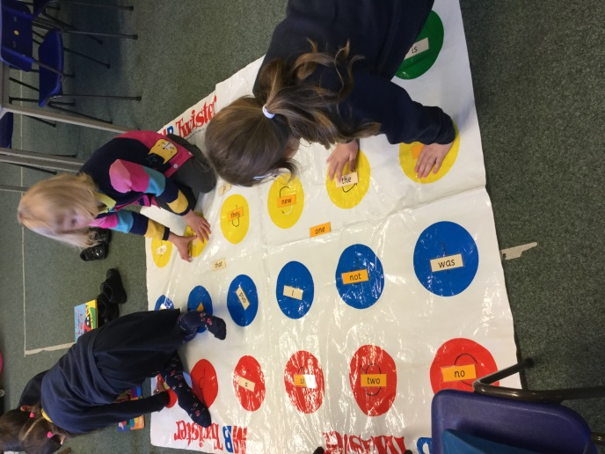**Activities:**

* I spy a word beginning with, ending in, etc
* Snap
* Pairs
* Jenga (write the words on Jenga blocks)
* Tricky word hunt
* Spot them on subtitles
* Splat the word with a fly swatter
* Tricky word twister
* Put the word in a verbal sentence
* How many words can you read in a minute
* Find in the natural environment (in supermarket, swimming, etc)
* Highlight them in newspapers
* tricky word dominoes
* draw a picture of the word
* make top trump cards with words on them
* flashcards, snap, etc

|  |  |  |
| --- | --- | --- |
| the | and | I |
| of | in | is |

|  |  |  |
| --- | --- | --- |
| it | he | that |
| a | to | was |

**P1 tricky words**

**Pre-handwriting Skills**

**It is very important to provide your child with as many of these activities as often as possible.**

* Threading pasta
* Lego
* Cheerios on pipe cleaners or pasta
* Colouring in pictures
* Dressing dolls, teddies, etc (Zips, buttons, velcro, etc)
* Planting seeds
* Jigsaw puzzles
* Freezing toys in ice cubes to chisel out
* Drawing people, tracing lines and shapes, etc
* Finger painting
* Chop sticks and tweezers
* play dough (pinching, squeezing, cutting, etc)
* cutting cardboard
* loom bands
* peeling stickers off
* 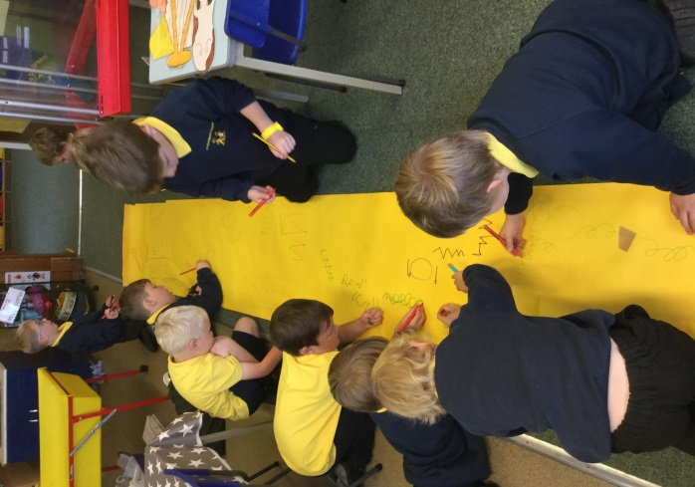dot to dots
* Shoe laces

