Topical Science
What is Science Enquiry?
Science Enquiry
Identify& classifying
Research & Questioning

Fair Testing & Explaining
Observing over time & Evidence
Pattern Seeking

Explore the following question…
HOW is PLASTIC affecting the environment?
Read Aprils Topical News Update | Read current news reports  BBC news, etc | Carry out an experiment
Design a poster with important facts | Make a PowerPoint of your findings | Watch relevant documentaries
Make a leaflet | Become a news reporter and present your findings to the class. | Make a link on a map Geography
Learning log date
Project 3 – Friday 26th May 2018
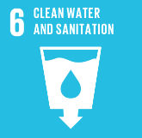
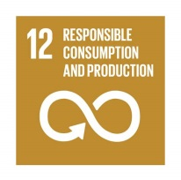
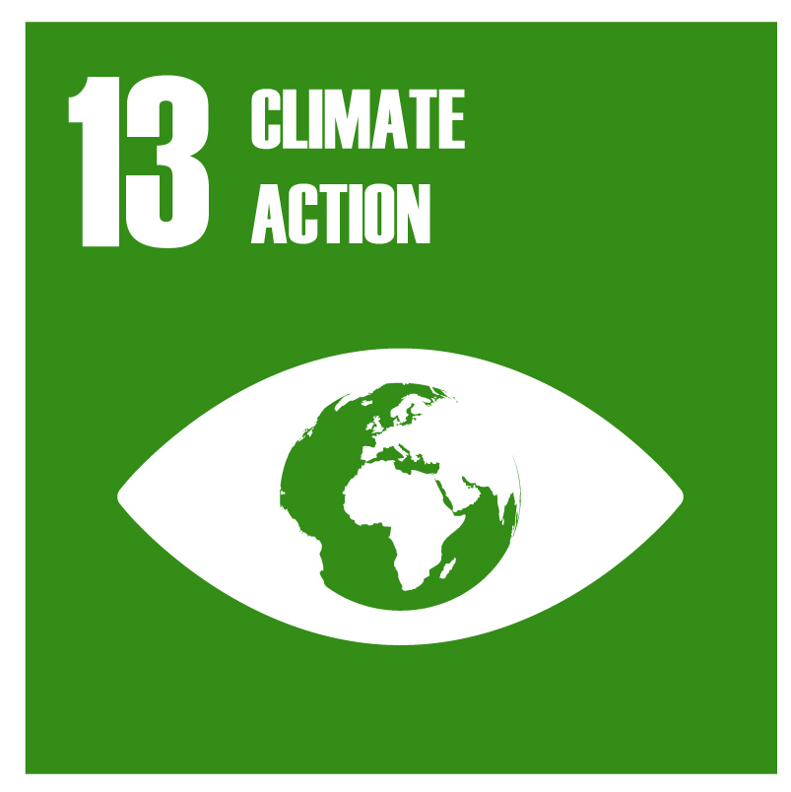
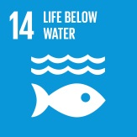
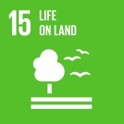
Global Goals

Article 17 - Children have the right to reliable information from the media. Mass media such as television, radio and newspapers should provide information that children can understand and should not promote materials that could harm children.

