PRIMARY 2
Primary 2 Numeracy Home learning September - December
Number  Use a hundred square or number line to count on/back in 1’s, 5’s, 10’s (numbers before/after) | Number Identification  Read, write and match 2-3 digit numbers to words.  e.g 21 – twenty one | 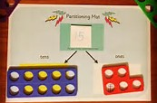  Partitioning to 100 | Shape  2D & 3D shape  Find these in or around your house!
Place Value  Write a range of 2/3 digit numbers in order | 1, 2 & 3 numbers  Before & After  43, 44, 45, 46 or  18, 17, 16, 15 etc | Maths Online  YouTube songs and rhymes, Mr Crammond or any number app | Money  Identify and use all coins to £2.  Collect receipts and discuss money in written form.
Time  Keep a log of each time you do something in your house.  E.g in class a digital clock is used to record toilet trips | Ordinal numbers  1st, 2nd, 3rd, 4th, 5th, etc  Beyond 20 | Tens & Ones  Quick draw – say a number and record it as a ten and a one  17 10 + 7  43 10+10+10+10 + 3 | Addition  Make a 10 to add 9  8 + 9 =?  8 + 10 = 18 – 1
Skip counting  in 2, 5’s & 10’s  beyond 100 (start at any number counting forwards and back) | Months of the Year  Recite poem….  30 Days Has September! | Rounding Numbers  Round numbers to nearest  10 or 100 | Games  Play Connect Four, Snakes and Ladders, Monopoly, etc

PLEASE see our class blog for ideas for number activities!
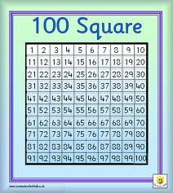
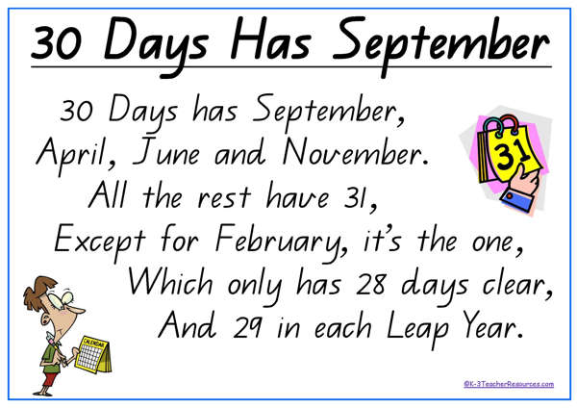
The listed activities will help further reinforce practical activities being taught in class. Please support your child in selecting and carrying out these tasks. Remember to tick off and date once the activity has been completed. Feel free to add any comments into the box letting me know how your child got on.
Have fun!

