PRIMARY 2
Numeracy Home learning September - December
Number Sequences  Say/sing/chant forward number sequences between 0-50/100  FNWS & BNWS | Number Identification  Read, write and match 2-3 digit numbers to words.  e.g 21 – twenty one | Number bonds  to 10 and 20 | Estimating  Guessing quantities in a jar, box, etc before counting exact amounts.
Place Value  Ordering 2 digit numbers | 1, 2 & 3 numbers  Before & After  43, 44, 45, 46 or  18, 17, 16, 15 etc | Double Numbers  Discuss doubles to 10/20 | Money  Collect loose change
Time  Create a weekly timetable, calendar, etc | Ordinal numbers  1st, 2nd, 3rd, 4th, 5th, etc | Subtraction  subtracting 1 + 2 digit numbers from a 1 or 2 digit number to get a total | Addition  Adding 1 + 2 digit numbers to a 1 or 2 digit number to get a total
Skip counting  in 2, 5’s & 10’s | Months of the Year  Sequence, which month is 4th, 6th, etc | Symmetry  Can you find symmetry in your home environment? | Maths Online  Find maths games online or play number board games.

PLEASE see our class blog for ideas for number activities!
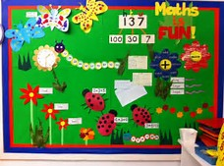
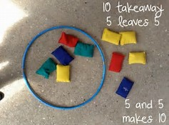
The listed activities will help further reinforce practical activities being taught in class. Please support your child in selecting and carrying out these tasks. Remember to tick off and date once the activity has been completed. Feel free to add any comments into the box letting me know how your child got on.
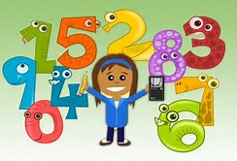
Have fun!

