PRIMARY 1
Primary One
Numeracy Home learning January - March
Number Sequences  Count backwards from any given number by rote | Number Identification  Make 2 digit numbers | Number bonds to 5 and 10  Learn the bonds rhyme P2 made up last year & watch Farmer Pete on you tube | Estimating  How much money in the bank!  Put different amounts in regularly for your child to guess.
Place Value  Order a range of 2 digit numbers to 100 | Number Sequences  Say number before or after a given number. | Games  Play snakes and ladders or a cards game | Money  Identify all coins to £2  Use money in real life contexts.
Time  Time how long it takes you to complete a task at home and record it. (race cars start to finish) | Missing numbers  3+?=7 or ?+10=16  2+?=10 | Subtraction  Subtract money from 10p | Addition  Add money to 10p/20p
Skip counting  Say tens numbers in order, start from any tens, make the tens number using materials, etc | Compass Points  Identify north, south, east & west within your home environment. Position toys, locate North in your bedroom, which side of the house does the sun rise at, etc. | Shape  Look at the different shapes of coins and notes. Discuss | Maths Online  http://www.kidsmathgamesonline.com/  http://78.141.43.195/mrcrammond/
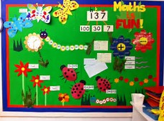
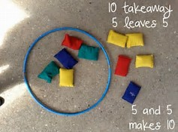
The listed activities will help further reinforce practical activities being taught in class. Please support your child in selecting and carrying out these tasks. Remember to tick off and date once the activity has been completed. Feel free to add any comments into the box letting me know how your child got on.
Have fun!

