PRIMARY 1
Primary One
Numeracy Home learning October - December
Number Sequences  Say/sing/chant forward number sequences between 0-30/50 or 100 | Number Identification  Read, write and match numbers to words. 0- 20  e.g 20 – twenty | Number bonds to 10  6+4=10  3+7=10  5+5=10 | Estimating  Guessing quantities in a jar, box, etc before counting exact amounts.
Place Value  Ordering teen numbers | Number Sequences  Say/sing/chant backwards number sequences between 0-30/50 or 100 | Games  Play Connect Four, Snakes and Ladders, Monopoly, etc | Money  Identify all coins to £1  Creative play with money
Time  Days of the week  Create a weekly timetable  Make a watch or start wearing one! | Ordinal numbers  1st, 2nd, 3rd, 4th, 5th, etc | Subtraction  Within 10  5 peas subtract 2 peas =  Language – 5 take away 2, count back, etc | Addition  Adding to 10  4 spoons plus 3 forks =  Language – 4 plus 3 more, add on, etc
Skip counting  10’s  Forwards and Backwards | Months of the Year  Sequence, which month is 4th, 6th, etc  Name the months in order | Shape  2D & 3D shape  Find these in or around your house! | Maths Online  Find maths games online or play number board games.

PLEASE see our class blog for ideas for number activities!
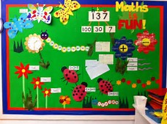
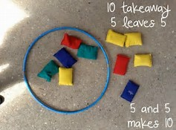
The listed activities will help further reinforce practical activities being taught in class. Please support your child in selecting and carrying out these tasks. Remember to tick off and date once the activity has been completed. Feel free to add any comments into the box letting me know how your child got on.
Have fun!

