P6 Class Newsletter Term 1 2023

Literacy  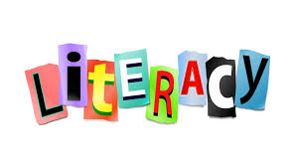 | - Weekly talking & listening activities through group and class discussions  - Reciprocal group reading sessions with independent activities including comprehension, spelling and grammar tasks  - Whole class developing Higher Order Reading skills using a class novel  - Weekly spelling sessions & interactive activities  - Writing linked to our IDL of Scottish battles and key historical individuals – Creative and Report writing
Numeracy | - Developing pupil knowledge and understanding of numbers through a range of mental maths activities  - Revision and extension of place value, rounding and number sequences  - Real life scenarios to develop understanding of money and probability  - A range of problem-solving experiences through fun challenges
HWB | - Classes will be following Jigsaw lesson plans as part of a whole school approach – Being Me In My World  - Building a class community - working together, being successful as a team, celebrating others success, recognising and celebrating differences  - Both classes will be developing their PE skills and learning with Miss Inkson our PE teacher
Expressive Arts | Through our topic of Scottish Battles and key individuals, pupils will;  - Explore and experiment with textiles to create their own woven material  - Discover the history and meaning behind Scottish tartans and coats of arms, following a design brief to create their own  - Analyse and discuss their own and other’s work  - Listen to traditional Scottish music, discussing differences and similarities to current music  In addition pupils will undertake drama activities related to our HWB and IDL
I.D.L. | Through the topic of Scottish battles and key historical individuals, the children will;  - Use a variety of resources to complete research topics  - Investigate how the actions of key historical figures and battles have shaped Scottish society  - Collaborate in activities including drama and storytelling to recreate key moments from Scottish history.
ICT | - Pupils will be developing their IT skills through weekly lessons with Mrs McClure  - Homework will be issued through Glow and Class Dojo. Pupils will be supported to develop their knowledge of using Glow email to access, attach and return homework files.
Homework  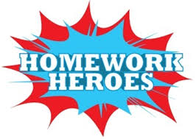 | - Homework will be issued on a Monday and should be submitted by a Thursday.  - Homework will consist of spelling, numeracy and IDL activities to support and consolidate learning in class.  - All documents will be sent through Glow mail and Class Dojo.

