Seafield Primary School
Primary 1 - Term 1 Newsletter
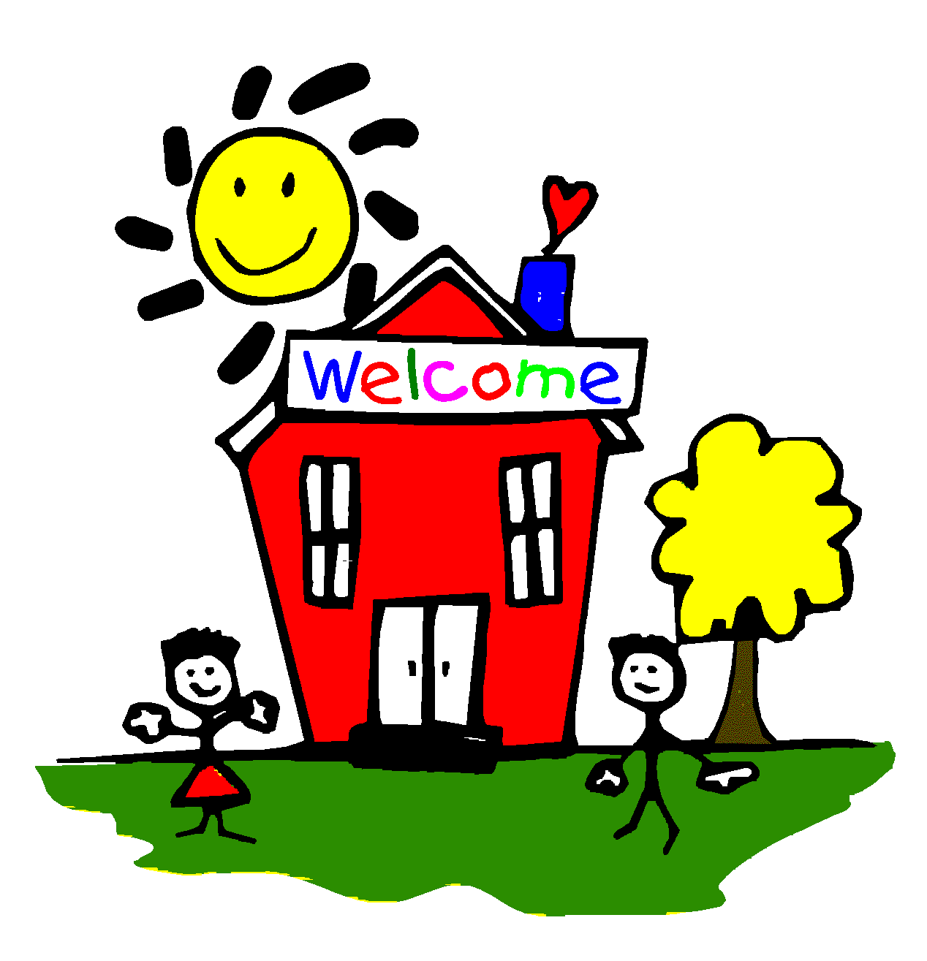
Welcome to Primary 1 at Seafield Primary School.
Thank-you very much for your co-operation and support with making the transition into school as calm and safe as possible for the children. They have settled in really well and are enjoying learning new routines.

Glow emails – All children will receive a GLOW e mail. Please make sure you check your child’s GLOW email weekly to access homework and weekly updates.
Snack – Children should bring one small snack for their morning break and a water bottle (with only water). They may bring juice as part of their morning snack but will not be allowed to drink this during the day in class. They may also bring a fruit snack for a “brain break” in the afternoon which will be optional.
Lunches- All Primary 1’s are entitled to free school lunches so they can order daily when they come into school. Please discuss the menu options with them so if there is nothing they like they can bring their own packed lunch from home with them.
Spare clothes - If you have not done so already, could you please send in a plastic bag with a spare set of clothes to leave in school in case of accidents/ wet weather. Children should have gym-shoes in school which we use as indoor shoes and for PE.
PE times: P1M & P1S Monday and Friday. Please can children come dressed in their PE Kit on these days. These sessions will be indoors or outdoors so please ensure children come suitably dressed. They will remain in their kits for the duration of the day. PE on Mondays will be with Miss Inkson.
Outdoor Play/ Playtime: Please can children bring a jacket and sensible outdoor shoes every day as the weather is so changeable. We will try to get outside as much as possible.
Sun cream: In the event of nice weather, please can you ensure your child is wearing sun cream before coming to school. Unfortunately we cannot help children apply suncream.
Music: Children will receive weekly music lessons from our specialist Mrs Taylor.
Homework: This will be issued via GLOW. Each week children will receive 2 new sounds with actions to practise at home. They will also have weekly maths homework. Usernames and passwords for this will be sent out shortly. We will also send home a weekly information sheet about what we have been learning about in class.
Please feel free to contact us via GLOW e mail:
P1S | Mrs Stewart  gw11stewartrachael2@glow.sch.uk
P1M | Miss McDermid  gw22mcdermidalexandr@glow.sch.uk

This pro-forma outlines for you the MAIN FOCUS of the work to be covered in class by your child this term. We take each child's previous learning experiences and prior knowledge into consideration.
Language | - Talking to others about their experiences  - Listening to each other in large and small groups  - Writing – scribed stories with drawings expressing their ideas  - Learning to form and write letters on whiteboards  - Beginning to recognise and read key words and simple sentences  - Phonics- hearing the sound a word begins with and recognising the letter that makes the sound  - Retelling stories and predicting what might happen next
Maths | Developing children’s knowledge and understanding of numbers through:  - Counting forwards and backwards and around the circle to 10 then 20 and beyond  - Recognising and using numbers to 10 and beyond through counting games, rhymes and songs  - Finding the number that is 1 more or 1 less from 1 to 10 and beyond  - Sorting objects for a range of criteria including colour, shape and size  - Problem solving activities  - Other aspects of Maths will include measurement
Social Studies/ Science | We will be planning in the moment this year so your child will lead their own learning but will be involved in the following activities:  - We will be looking at simple information books, pictures and videos to gain information.  - Naming and finding out about parts of the body.  - Looking at similarities and differences in people.  - Exploring and investigating the senses.  - Children will become involved in first hand experiences to make their discoveries, draw and paint pictures and make artefacts linked to their own interests.  - Working towards RSPB Wild Challenge Bronze Award
RME/  HEALTH/  RRS | - Following our Discovery RME programme  - Participating in activities linked to Harvest  - Playing simple circle games to help children form friendships.  - Sharing and working together.  - Learning to look after our bodies.  - Talking about our feelings, what makes us happy, sad, angry, scared  - Zones of Regulation  - Drawing up a set of class rules to keep everyone safe and happy  - Linking the rules to children’s rights (UNICEF- Rights Respecting Schools)  - Following our Jigsaw – Health and Wellbeing programme  - Child Smile – Toothbrushing  - Outdoor Learning
Expressive Arts | PE - travelling in a variety of ways over the floor - change of speed/ direction  Making different body shapes and using space – Games:-  Traffic lights, Beans, Statues | Music:- - Experiment with making sounds.  Focus on listening skills.
 | Drama- role play corner in classroom linked to interests, music and movement, yoga sessions | Art- drawings, paintings, model making and collage both free choice and linked to interests

