Moray Council

Digital Inclusion Laptops
Prepared By:
[Moray Council - ICT Department]

Contents
Contents 2
Overview 3
Connecting and Logging On 3
Overview 3
Connecting Within a School 3
Connecting at Home 3
FAQs 4
Overview 4
Unable to connect to the Internet, access mapped drives (Student In and Student Out) or applications 5
Reporting an Issue 5

Overview
Please note the technology that always learners to connect to their schools mapped drives and access learning safely through a restricted internet connection is still in a ‘pilot’ phase and the ICT Team at Moray Council are continuing to work on improvements. Any updates will be communicated via your school. Please ensure that you have referred to the FAQ’s before reporting any issues.

Learners issued with a Digital Inclusion laptop can use it as and when required outside of school, and can continue to log onto other school PCs or laptops as required.

Connecting and Logging On

Overview
The laptop you have been allocated has been configured for use both at school and at home, but learners are not required to take their devices into school unless specifically requested by a teacher.

Connecting Within a School
If requested to bring the device into school learners will not be required to take any action in addition to the normal log in process. The laptop will connect automatically to the network via the school’s Wi-Fi infrastructure.

Connecting at Home
Configure the laptop to connect to the internet using your own internet/broadband router (supplied by your Internet Service Provider (ISP)). To do this you MUST know the ‘name’ or ‘SSID’ of your internet router, and the password – these details are normally found printed on, or attached to, the router itself. Some providers may provide a card with these details on when your wifi was first set up.

The following steps should only need to be carried out once, unless the router is reconfigured or replaced, as the laptop will remember the necessary settings and password.

When you first power up the laptop at home, after pressing Ctrl-Alt-Del, you will reach the normal logon screen:-
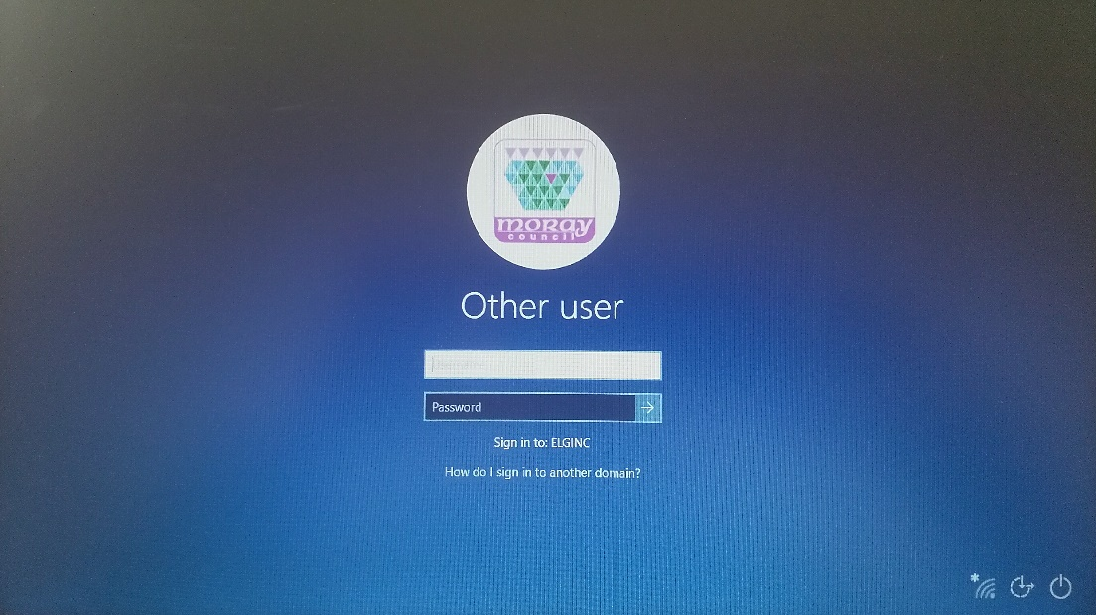
Please note the ‘Internet Connections’ icon at the bottom right hand corner of the screen indicates that there is ‘no connection’:-
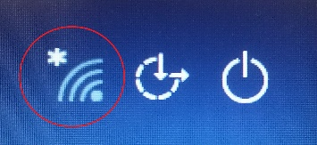

Clicking on the icon will present a list of available Wi-Fi-enabled routers nearby – the image below is just a representative example, but you should see something similar. You should select the ‘name’ of your router from the list, click ‘Connect’, enter the password, then ‘Next’:-

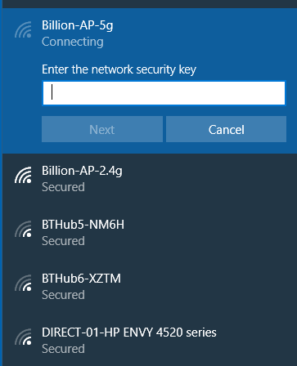

If all is OK, your ‘Internet Connections’ icon should appear as below, to indicate that you are connected to the internet:-

The learner can then proceed to logon to the system, using the same username and password that they would normally use in school.

FAQs

Overview
FAQs will be added to as the project progresses.

Unable to connect to the Internet, access mapped drives (Student In and Student Out) or applications
The most common cause for this is that the ‘User Always On’ connection is not connected. Once this connection is active, a task runs which will look to refresh access to the mapped drives. This may take up to two minutes. To activate the connection, do the following:
- Click on ‘Internet Connections’ icon as shown above
- Check that ‘User Always On’ is connected
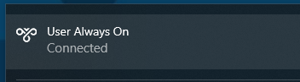

- If it is not connected, click the name and then click the ‘Connect’ option. It is possible that the connection will stay showing as ‘connecting’. This is a feature and usually means you are connected. If you are able to connect to the Internet then the connection is working.
- Wait 2 minutes and check for the appearance of the mapped drives.
- If the laptop does not connect consider restarting your laptop and restarting your wifi router before logging back onto your laptop.

Reporting an Issue
Any issues regarding connecting to the AOVPN (User Always On) should be done in the normal way by contacting your school. Please ensure that you provide them with as much information as possible including the Asset number of the device (6 digit number on a sticker on the laptop) dates/times you tried to connect and the frequency of the issue.

