1. Look along the tabs at the top of the Teams

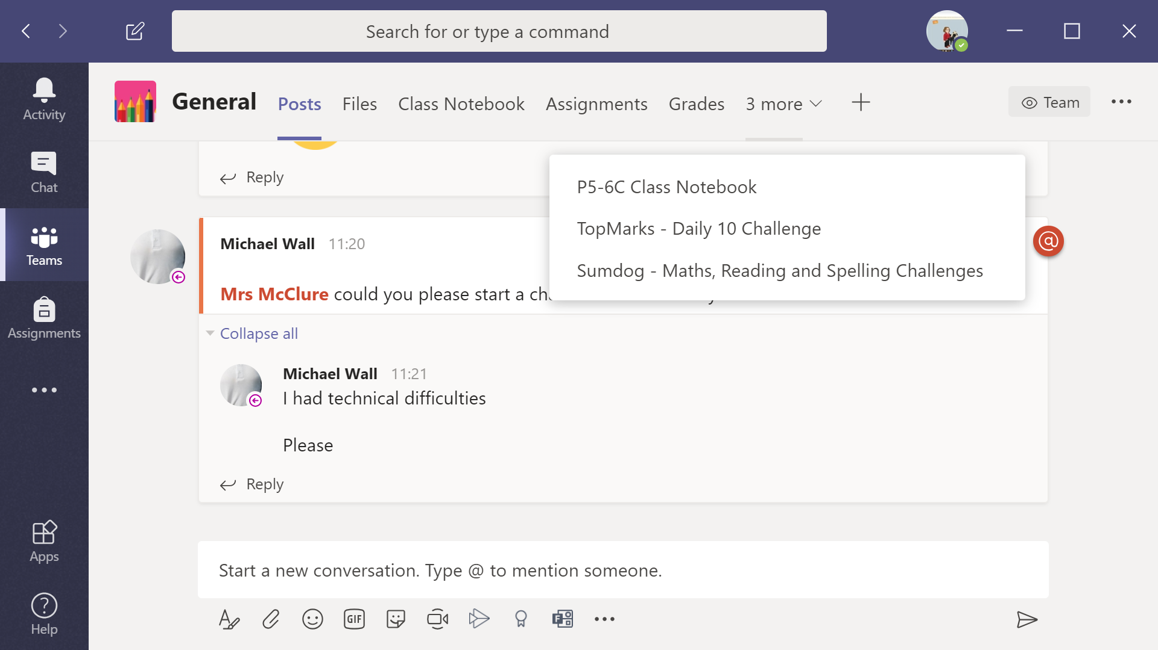

2. You will see a tab saying ‘more’. Click on this tab. You will see P5-6C Class Notebook.
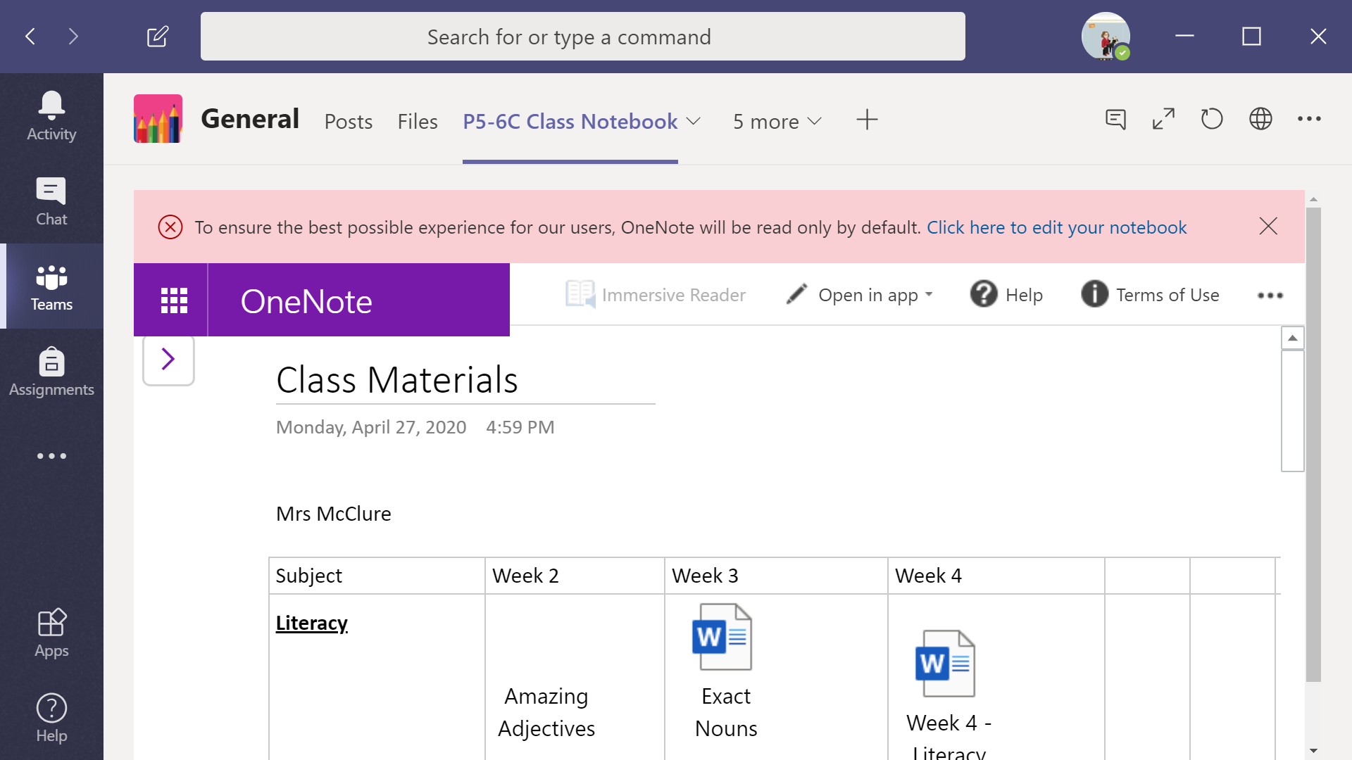

3. The message in pink says ‘Click here to edit your notebook’. Click on the message. It will open Notebook online (I am signed into GLOW).

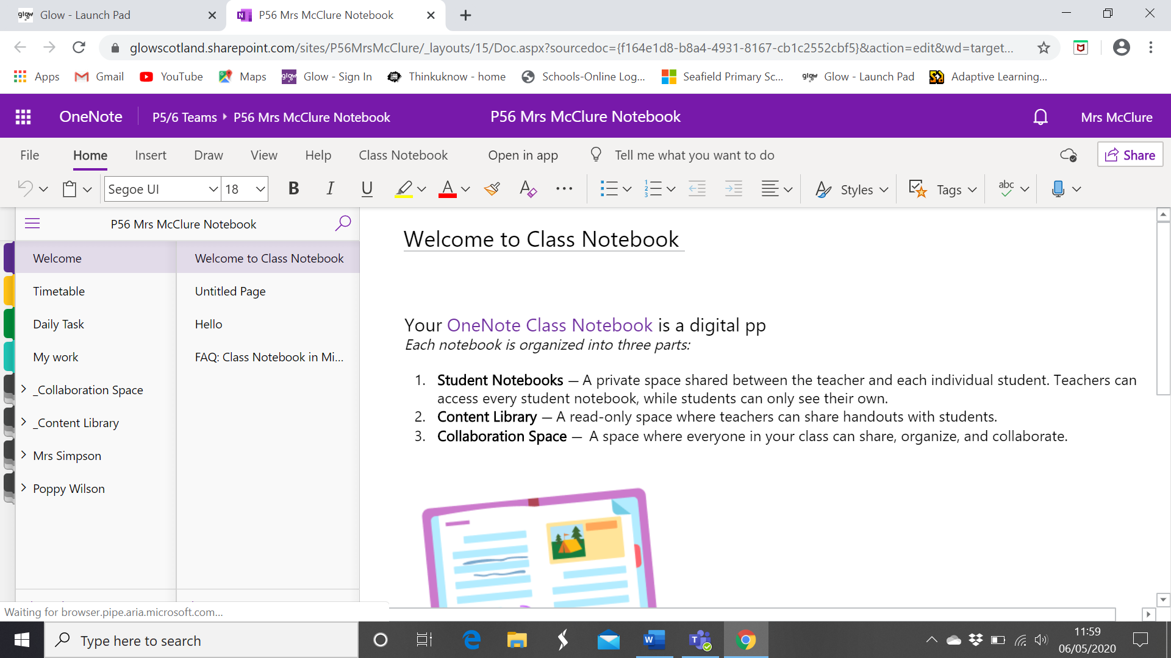

4. Click on the words ‘Collaboration Space’. It will show a list of names of the children in that Class.

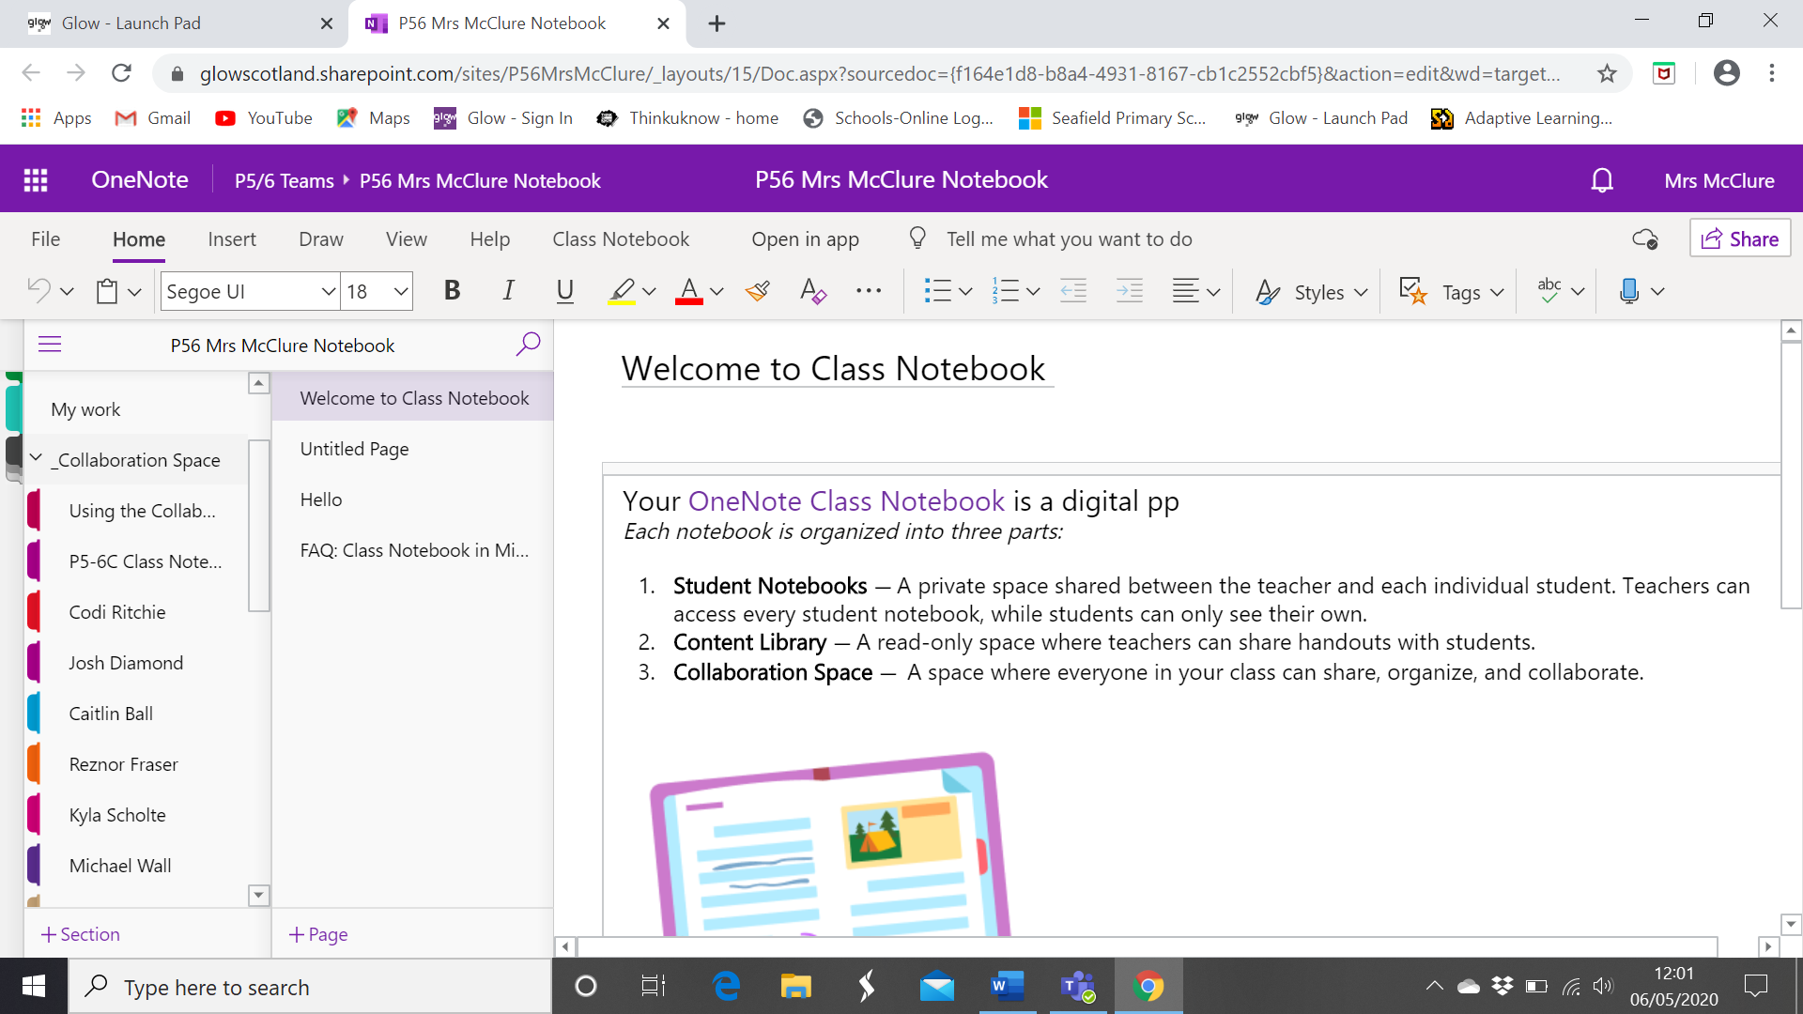

5. Click on the name that you want.

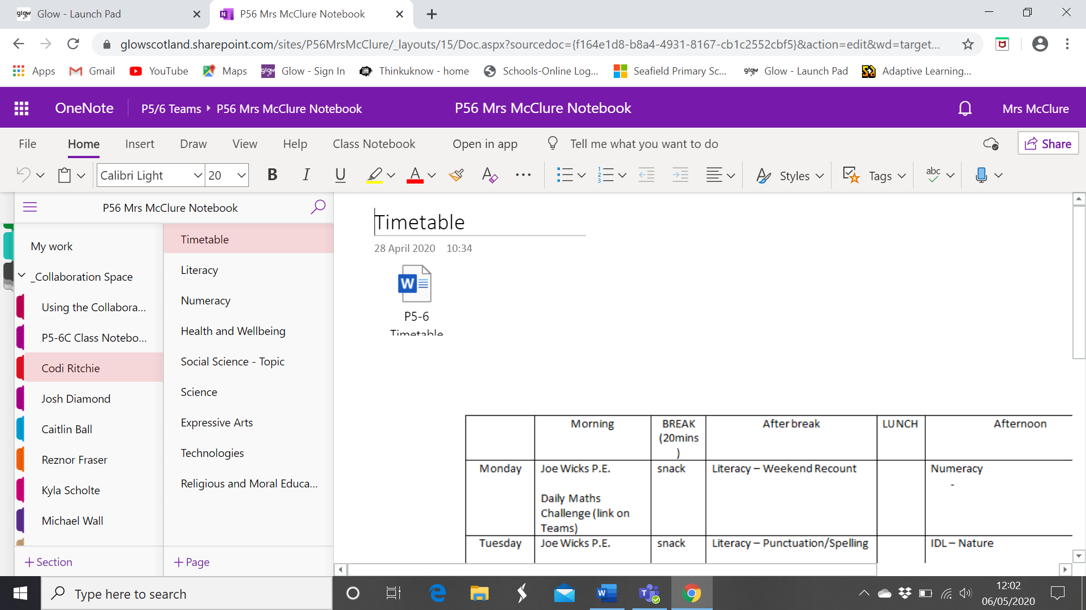

6. Click on the area of the curriculum that you are looking for. Click on that area of the curriculum.
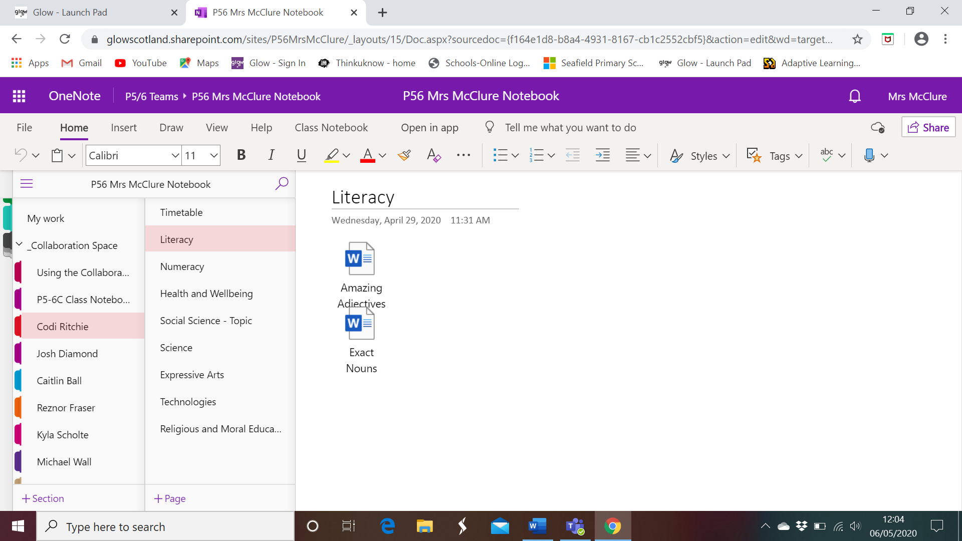

7. You can upload files to the area that you want by Insert – File – Insert as Attachment or Insert as Printout. You can choose either option. Insert Attachment gives you a File attachment. Printout will give you the information in the file so that everyone can see it.
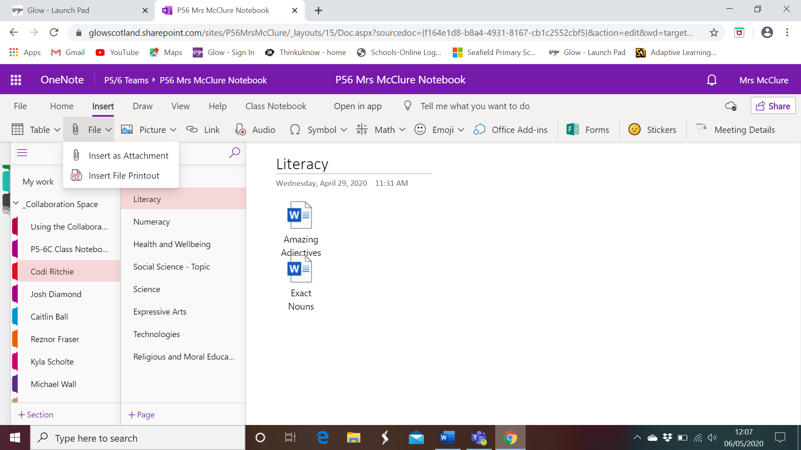

8. It will ask you then choose a file.

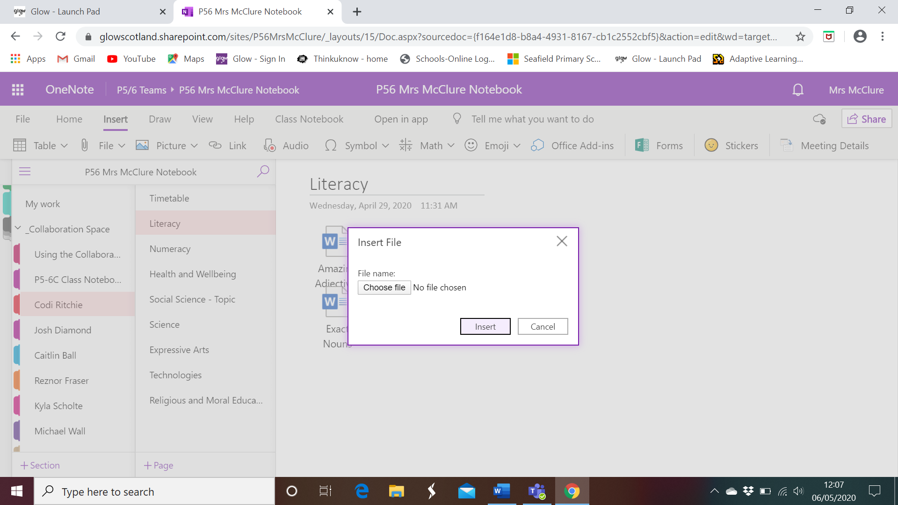

9. Click on ‘Choose File’ and upload the file you want to use. You can do this by double clicking the file or by pressing Open on the bottom of the Open File Box. You will then need to press ‘Insert’ on the Insert File Box.

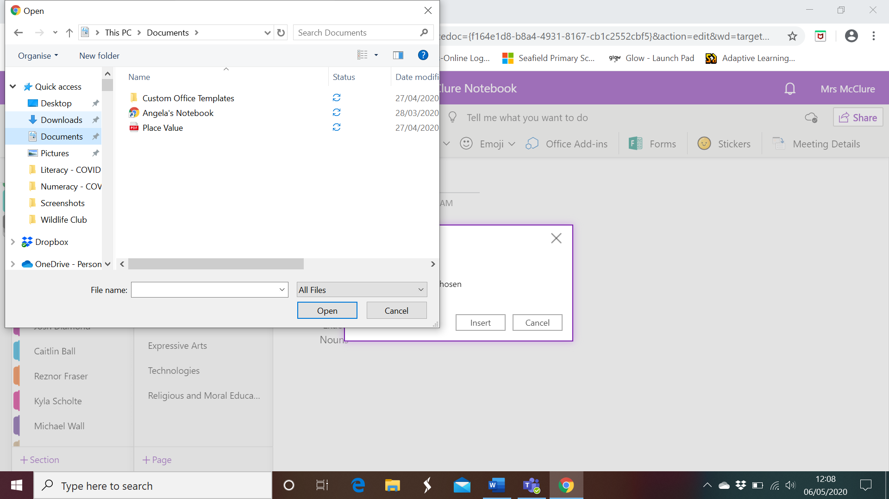

10. You should your file in the area of the curriculum you have chosen.

