How to Take Screenshots in Windows 10

(thanks to How-To-Geek) Guide

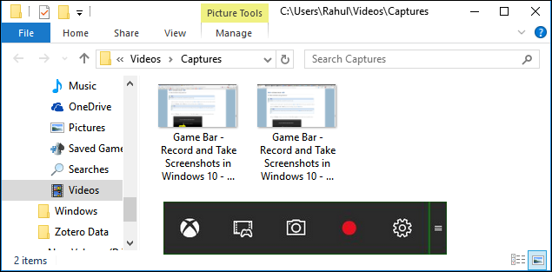

A screenshot is an image taken of whatever is on your screen.

You can take a screenshot on just about any platform and taking screenshots in Windows is no different. It has a built-in option that works great for basic tasks, but many third-party programs offer more ease of use and features

Method One: Take Quick Screenshots with Print Screen (PrtScn)

- Press the PrtScn button to copy the screen to the clipboard
- Press the Windows+PrtScn buttons on your keyboard to save the screen to a file
- Use the built-in Snipping Tool
- Use the Game Bar in Windows 10

The Print Screen button on your keyboard can take a screenshot and save it as a file, take a screenshot without saving it as a file, or take a screenshot of only one window (instead of the whole screen). The print screen button may be labelled as “PrtScn,” “PrntScrn,” “Print Scr,” or something similar. On most keyboards, the button is usually found between F12 and Scroll Lock. On laptop keyboards, you may have to press the “Function” or “Fn” key to access the Print Screen feature. When you press the key, it will look like nothing happened, but the screenshot has been saved to your clipboard.

To Save Your Screenshot as a File

Press the “Windows logo key + PrtScn.” If you are using a tablet, press the “Windows logo button + volume down button.” On some laptops and other devices, you may need to press the “Windows logo key + Ctrl + PrtScn” or “Windows logo key + Fn + PrtScn” keys instead. Check your laptop’s manual for more information.

The screen will dim for a moment, and you will see the screenshot appear as a file in a folder entitled “Screenshots”, inside your default “Pictures” folder. The screenshot is automatically labelled with a number.

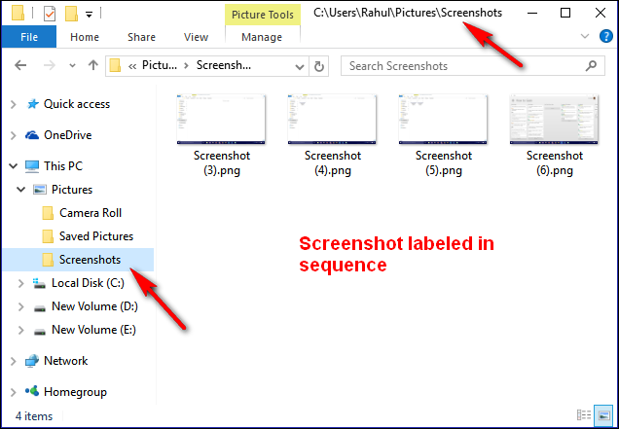

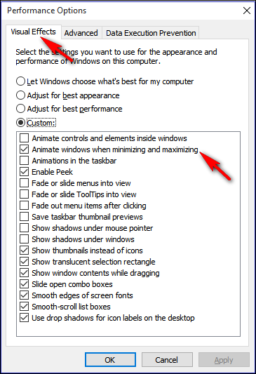

To Take a Screenshot Without Saving

Press the “PrtScn” key. A screenshot of your display is now copied to the clipboard. Open your favourite image editor, word processor, or other program you want to use the image in. Choose Edit > Paste to paste the screenshot wherever you like. The dimensions of the image will be the same as your desktop resolution. Note: On some laptops and other devices, you may need to press the “Alt + Fn + PrtScn” keys instead. Check your laptop’s manual for more information.

To Take a Screenshot of Only One Window

Click on the title bar of the window that you want to capture. Press “Alt + PrtScn”. A screenshot of your currently active window will be copied to the clipboard, just as in the last section. Paste it into your favourite image editor or document editor. Note: On some laptops and other devices, you may need to press the “Alt + Fn + PrtScn” keys instead. Check your laptop’s manual for more information.

To Take a Screenshot of Part of Your Screen

Press “Windows + Shift + S”. Your screen will appear greyed out and your mouse cursor will change. Click and drag on your screen to select the part of your screen you want to capture. A screenshot of the screen region you selected will be copied to your clipboard. You can paste it in any application by selecting Edit > Paste or pressing Ctrl + V, just as you would paste a full-screen shortcut taken with the Print Screen key.

This only works in Windows 10’s Creators Update. On older versions of Windows, this shortcut is part of Microsoft’s OneNote application. With the Creators Update, Microsoft integrated this shortcut into Windows 10 itself.

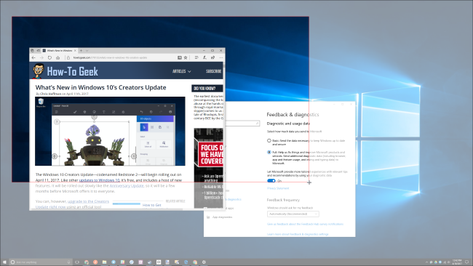

Method Two: Take More Flexible Screenshots with Snipping Tool

The Snipping tool has been a part of the Windows for long time. This tool was first included in Windows Vista, and never got any new features apart from few bug fixes. Snipping tool can take screenshots of an open window, rectangular area, a free-form area, or the entire screen. You can annotate your snips with different coloured pens or a highlighter, save it as an image or MHTML file, or email it to a friend.

Snipping Tool in Windows Vista, 7, and 8 has one limitation: it cannot capture screenshots that involve mouse movements. To capture something that involves mouse movement, like pop-up menus and tooltips, you will have to use the Print Screen method.

In Windows 10, Snipping Tool has a new “Delay” option, which will allow you to capture screenshots pop-up menus and tooltips. Open the Snipping Tool app and click Delay. From the drop-down list, click on the number of seconds you would like to wait until your screenshot is taken.

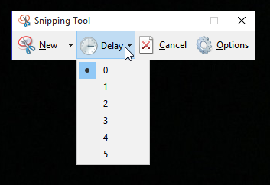

Now choose the type of snip you want to make by clicking the arrow next to “New.” You can choose from one of four types of snip: free-form, rectangular, window, and full-screen.

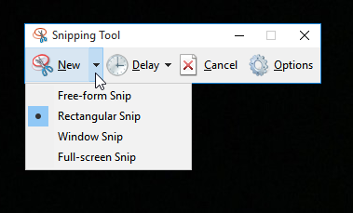

Unlike a regular snip, the screen will not immediately fade out. Instead, you will have between 1–5 seconds, depending on the delay you chose, to set up your screenshots. You can use this time to open that pop-up menu or tooltip you want to capture. Once your seconds have passed, the screen will freeze and fade out so you can create your snip. If you chose window or full screen, it would just capture the snip immediately.

How to take a screenshot on an iPad (any generation)
Sometimes there is no easy way to share something. You have stumbled across the perfect picture online, but there is no way to save it. There is an excellent recipe on a cooking app, but you will not have an internet connection later to look it up again and there is no option to save it for offline access. Or, you just want to show off your Fortnite skills to your friends. All of these small problems can be solved with a simple screenshot.
The iPad has a great built-in feature where you can take screenshots of anything as an image file, which can then be shared with anyone. In this guide, we walk you through all the steps on how to take a screenshot on your iPad.

How to take a screenshot on an iPad using the Top and Home or Volume up buttons
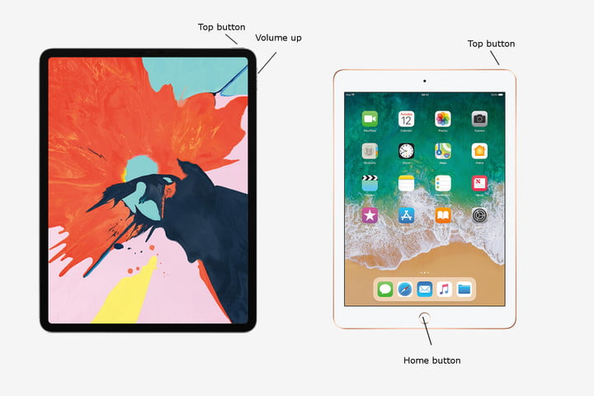
Step 1: Locate the Home and Top (Power) buttons. The Home button is located directly below your iPad’s display and is the only button on the front-side of the iPad. The Top button, on the other hand, is the oval-shaped button atop the iPad in the right-hand corner. If you have a new, 2018 iPad Pro, then you need to find the Volume Up button, since there is no Home button.
Step 2: Press and hold the Top button when viewing the screen, you want to capture, then tap the Home button and release both. For the 2018 iPad Pro, press and hold the Top button and then tap the Volume up button and release both. Your iPad screen will then flash momentarily if done correctly, and you will hear a faint shutter noise, assuming your device is not in silent mode.
Step 3: Once captured, your iPad will automatically save the screenshot directly to your camera roll in the Photos app. Tap the Photos app as you would normally — the app icon resembles a multi-coloured flower — and swipe to the bottom of the screen to view your recently captured screenshot.

Take a screenshot on your Mac
You can capture the entire screen, a window or just a portion of the screen.

How to take a screenshot on your Mac

- To take a screenshot, press and hold these three keys together: Shift, Command and 3.
- If you see a thumbnail in the corner of your screen, click it to edit the screenshot. Or wait for the screenshot to save to your desktop.

