Logging in to Glow
You need a username and password to access Glow. Pupils will have an account from school and they will have a Username and Password. All passwords have been set at glow (space) glow. Please do not change your password.

Step 1 – Sign in to Glow
Visit the Glow sign in screen: https://glow.rmunify.com/

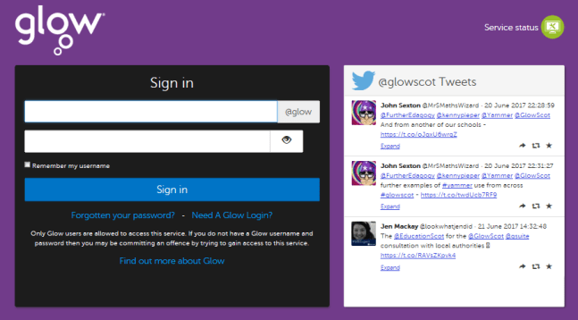
Enter your username and password in the boxes shown (clicking the eye icon allows you to see your password as you type it in) then click ‘Sign in’.
Please note: If you log in to Glow using the Glow RM Unify screen it will automatically add the @glow. If you don’t see this you can add the @glow to the end of the address yourself.

