Education, Communities and Organisational Development: Education

Moray COVID-19 Response
School Name
Learner Guide

This guide has been produced in two parts:

Part A: Learner Guide which can either be issued to older children and young people in its entirety or used as a learning tool for staff to use with younger pupils.

Part B: Top Tips for Learners which can be printed and displayed around the school. These have been sent to parents. You may also wish to print and issue these to children and young people.

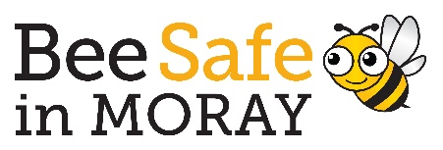

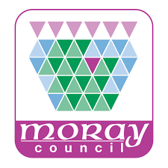
Part A: Learner Guide
Information for our Learners returning to school: Covid-19 Guide

We are delighted to welcome our learners and staff back to school following a long period of absence due to the impact of Coronavirus. We have produced this Learner Guide in order to support your return to our school and to let you know about changes that we have put in place to support and protect everyone. You must read this guidance and familiarise yourself with changes to the school building and routines. This may involve differences in the way our school operates, how we move around our school building and how we must behave responsibly in order to protect ourselves and others in our school community.

Signs and Symbols: “Bee Safe in Moray”

As we all travel around our school we need to take notice of different signs and symbols. These are in place in order to support us in our movement around our school and to remind us for the need to wash our hands and hand sanitise regularly, using designated hand washing facilities and sanitisation stations. Signage you may see in school to provide clear instructions and direction to all learners and staff to “bee safe” includes:
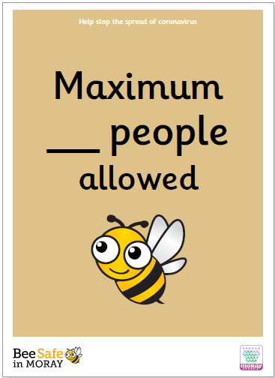
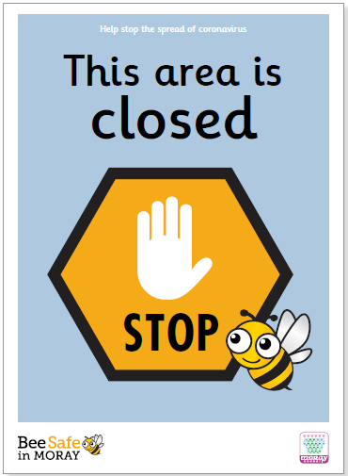
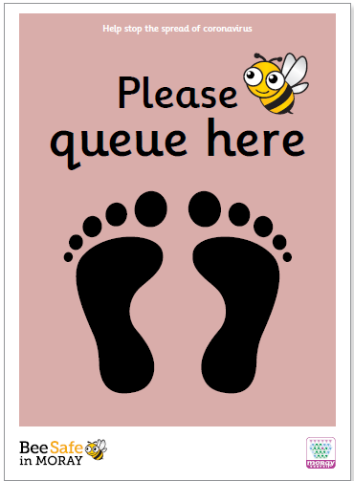
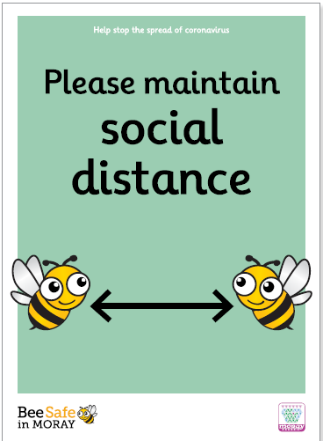

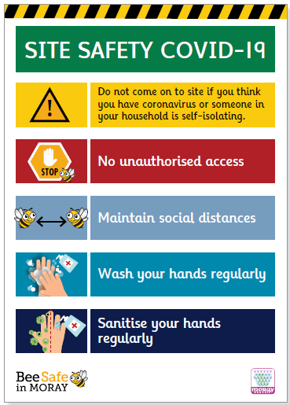
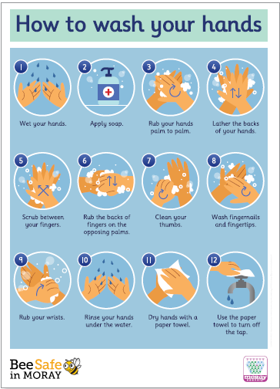
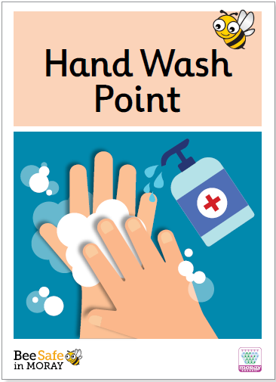
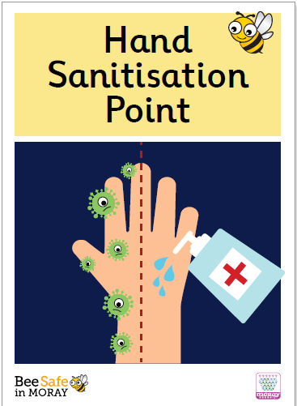

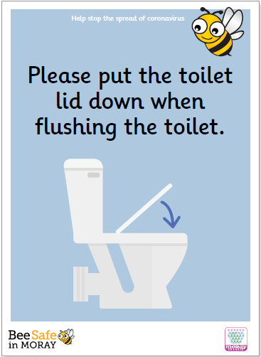
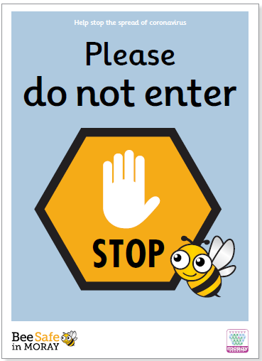
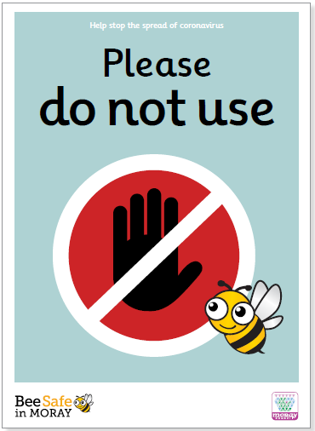
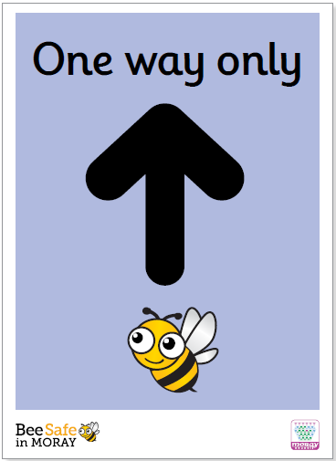

If at any time you are feeling anxious or worried about returning to school, please speak to a teacher you know and trust which may be your class teacher, Guidance Teacher in Secondary School, a member of the Senior Leadership Team or the Head Teacher. Your school may also have the following posters to remind you:

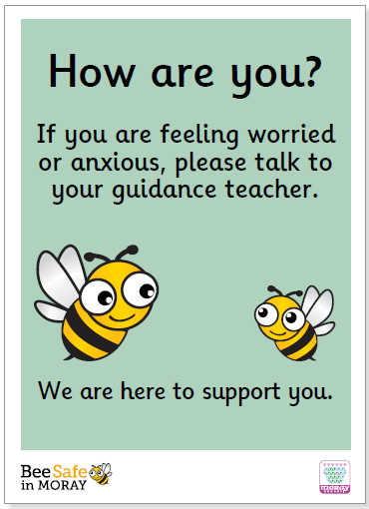
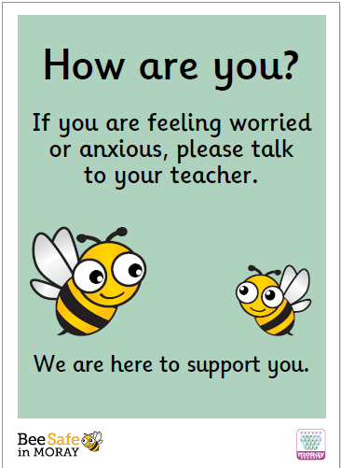

In addition, your school may have clear instructions provided using floor stickers. This may include directing you to the one-way system that is operating in the school or the reminder to maintain social distancing. Examples of floor stickers include:
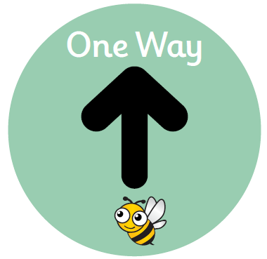
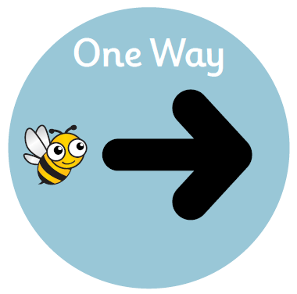
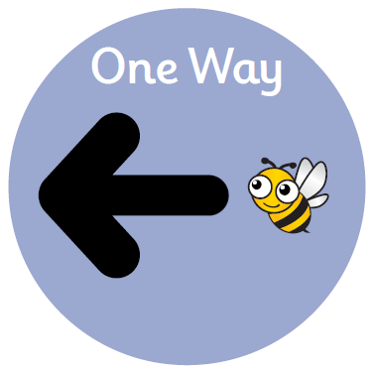
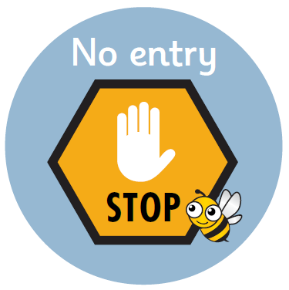

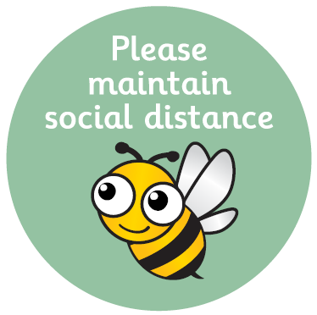
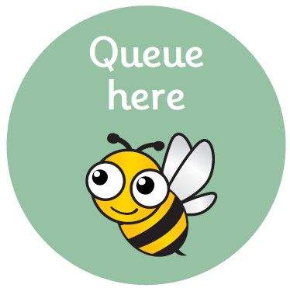
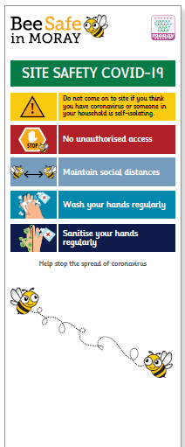
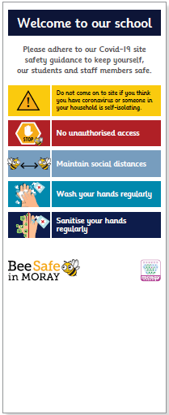

Your school may also have pull-up floor banners at main entrance and exit doors in order to remind learners and staff about key signage and instructions in order to make sure everyone is safe in school. At all times we must remain careful and alert, where return to school will be very different to what we are used to.

Arriving to school, movement around school, break/lunch and leaving school

At all times, large gatherings should be avoided near to school. You should aim to arrive at school in the morning near to school start time and avoid gathering unsupervised. Parents will not be able to enter school buildings unless required to do so by the Head Teacher or Senior Leadership Team for specific reasons. Dropping off of PE kits, resources and equipment is not possible during the school day.

Some measures schools may introduce for supporting social distancing are:
- Staggered drop off/pick up times and locations so everyone arrives at school safely, at different times
- Use of different entrance/exit doors to reduce large numbers of people accessing the same doors
- Specific arrangements once you arrive at school – for example, going straight to a specific classroom/area or indoor/outdoor space
- Discouraging gatherings of parents outside school, where parents should maintain distancing of 2 metres as far as possible when dropping off
- Senior pupils who have a vehicle may wish to “park and stride”, avoiding travel with non-family members to school
- Direct access to classrooms from outside where there are doors that allow this may be permitted

Passing briefly in the corridor or playground is considered low risk, but gatherings in corridors, entrances and exits should be avoided, and one way and/or external circulation routes may be put in place in school.

At break or lunch, you may have a different break and lunch time to other year groups in order to reduce the amount of people gathering in school. This may also mean different lunch arrangements which may include more ‘grab and go’ lunch options as opposed to previous full meal service choices. In secondary school, if you are permitted to go off school grounds, you should follow the rules in place for wider society, for example wearing a face mask when entering a shop and maintain social distancing. Good hand hygiene (hand washing and hand sanitisation per below) should be carried out before leaving and following return to school. Your school will let you know if this remains a lunch option in this current Covid-19 pandemic. Beware of any hungry seagulls!
At the end of the school day, pupils should leave the school building in a safe and orderly fashion. You should be mindful of social distancing and the importance of positive and respectful behaviour.

You should make your way from the school building avoiding gatherings and if being collected by a parent/carer, move to your designated collection point. Care should be taken to follow any one-way system if in operation, leaving the school via the correct exit door. You will be informed about Fire Exit procedures.

Personal belongings and resources

You should not share personal belongings when in school. Younger children should avoid bringing toys and games in to school from home. If a learner brings their own book, bag or personal device that only they use then this should not increase the risk of indirect spread of Coronavirus if present. However, any books, bags or personal devices (or any other personal belonging) should not be shared.

You should keep your bag on the floor and not on your desk or worktops when in classrooms. You may be permitted to take books and other resources home. However, sharing resources including textbooks should be avoided.

Personal Hygiene routines, hand washing and sanitisation
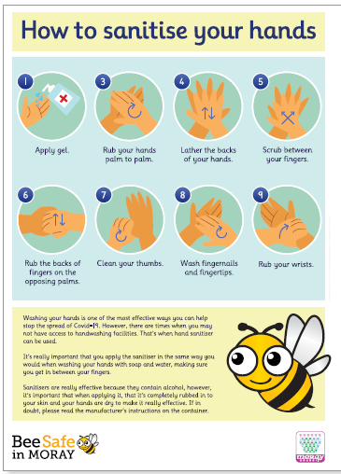

Enhanced personal hygiene must be practised which should include regular hand washing and the use of hand sanitiser in all rooms and spaces across the school.

It is essential that we all ensure strong personal hygiene which includes:

- Frequent washing/sanitising of hands for 20 seconds and drying thoroughly, and always when entering/leaving the building, before/after eating and after using the toilet;
- Avoiding touching our faces including mouth, eyes and nose and
- Using a tissue or elbow to cough or sneeze, and use bins that are emptied regularly for tissue waste.
It is everyone’s responsibility in the school to observe good hygiene to minimise the risk of infection. As part of being a responsible citizen, you are urged to follow all instructions and signage relating to hygiene and safety.

Hand sanitiser will be available throughout school buildings and at entry/exit points. Over time it is possible that members of the school community become complacent about hand hygiene. Schools will involve you in plans to ensure continued rigour in hygiene.

Toilets
Your school may have certain toilets for your class or year group to use. Please be aware that some toilet cubicles or handwashing stations may be out of use with signs or tape showing this.
At all times, please avoid loitering or gathering in toilet areas. Please follow instructions provided for use of toilets and only use toilets designated for your class or year group to use. If you have a medical condition requiring immediate use of toilets, please speak with your Guidance Teacher or a member of the Senior Leadership Team (or Head Teacher).

Once you have used the toilet, please maintain good hygiene practice and close the lid where available, flush the toilet and then wash your hands using the 20 second rule (or sing the “Happy Birthday” song x 2). Where available, please also hand sanitise after leaving the designated toilet area that you have used. Enhanced cleaning for toilet areas has been put in place. However, please bear in mind that movement between classrooms and during class times will be minimised wherever possible.

Cleaning

You may see increased cleaning in your school with cleaning of commonly touched objects and surfaces (for example, desks, handles, dining tables and ICT areas) by cleaning staff. There will also be increased cleaning of toilets, changing rooms and social spaces.

Appropriate cleaning supplies may also be provided in order for you to wipe down your own desk, chair or surfaces you may use on entering and leaving classrooms as part of overall hygiene practices in support of everyone’s safety in school. Where necessary, this should be carried out along with appropriate and regular hand washing and hand sanitisation.

Hand sanitiser will be available at different entry/exit points and classroom areas across the school.

Social and Physical Distancing

There is no requirement for children and young people to remain physically distant from each other in school. The advice is also to “encourage” distancing for those in secondary schools.

There is, however, a clear requirement for adults to remain 2 metres distant from children and young people and from other adults. In school, large gatherings of pupils and crowded spaces are to be avoided wherever possible.

As a precaution, secondary schools will encourage distancing where possible between young people particularly in the Senior Phase (S4-S6).

In order to support social distancing, pupils may be:

- Encouraged to maintain distance where possible, particularly indoors. This does not have to be strict distancing of 2 metres if this is not achievable, but encouraging children and young people not to crowd together or touch their peers is recommended
- Discouraged from social physical contact (for example, hand to hand greeting and hugs)
- Provided with alternative points to muster during fire test drills and evacuation to support social distancing

Classroom layouts and organisation

Where adults in school are required to remain 2 metres distant from children and young people, and other adults, you may notice changes to your classrooms and other learning spaces in order to allow for this. This may also mean that extra furniture, resources and equipment are not available in order to provide more space for movement around classrooms. Some schools have large storage containers in the school grounds to store this.

In Primary School there is no requirement for children to physically distance from each other. The advice at the moment is to ‘encourage’ distancing for young people attending secondary school. However, adults are required to remain 2 metres distant from children and young people, and other adults.

Changes to spaces where you learn may include:

- Increased spacing between desks or between other pupils in your class
- Seating side by side and facing forwards, rather than face to face
- Avoiding situations that require you to sit or stand in direct physical contact with other pupils
- Where you need to move about within the classroom to perform activities (for example to access a shared resource) this may be organised to minimise congregation around shared resources
- Use of all available spaces in school for learning, which may include classrooms, halls, libraries and social spaces
- A reduction in the number of classroom moves that you may have during the day

School Uniform

School uniform should be worn or dress code followed, as agreed by the school. School uniforms and clothing should be washed and cleaned as normal. Any arrangements in place to support washing of school uniform and clothing should be continued.

Subjects and Curriculum

There may be some changes to subjects and the way they are taught due to Covid-19. In particular, there may be changes to how the following subjects are delivered:

- Subjects where there are normally practical activities, experiments and investigations: there may be changes to how these activities are carried out in a safe way
- Physical Education: there may be changes to sporting activities and in particular any sports where there may be physical contact including outdoor sports
- Home Economics: ensuring safe practice
- Music/Drama/singing: in particular, how singing, talking at volume (for example, in theatre performance) or playing wind/brass musical instruments can be managed safely. We will update you separately if you currently receive music instruction.

There may also be changes to the way that your curriculum is delivered. For example, there may be less opportunities for group work in secondary school or movement around school buildings for changes in activity. As terms begin, activities or clubs outside usual school timetable will be reviewed and may be reintroduced in time with initial focus on return to school and formal learning.
What to do if you feel unwell

Everyone in school should be aware of the symptoms of Covid-19. The most common symptoms are:
- New or continuous cough
- Fever/high temperature
- Loss of, or changes in, sense of smell or taste

You should not attend school if unwell and showing any of the symptoms above.

If you feel unwell during the day with symptoms of Covid-19, you must inform a member of staff straight away. Arrangements will then be made for you to go home where you may be asked to wait in a separate area (for example, First-Aid Room) while waiting to be collected. If over the age of 16, you will be sent home immediately if you are able to do so.

You should avoid touching people, surfaces and objects and follow the same guidance as in the Personal Hygiene section above.

What to do if you are anxious or concerned

The past five months have been a time of great change and there will be times where you may feel worried or anxious. It is important to follow all instructions to ensure your own safety and remember, if you are anxious or worried, tell a teacher you trust in your school or in secondary school, your Guidance Teacher.

It is important that all children and young people attend school to benefit from their right to education (UNCRC Article 28) and are able to see friends and have social contact. This also allows for schools to provide for care and support, in addition to supporting routines and to reconnect with others.

The wellbeing of all children and young people will be the central focus when preparing for the reopening of schools. The Getting it right for every child (GIRFEC) approach is key to that, ensuring that every child and young person in need of support can access that support through their school.

Attending school on time is important in order to meet with other pupils, adults who know you well who work in our schools and for continuity in your learning. Please ensure you arrive on time to school to support your wellbeing and learning.
School Transport
On dedicated School Transport – only used by school pupils - you do not need to distance from one another. In order to reduce mixing, you may wish to sit with your own siblings. However, drivers and any staff travelling on School Transport (for example, School Buses where only pupils from school travel on the bus), will require to wear appropriate Personal Protective Equipment - masks, visors - and will need to distance for journeys they share with children. This is based on current guidance where infection rates of Covid-19 remain low in Scotland. You may also be given a particular seat on school transport depending on your transport operator. In secondary, this may be undertaken to support distancing between Senior Phase young people or children and young people, and adults travelling on School Transport (e.g. driver).

As a child or young person, you do not need to wear a face mask on school transport but you may do so if you wish. Any face coverings used should be taken off of school transport and if temporary, placed in an appropriate bin, or placed in a plastic bag for re-use. Prior to boarding school transport you should hand sanitise and following arrival at school, you should wash your hands and/or hand sanitise. You may wish to have your own bottle of hand sanitiser for personal use.

Any rubbish (including used tissues) you have should be taken home or placed in an appropriate refuse bin at school. If anyone feels unwell, they should not board school transport. If you or a member of your household have symptoms of COVID-19, you should not board school or public transport either.

If you use public transport (e.g. Stagecoach Service Bus, Train, Taxi etc), Scottish Government advice will apply:

- Compulsory use of face coverings (unless exemption in place)
- Physical distancing where possible
- As above with dedicated School Transport

If you are unsure whether you travel on dedicated school transport or public transport, ask an adult at home or alternatively, get in contact with your school.

As an alternative to school or public transport – where is it safe and possible to do so – you may prefer to walk, cycle or scoot to school. Much will depend on the distance you have to travel and availability at school of suitable storage (and your own locking chain etc for security). If you travel to school in a taxi, you will likely travel in the back seat only and where appropriate, wear a face covering. Eating and sharing of food and drink on School Transport is not permitted at this time.

A number of new terms for travel to school have been launched recently and depending on where you live, you may take part in:

Park and Stride: where you are driven part of the way to school and then walk the final 5-10 minutes from a safe stopping place. This means there are fewer cars around schools and more space for everyone at the school entrance. This also supports health and fitness

Park Smart: where you may be driven to school but instead of being dropped off at the school entrance where there may be a “No Stopping” or “Keep Clear” notice, you are dropped off further away at a safe parking place

Walk, Cycle, Scoot: where safe to do so, you are encouraged to walk, cycle or scoot to school and in doing so, support the environment, your health and fitness

Wearing of face masks and Personal Protective Equipment (PPE)
Staff in your schools if working closely with you for over 15 minutes may be wearing a face covering. Anyone (staff or pupils) who wants to wear a face covering is allowed to do so if they wish.

PPE will not be needed when undertaking general classroom activities but will be worn by staff if supporting anyone unwell with symptoms of Covid-19. Also, if anyone is supported with Additional Support Needs or intimate care, staff will wear PPE. Evidence suggests that face coverings do not provide significant protection for the wearer, rather they reduce the risk of passing on the virus and help defeat the virus.

Our school will raise awareness amongst children, young people and staff about the correct way to remove and store face coverings when those who use them (e.g. on public transport) arrive at school. Cloth face coverings should be washed at home regularly and in accordance with current Scottish Government advice.

Promoting Positive Behaviour and Positive Relationships

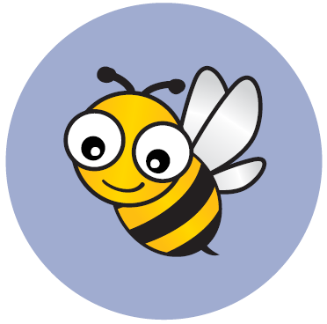
The cooperation of everyone in school is essential in order to support a safe return. Positive behaviour at all times is essential and this means being mindful of the feelings of others, any anxiety people may have in returning to school and adhering to all guidance. This includes use of PPE when needed, social distancing, new one-way systems and entrance/exit routes and making sure we take notice and comply with instructions on new signage.

If you are unwilling to follow clear guidance and rules in place to ensure the safety of yourself and others in the school, your parent/carer will be asked to collect you from school. Please be respectful at all times noting that following guidance and rules is essential – they are in place to keep everyone safe.

Evacuation Procedures

You may find on return to school that Fire Evacuation procedures and gather points outside have changed due to Covid-19. This may have been carried out to support distancing and ensure the safety of everyone during Covid-19.

Please follow the instructions of staff during any fire drill or evacuation, exiting the building and gathering at muster points. Staff in school will update you on this if any changes are made. In the event of a Fire, the one-way system will not be in operation.

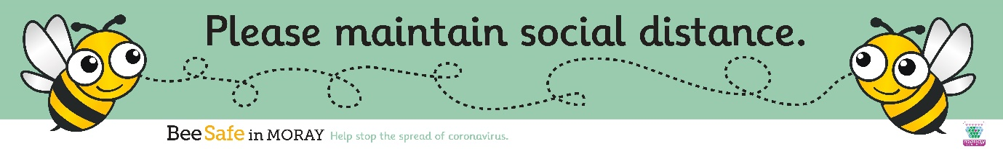
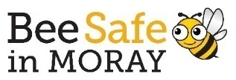
Part B: Top Tips for Learners

Before going to school:

- If you feel unwell, tell someone at home – are you hot, have a constant cough or lost your sense of smell and taste?
- Make sure you have breakfast
- Make sure you have packed everything you need for the day including your own hand sanitiser, mask and tissues if you want
- Remember to bring your own packed lunch if you are having one that day
- Check if you need your PE kit today
- Leave anything you don’t need at home (for example, toys, games and devices)
- Wash your hands before you leave the house (20 seconds)
- Avoid touching your face, eyes and mouth at all times

When travelling on school or public transport:

- If you can, walk, cycle or scoot to school as a healthier option
- Hand sanitise before going on to school or public transport
- Wear a mask if you want to (remember to do this on public transport)
- Don’t eat or drink on transport
- Take your rubbish with you and place it in a bin on leaving transport
- Avoid touching seats, handles and surfaces if you can
- Keep 2 metres away from adults

When arriving at school:

- Arrive as near to the start of the school day as you can – don’t be late!
- Avoid gathering with others in groups
- Follow instructions from adults
- Wash your hands and hand sanitise
- Avoid standing at busy areas – for example, at entrance doors
- Be kind and respectful at all times and follow rules for everyone’s safety
- Carry your personal belongings with you at all times – lockers and coat pegs will not be in use

During the school day:

- Wash your hands regularly, dry them properly and hand sanitise
- Move around the school and classroom only when you need to
- Use toilets at break and lunch times where possible - moving around during class times will be limited
- Put your coat on the back of your chair
- Put your bag and packed lunch on the floor – do not place this on tables or surfaces/worktops
- Stay in your own chair
- Don’t share equipment
- If you use tissues to sneeze/cough, put them in the bin and wash your hands
- Avoid touching other people, handshakes and hugs
- Smile and wave at other people to greet them
- Follow instructions given by staff
- If you feel unwell at any time, tell a teacher or an adult straight away
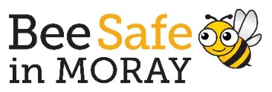

At break and lunch times:

- Wash your hands and hand sanitise
- If you feel unwell, tell someone straight away which may involve going to the School Office
- You will be told when and where to go for lunch
- Put all rubbish in bins provided
- There may be different toilets for your class or year group – use the correct ones!
- Adults on duty will help you when moving around the school – please follow their instructions to keep everyone safe
- Secondary Schools: identified year groups may be allowed to leave school premises at lunchtime. Scottish Government guidance when off school premises must be adhered to – please be a good neighbour, be respectful, follow social distancing and wear a mask

At the end of the school day:

- Follow instructions of school staff
- Leave the building, taking all personal items with you
- Use the correct exit route and exit door
- Avoid gathering outside the school building or on the way home from school
- Be kind and respectful to people and the area around the school

When you return home:

- Wash your hands and hand sanitise
- You may want to change out of your school uniform
- Remember to do your homework or studying

At all times:

- Please be kind and think of others
- Please follow all rules, arrows and instructions
- Try your best and be supportive of one another
- Enjoy being back at school and your learning

We will do everything we can to make you feel safe in school and to support you with your learning.

In the very unlikely event that you are unable to follow the above advice and expectations for keeping everyone safe, we will contact your parent/carer to collect you from school.

