Transition Week 12
Shape hunt  Go on a walk and see how many shapes you can spot. Can you spot all the regular shapes (eg squares, triangles rectangles, hexagons and pentagons). Extension: spot 3d shapes and explore their properties. If you have a camera or tablet, you could even take photos.  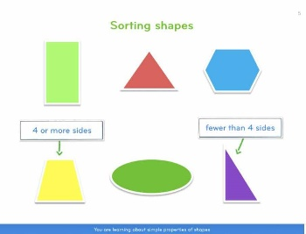 | Health and Wellbeing 1  Design and colour a SHANNARI Superhero (see sheet in Teams). Your superhero will have the superpower to help to make sure that everyone always feels Safe, Healthy, Achieving, Nurtured, Active, Respected, Responsible and Included. What will your superhero wear? Can you think of a good name for your superhero? | Two Truths and One Wee Fib  One just for fun! Write down or email your current teacher two truths about yourself. Then think carefully of a wee fib to tell them, nothing too outlandish, we want to keep them guessing!  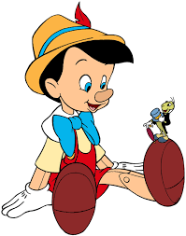
Lockdown Positives  Lockdown has been a difficult time, but even in the most difficult times it is important to keep looking for the positives, the rainbows, no matter how small or large they be. Tell us something positive that happened to you in lockdown. Was it spending time with family? Learning to ride a bike? Growing your own vegetables? Learning to skim stones? | I am successful!  It is important to celebrate your achievements outside of school too. We know a lot of you are missing your clubs and groups. Tell us about your biggest achievement so far. That could be learning to juggle, achieving a new badge at swimming, or mastering a new recipe. Or it could be something at school. | People who are special to me  Draw a picture of yourself in the middle of a piece of paper and around your picture draw everyone who is special to you. Don’t forget to name them. You can write why they are special too.
Music  1. Record your own music video to your favourite song.  2. Make a brand new instrument: Fill glass bottles with water (to tap – or if you’re really clever, to blow across), or make shakers by putting rice into tubs, or make a drum kit out of saucepans! Then record yourself playing, either along to a favourite tune or going solo!  3. Find out which song was Number 1 on the day that you were born and listen to it. Do the same for other family members. Who gets the best birthday tune?! | Ball games  Throw and catch a ball with a friend or family member. Each time a successful catch is made you count up in a particular multiple - e.g. in 2s, 5s or 10s. If you drop the ball you have to go back to the start. You can make this a competition by setting a time limit and seeing how high you can get. Can you beat your time from last time? | Writing – ‘I am unique’  Write a fact-file about yourself to show your P3 teacher. Include details like what your favourite foods are and what you like to do in your spare time. What was your favourite topic at school this year and why? What are you most looking forward to in P3? What are your highlights of the year 2019/2020? How are you feeling about going into P3? How can we make it easier for you?  OR:  Write a letter about yourself to your P3 teacher. Tell your teacher about yourself and include the information above.
Data collection  Step outside and observe cars and other traffic on a nearby road. Come up with your own question to answer e.g. what is the most common colour car? Gather the information and then have a go at representing it in different ways e.g. a tally chart and/or a bar graph. | French  Learn this French goodbye song. Replace the names of children with people from your class. Do you know what all the words in the song mean? Try using google translate to help you.  https://www.youtube.com/watch?v=f2ngc7QlXjg | Make shapes  Children could explore making 2D shapes in two ways: with their bodies, e.g. lie on the floor to make a triangle, or using large loops of string/ribbon. Can you make a triangle, a square and a rectangle?

