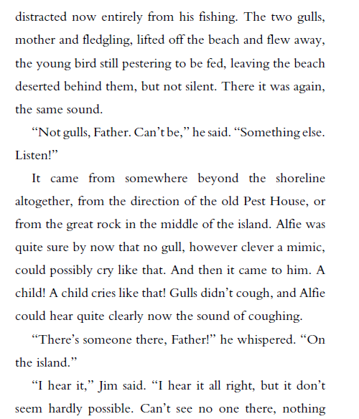
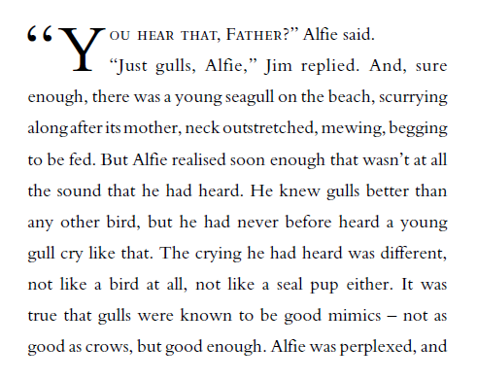
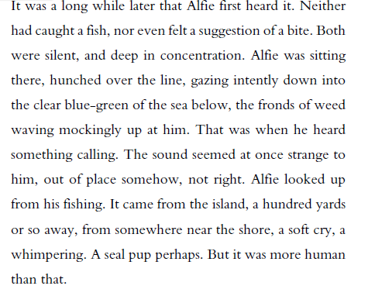
From ‘Listen to the Moon’ by Michael Morpurgo
Retrieving Information
- Use a dictionary to find the definition of:
- fronds
- intently
- perplexed
- Find and copy a word that shows the noise that Alfie hears is a sad one.
- What is the relationship between Jim and Alfie?
Making Inferences
- How do you know that Alfie spends a lot a time out on the coast?
- Have Alfie and Jim just arrived or have they been out for a while? How do you know?
- Why do you think that Alfie whispers to his father at the end of the extract?
Writer’s choices
- Why do you think the writer has started with the line, “It was a long while later that Alfie first heard it.”? What mood does this create?
- Why do you think the author describes the weed as “waving mockingly”?
Challenge question
- Why might Jim think that is not possible for a child to be on the island?

