Make a nature tic-tac-toe game

Tic-tac-toe (also known as noughts and crosses) is a fun and widely-played game for two people.

The rules are simple: each player takes it in turns to place a counter in the grid with the aim of getting three of their counters in a row (up, down or diagonally).

Here, we show you how you can make a nature-inspired version of the game that also involves a bit of arts and crafts to get started.

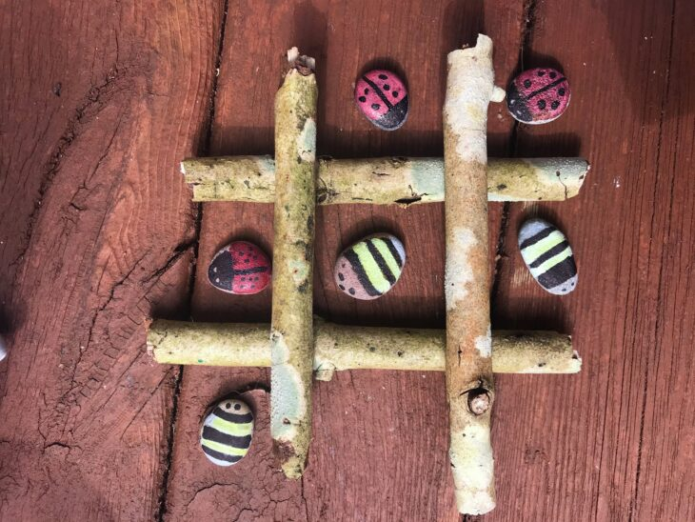© Lyndsay Mark

What you will need:

* Stones x10  (or other natural objects such as 5 pinecones and 5 leaves)
* Sticks x4
* Pens or paint
* Clear varnish to finish (optional)

How to make your tic-tac-toe game:

1. Choose two different designs (we’ve chosen bumblebees and ladybirds) and colour or paint the designs onto your stones. You should have five of each design.
2. Wait for the paint to dry and apply the varnish if you would like to make them shower-proof.
3. Make your game board by placing the four sticks in a grid (they can be tied together if you wish).
4. This game grid can be drawn if you prefer (on paper with pen or on the ground with chalk).
5. It’s time for tic-tac-toe!