**Properties of Numbers**

**Square numbers**

A square number is a number multiplied by itself. This can also be called 'a number squared'. The symbol for squared is ².

2² = 2 x 2 = 4

3² = 3 x 3 = 9

4² = 4 x 4 = 16

5² = 5 x 5 = 25

The square numbers up to 100 are: 1, 4, 9, 16, 25, 36, 49, 64, 81, 100

**Cube numbers**

A cube number is a number multiplied by itself 3 times. This can also be called 'a number cubed'. The symbol for cubed is ³.

2³ = 2 × 2 × 2 = 8

3³ = 3 × 3 × 3 = 27

4³ = 4 × 4 × 4 = 64

5³ = 5 × 5 × 5 =125

The cube numbers up to 100 are: 1, 8, 27, 64

**Factors**

The factors of a number are the numbers that divide into it exactly. The number 12 has six factors:

***1, 2, 3, 4, 6****and****12***

If 12 is divided by any of the six factors then the answer will be a whole number.

For example:

***12 ÷ 3 = 4***

**Factor Trees**

A special diagram where we find the factors of a number, then the factors of those numbers, etc, until we can't factor any more.  
  
The ends are all the prime factors of the original number.  
  
Here we see the factor tree of 48 which reveals that 48 = 2 × 2 × 2 × 2 × 3

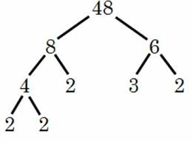

Here we see that the factor tree of 36 reveals that 36 = 3 x 3 x 2 x 2

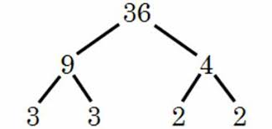

1. Write four odd numbers that are multiples of 7
2. What are the factors of 12?
3. Which two different square numbers under 20 when added together make another square number?
4. Ally swam a number of lengths of the swimming pool. The number of lengths is a multiple of 12 and a square number, and the sum of its digits is 9. How many lengths did Ally swim?
5. What is the smallest 2-digit prime number?
6. What is the largest 2-digit prime number?
7. Complete a factor tree for the number 12.
8. Draw a factor tree for the number 48.
9. Draw two different factor trees for the number 18.
10. a) 62 + 82 = b) 42 x 52 =

c) 82 ÷ 22 = d) 122 x 32 =

1. a) 33 x 5 = b) 23 + 42 =

c) 53 - 72 = d) 63 x 23 =